**BIT302**

**SOFTWARE ENGINEERING**

**Assignment 2**

**Design Specification and Testing Document**

**“Web based Academic Information System”**

Team Leader: Lovely (E1500367)

Contact Details: lovelyzheng98@gmail.com

Member: I Wayan Denny Harry Caka (E1500365)

Contact Details: dennycaka@gmail.com

**Table of Contents**

Introduction 3

Architectural Design 4

Design Class Diagram 5

Sequence Diagram 6

Database Design 11

Wireframe 13

Uses Cases 16

Test Objectives 17

Test Plan 17

Unit Testing and Integration Testing 21

System Testing 51

Test Analysis Report 94

Updated Gantt Chart 94

References 95

# Introduction

Every application is developed because clients or users encounter problems that need to be solved through information technology. However, it is important to know what are the requirements to solve the problems, and how the system works to help users or clients. Once, the requirements are known, solution can be developed to solve the problems. The creative process of transforming the problem into a solution is called design [1], and it is what we will discuss in this assignment.

There are two types of design, which are conceptual and technical design. Conceptual design is written in normal language that clients or users understand to describe the system’s functions, with no technical terms or jargon. Meanwhile, technical design is meant for system builders to understand the required hardware and software to develop the system.

In this particular assignment in relation to design documentation, we will produce architectural design, design class diagram, sequence diagram, database design, and the wireframe.

# Architectural Design

admin

School Database

(MySQL)



PHP and HTML

data

queries

Web Browser

User Interface



student

# Design Class Diagram

# Sequence Diagram

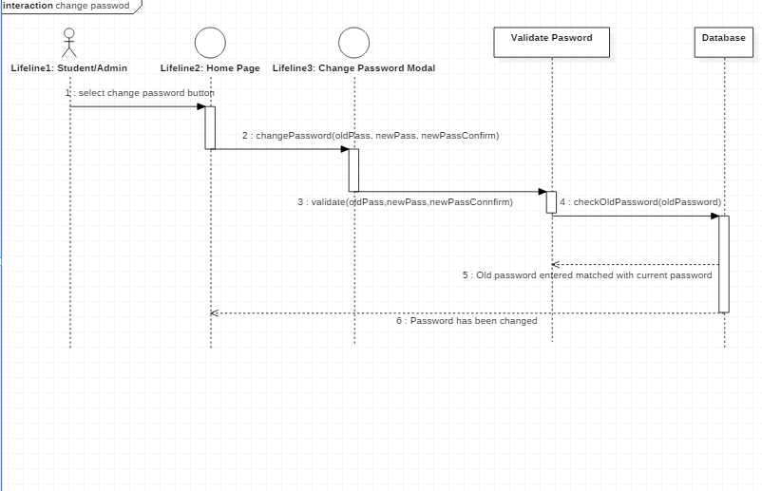

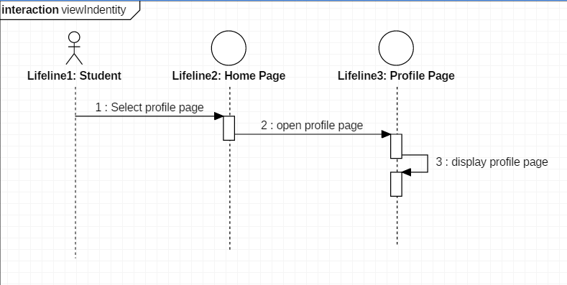

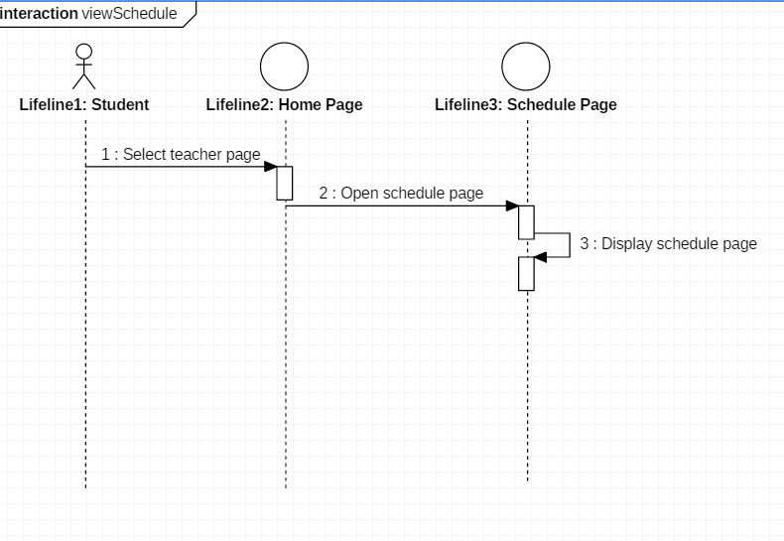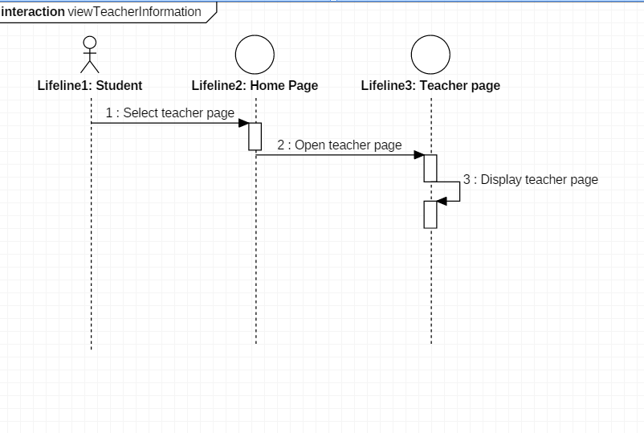

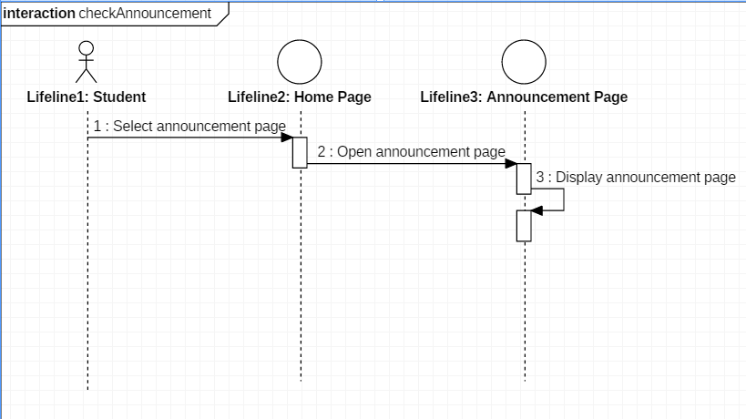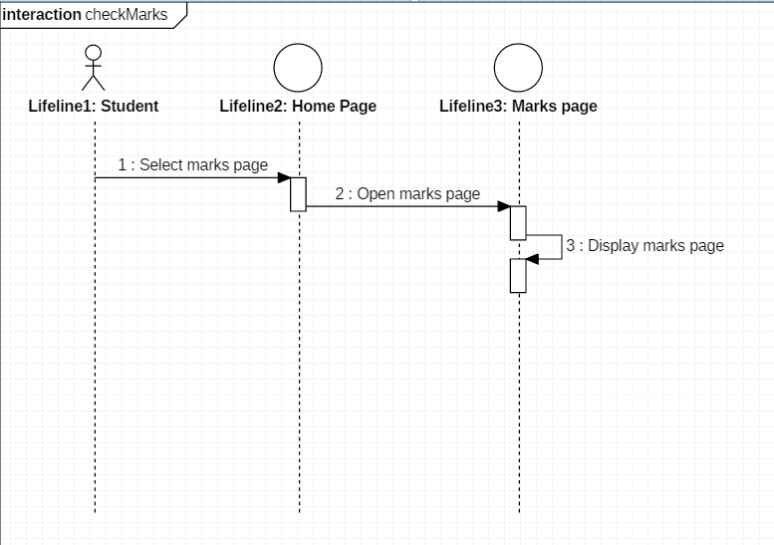

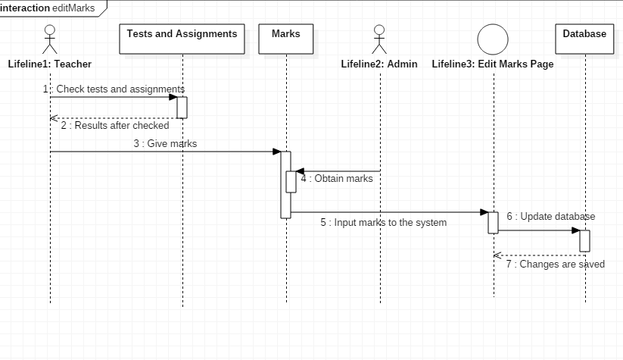

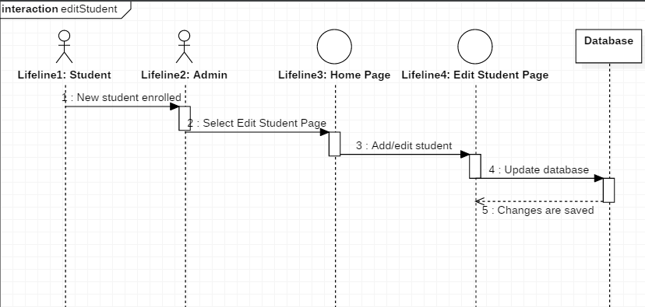

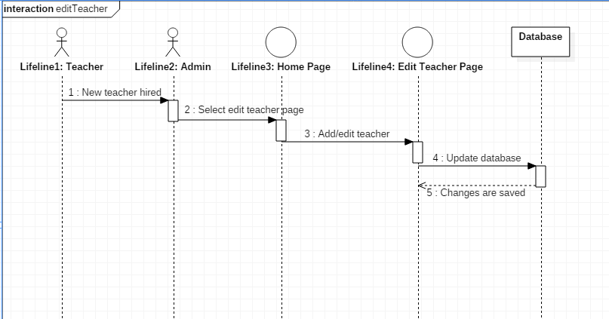

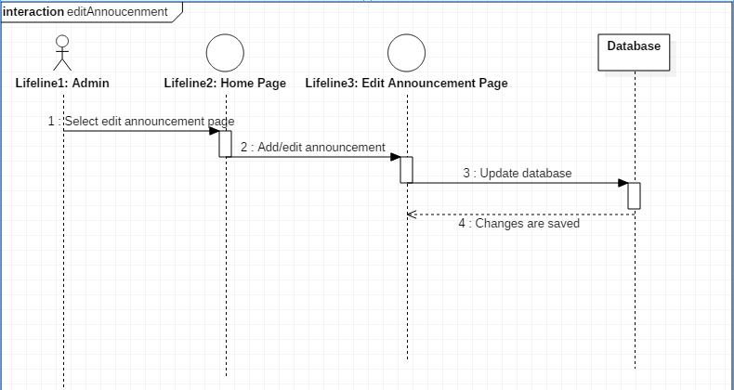

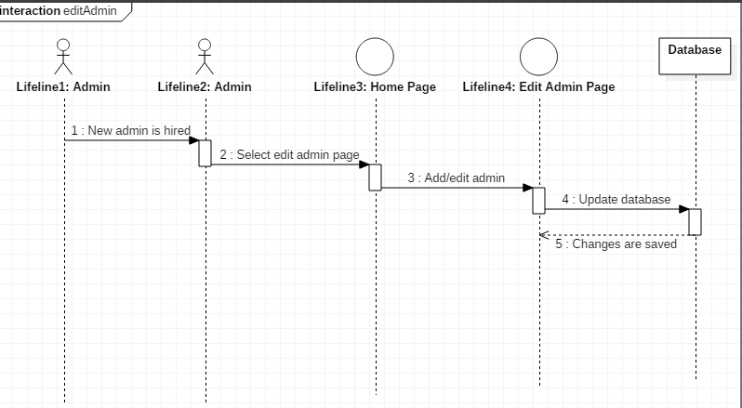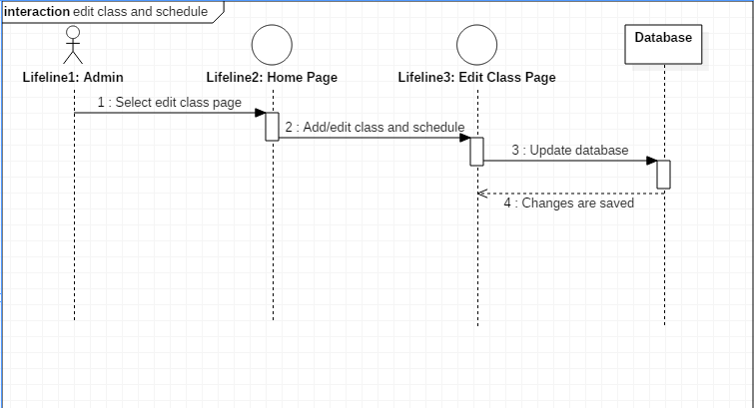

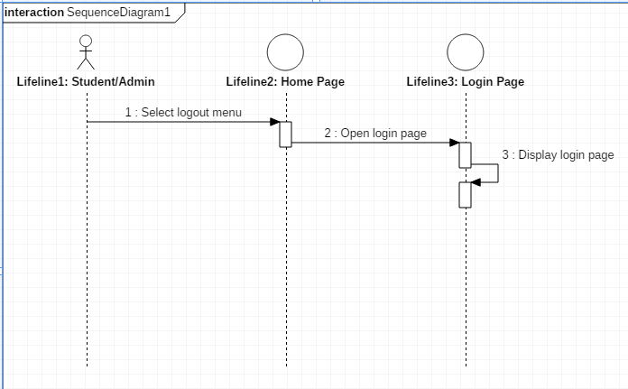

# Database Design

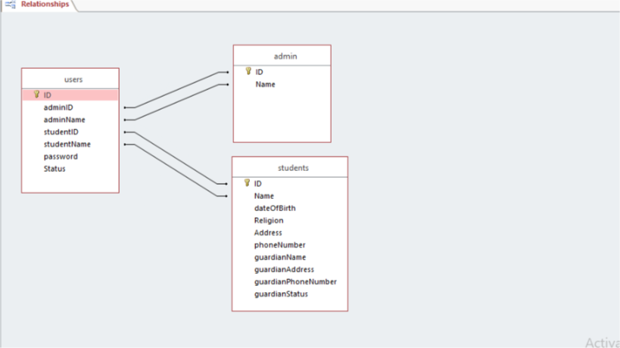

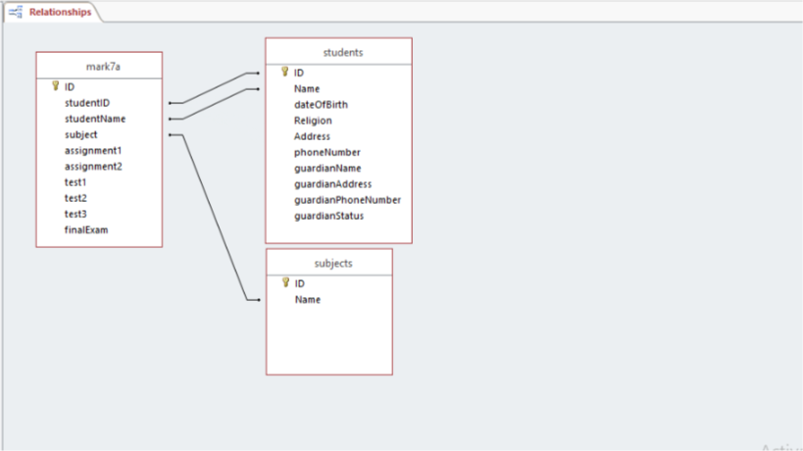

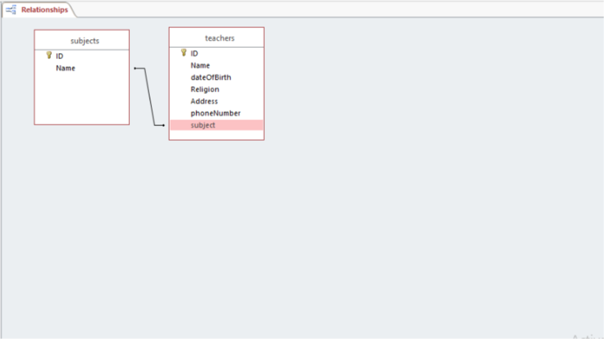

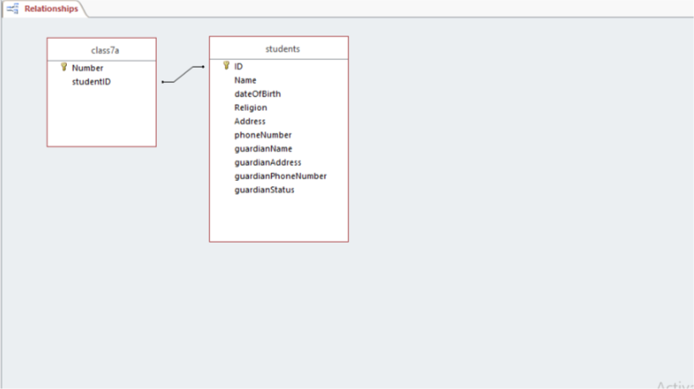

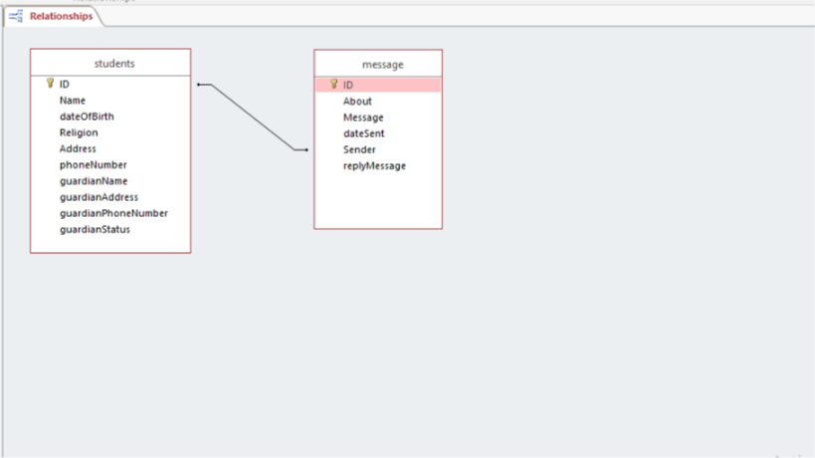

# Wireframe

Login page

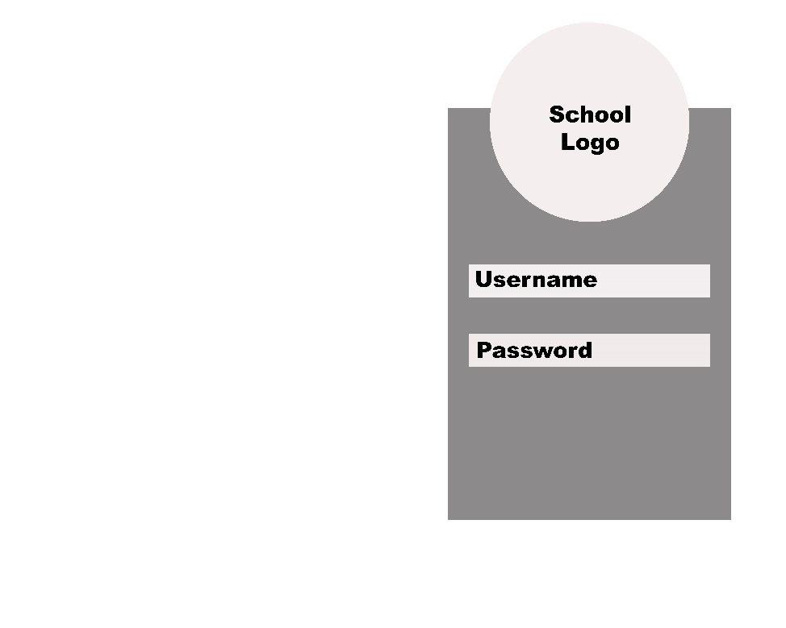

Admin home page

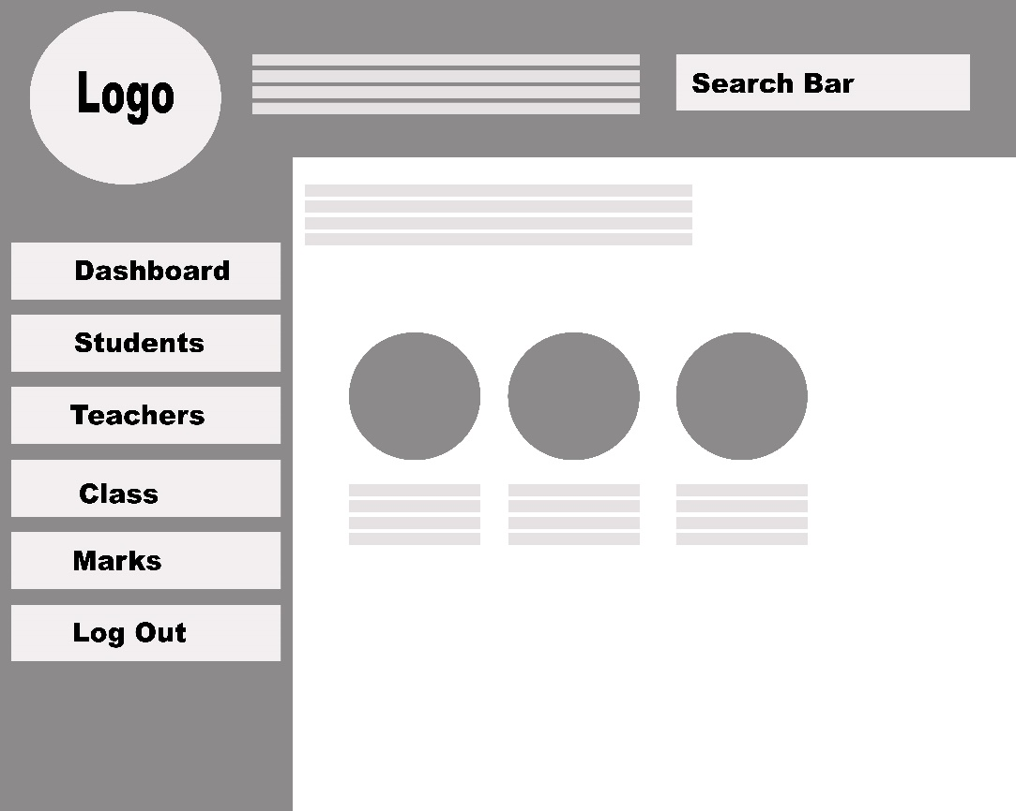

Admin menu page

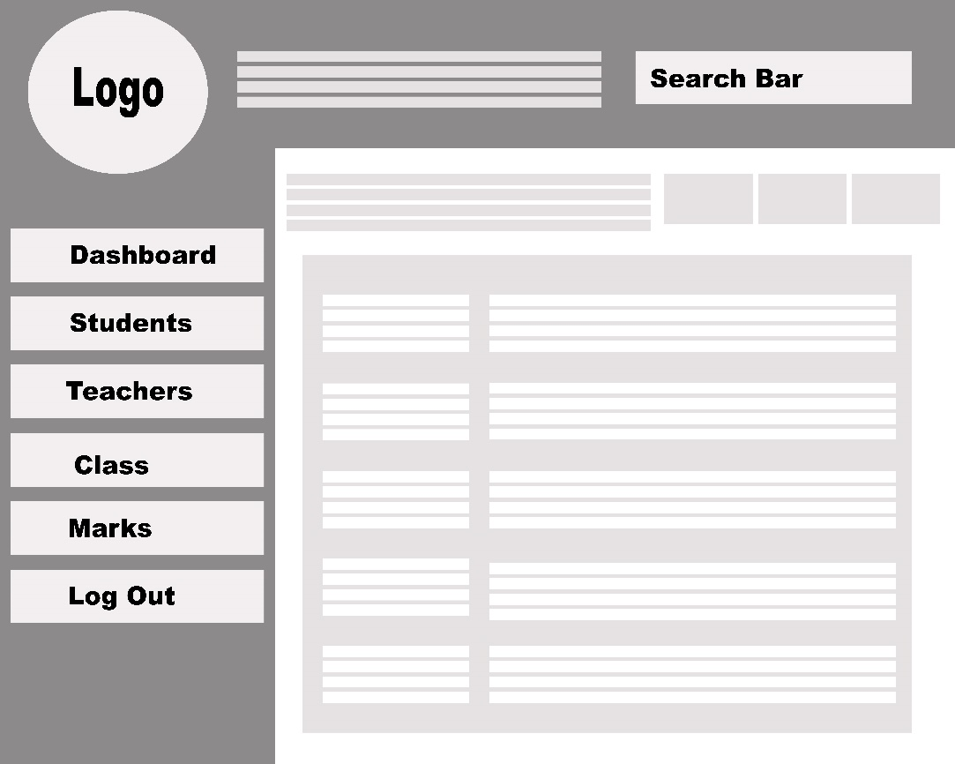

Student home page

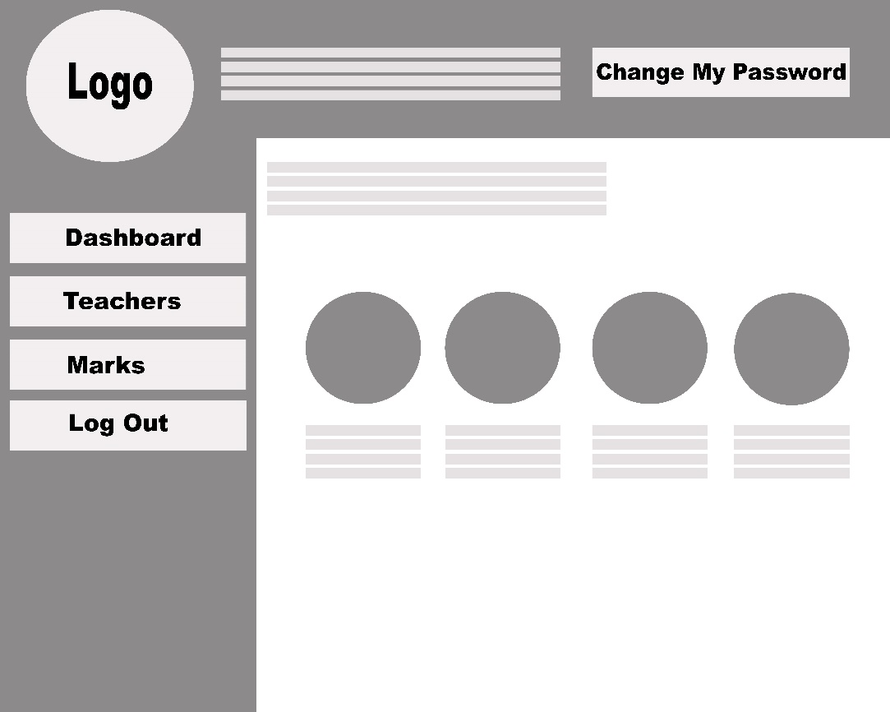

Student menu page

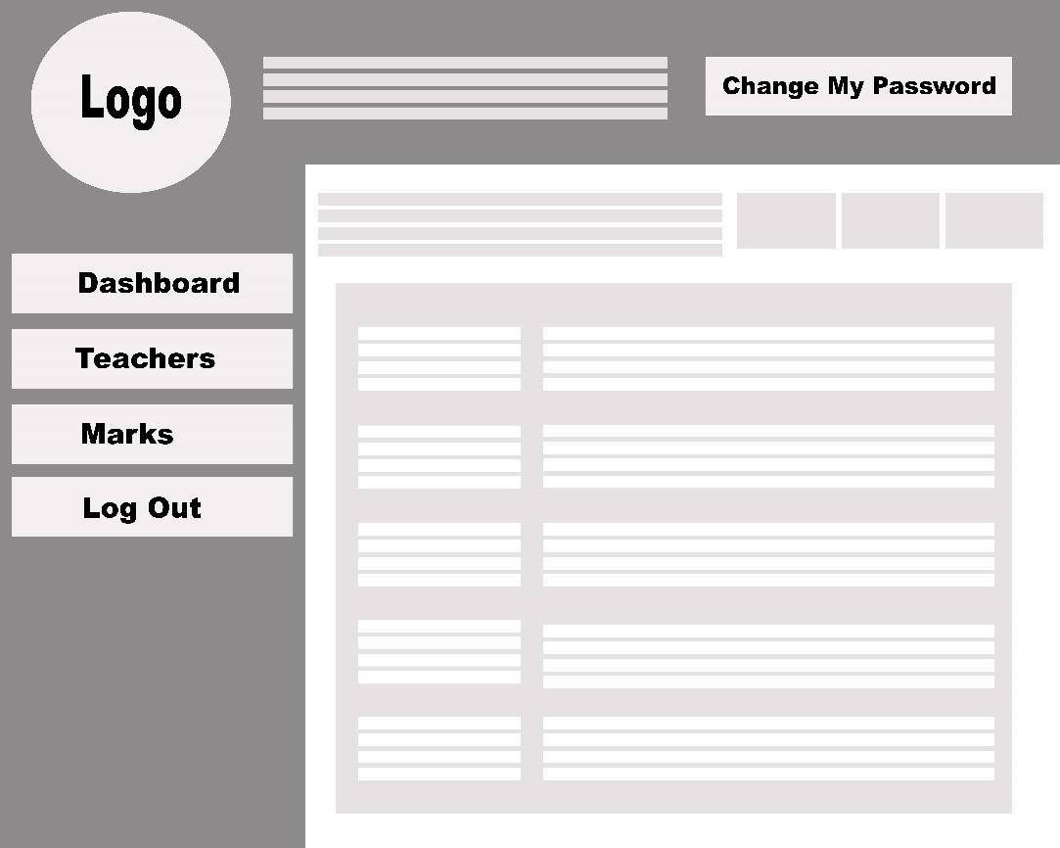

# Uses Cases

|  |  |
| --- | --- |
| Use Case | Developed By |
| Log in | Denny |
| Change password | Denny |
| View identity | Denny |
| View teacher information | Denny |
| View schedule | Lovely |
| Check marks | Lovely |
| Check announcement | Denny |
| Edit marks | Denny |
| Edit student’s data | Lovely |
| Edit teacher’s data | Lovely |
| Edit announcement | Denny |
| Edit class and schedule | Lovely |
| Edit admin | Lovely |
| Log out | Denny |

# Test Objectives

System developers are human that are not free from mistakes. Errors can present in the codes and design during development phase. Thus, the main purpose of testing is to find defects that may get created while developing the software. Testing is important to build confidence in the software quality before handing out the software to the clients. It is an essential stage to make sure requirements are met and all functions are performing well, in order to maintain clients’ reliability and satisfaction. Testing is also important to prevent any faults occur in the future, because it will be harder and more expensive to fix.

For our school information system, our first test objective is to make sure login validation works and password data is successfully encrypted with md5 encryption. Next, we want to test if the application (web pages) have the same view across different browsers. From the admin perspective, he/she should be able to add, edit and delete data in the system such as student, teacher, etc. Meanwhile, the student should be able to view data only related to that student, and able to send message to admin. We also have to test if all the links are working properly and directing to the right pages.

# Test Plan

In our school information system, we will be testing functions that will be performed by admin and functions that will be performed by students. We want to make sure that system boundaries are working. For example, students cannot edit or delete data, except edit his/her own profile. Students should not be able to add anything, except add message to ask question to admin. Login should also be tested, so that students after login are not directed to admin home page, and admin are not directed to student home page. During the testing process, we will test a function 3 to 5 times, to verify that the function has worked perfectly.

The interfaces between the following subsystems from admin view point will be tested:

|  |  |
| --- | --- |
| Admin home page | Manage classes and schedules |
| Manage announcements | Manage message and questions |
| Login page | Manage admin |
| Manage students | Manage teachers |
| Manage marks | Manage subject |
| Search bar | Change password |

The interfaces between the following subsystems from student view point will be tested:

|  |  |
| --- | --- |
| Student home page | View teachers |
| My profile page | Create message |
| Login page | View announcement |
| My marks page | View schedule |
| Change password |  |

Features to be tested from admin view point:

|  |  |
| --- | --- |
| **Features** | **Description** |
| Modify students | To add new student that enrolled to the school  To edit student profile if there is any change  To delete student that has quit from the school |
| View students | View existing students in the school |
| Modify teachers | To add new teacher that hired by the school  To edit teacher profile if there is any change  To delete teacher that has quit from the school |
| View teachers | View existing teachers in the school |
| Modify classes and schedules | To add class and its schedule, and the students that are included in the class  To edit class schedule or class name if there is any change  Deleting student means he/she automatically deleted from class |
| View classes and schedules | View students in a class, view classes in the school, and view schedule for each class |
| Modify admin | To add new admin that hired by the school  To edit admin name if there is any typing error  To delete admin that has quit from the school |
| View admin | View existing admin in the school |
| Modify subjects | To add new subjects  To edit subject name if there is any typing error  To delete subject that is no longer taught in the school |
| View subjects | View existing subjects in the school |
| Modify marks | To add marks of student based on subject and class  To edit marks if there is any change from the teacher  Deleting student means his/her marks are automatically deleted |
| View marks | View student’s marks based on subject and class |
| Change password | To change own password |
| Search student | Use the search bar and input student ID and the result should be the student with matching ID |
| Modify announcement | Add newest announcement for students  Delete announcement that has passed |
| View announcement | View existing announcement in the system |
| View message | View message send by student |
| Modify message | Reply message to answer student’s question  Delete message that has passed |

Features to be tested from student view point:

|  |  |
| --- | --- |
| **Features** | **Description** |
| View profile | View student’s own profile |
| Edit profile | Student edit his/her own data if there is any change |
| View teachers | View teachers’ information to contact them |
| View schedules | View the schedule based on the student class |
| View marks | View student’s own marks for all subjects |
| View announcements | View recent announcements made by admin |
| Create message | Add message to ask any question to admin |
| View message and reply | View message that has been sent and check if the admin has replied |
| Change password | Change student’s own password |

Features not to be tested:

|  |  |
| --- | --- |
| **Features** | **Description** |
| Registration | New student and new admin do not have to registered through the system, but they register manually and existing admin will give them user ID and password that they can change. Thus, it does not need to be tested. |
| Network security | Testing network security is out of our scope |

# Unit Testing and Integration Testing

Testing the addAdmin.php to test that adding admin to the database is successful

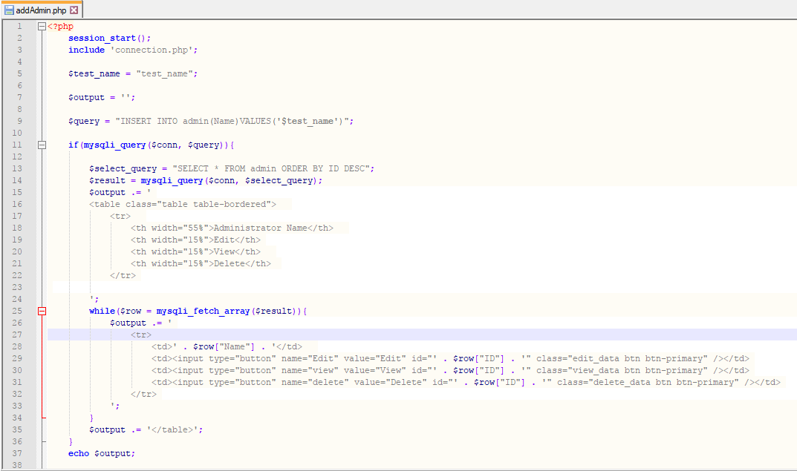

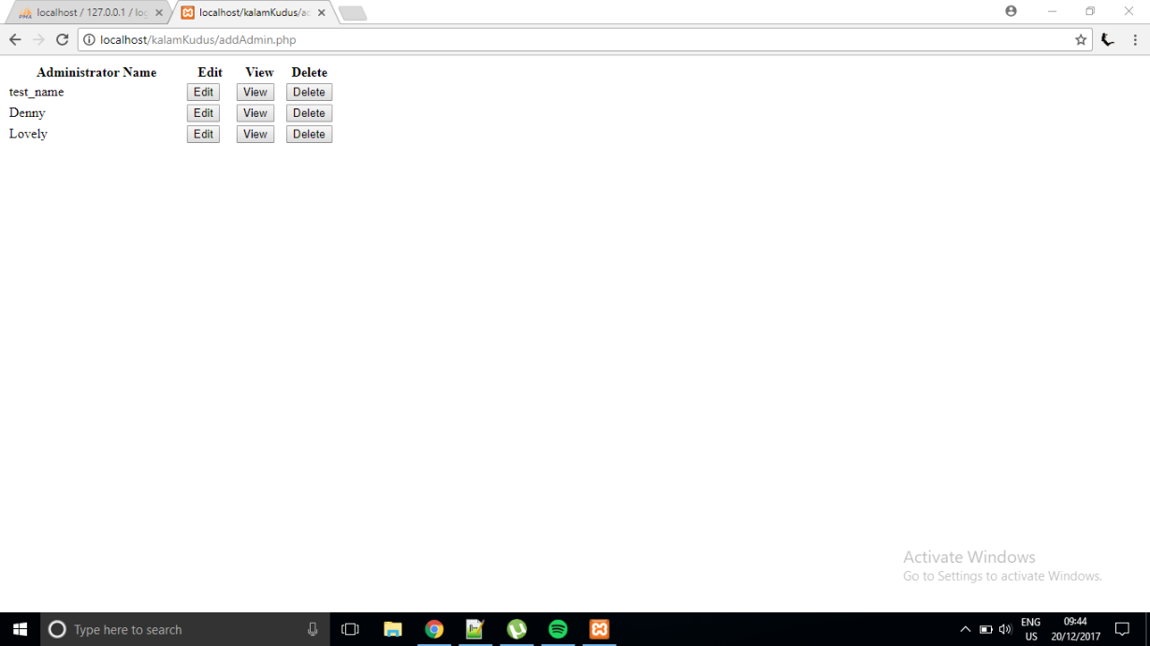

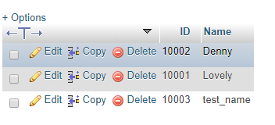

Testing the addAdmin.php to test that update existing admin in the database is successful

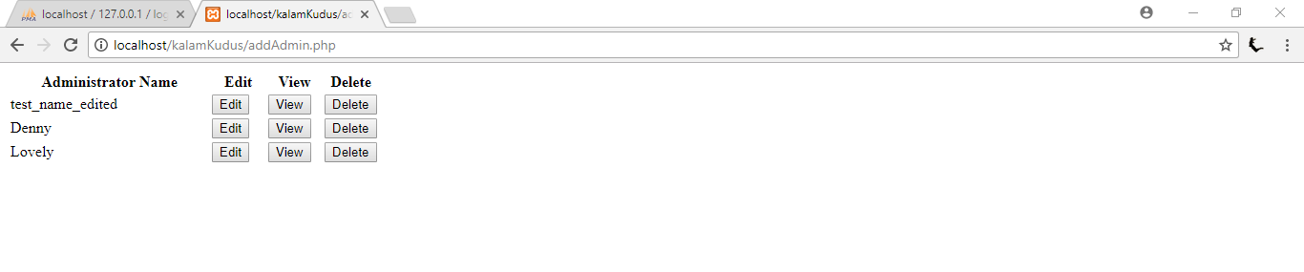

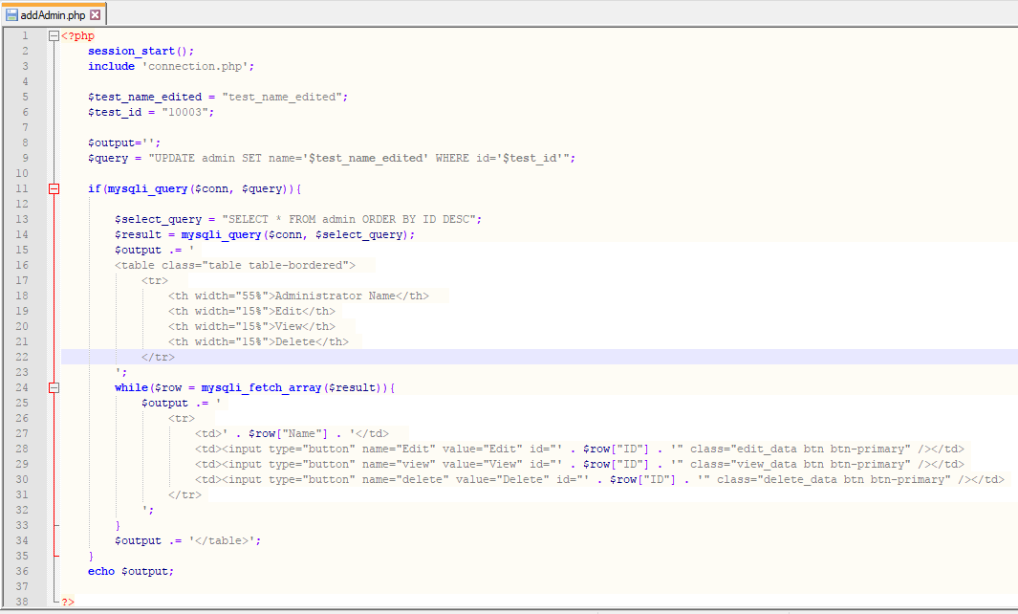

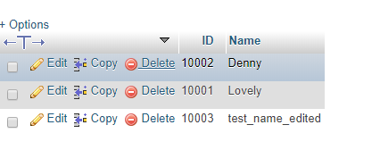

Testing the viewAdmin.php to test existing admin’s detail can be shown

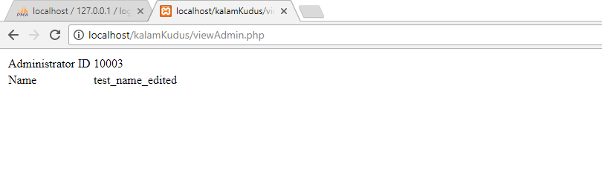

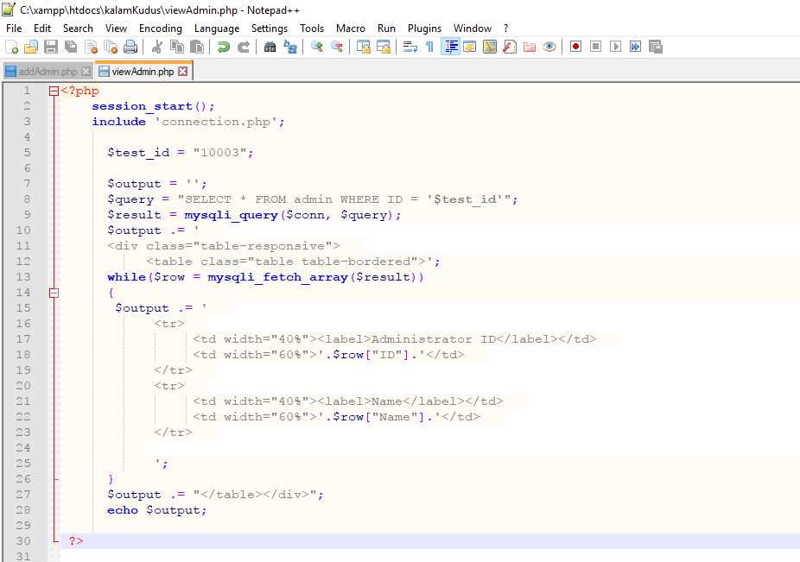

Testing the deleteAdmin.php to test admin can be deleted from the database

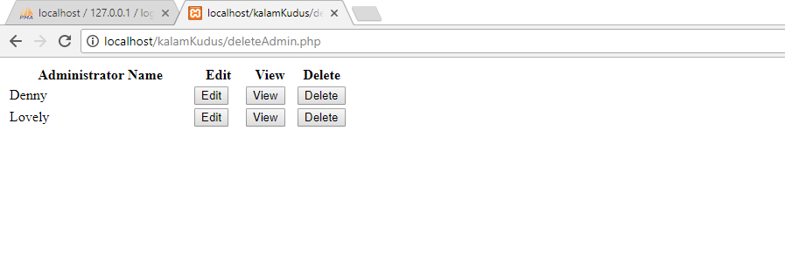

admin has been deleted

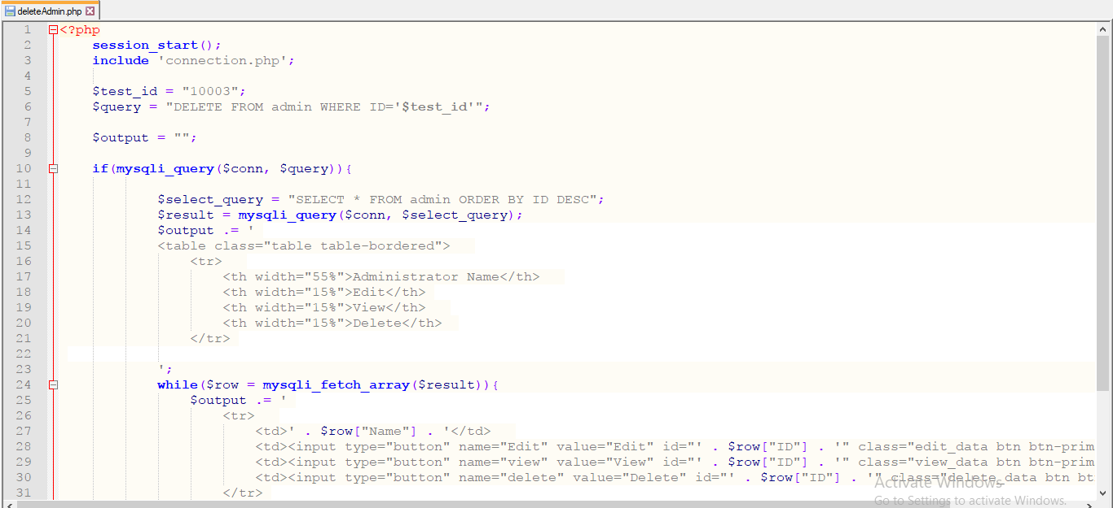

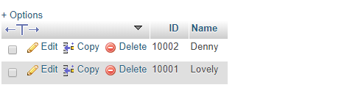

Testing the addStudent.php to test that adding student to the database is successful

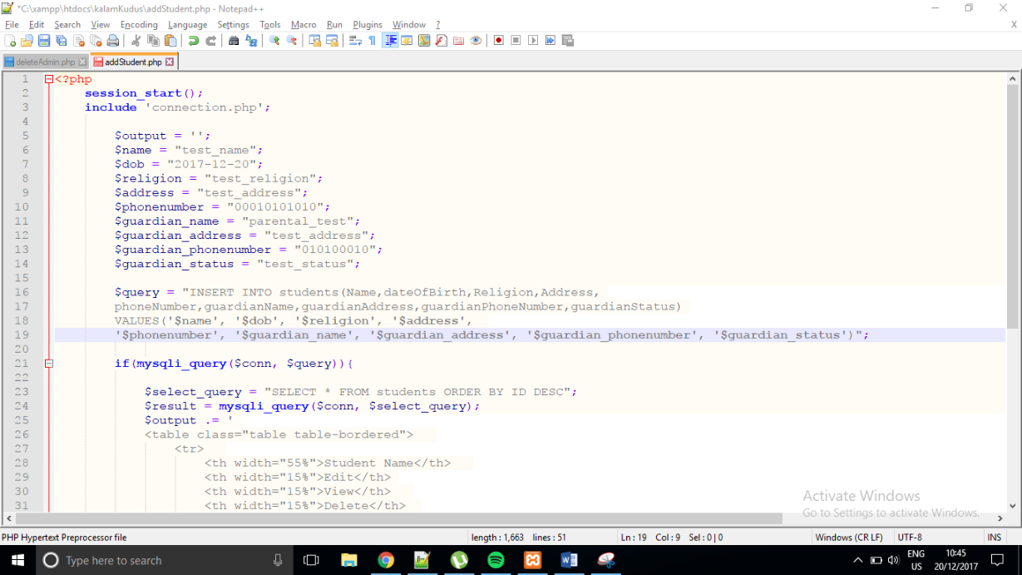

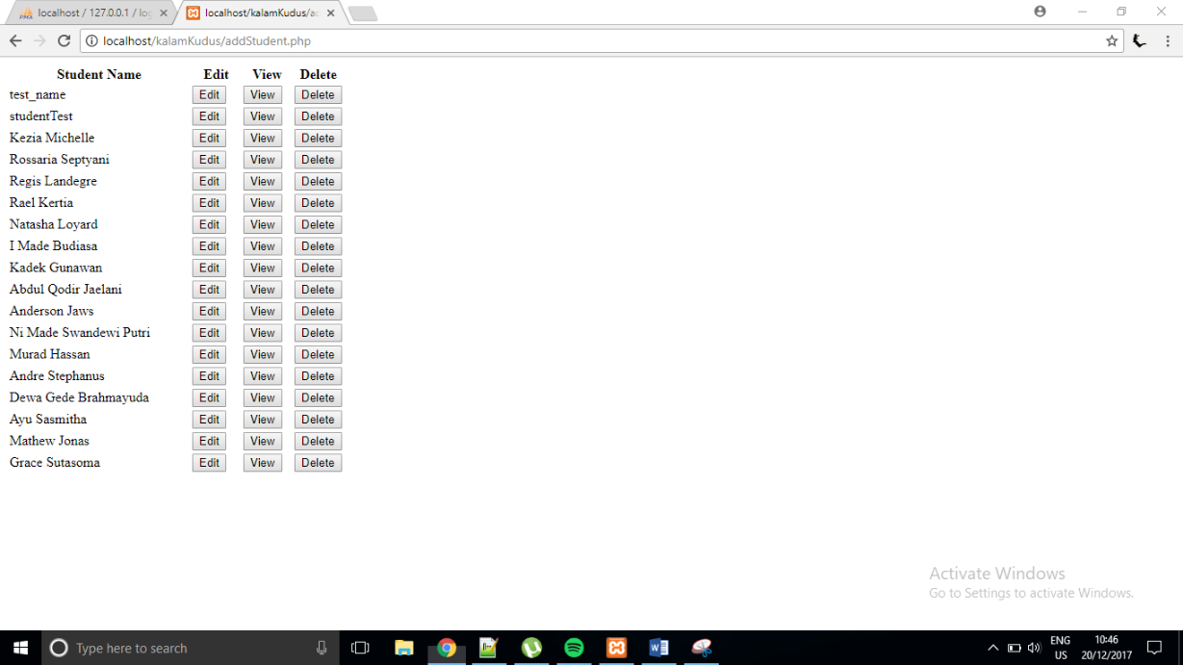

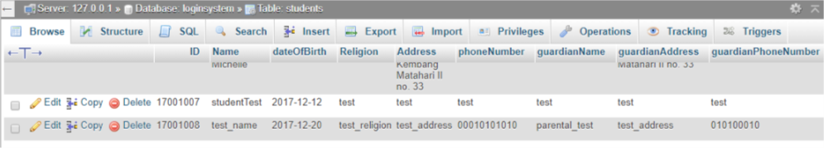

Testing the addStudent.php to test that update existing student in the database is successful

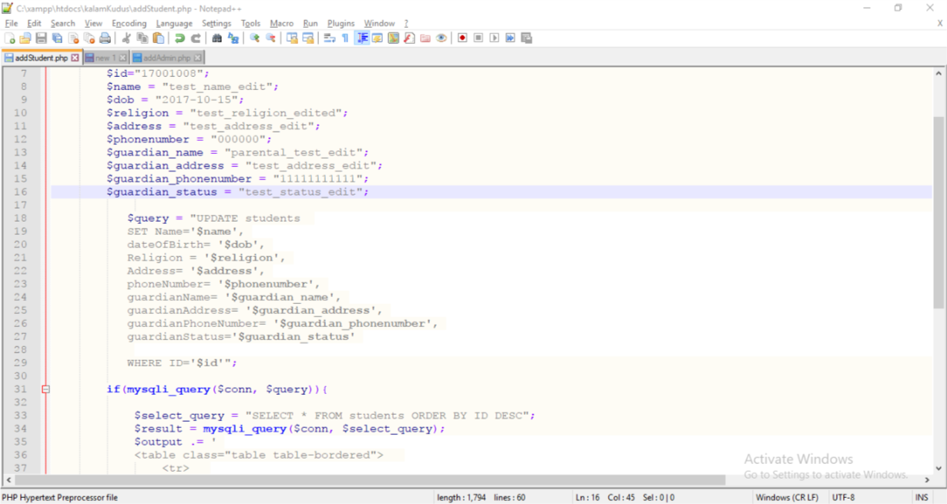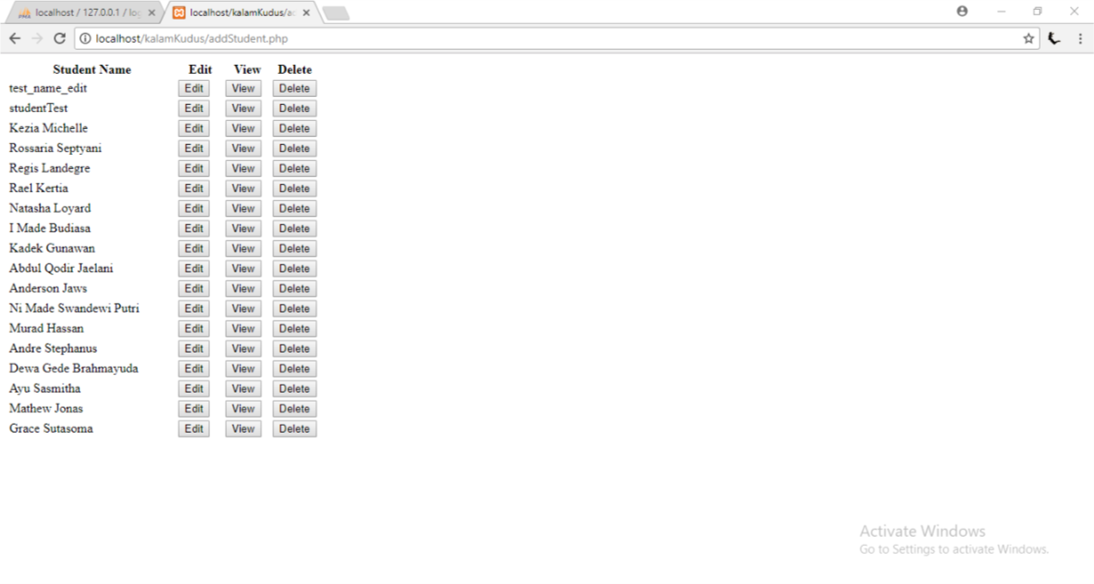

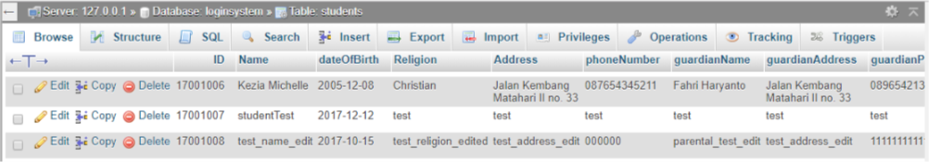

Testing the viewStudent.php to test existing student’s detail can be shown

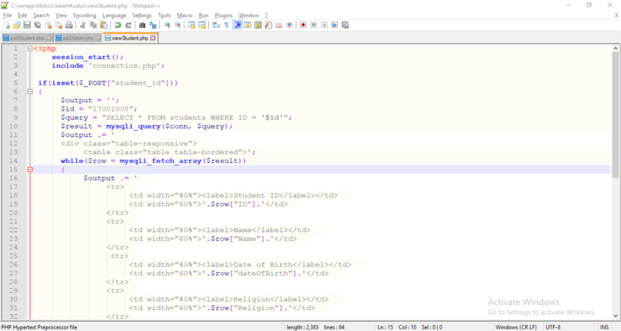

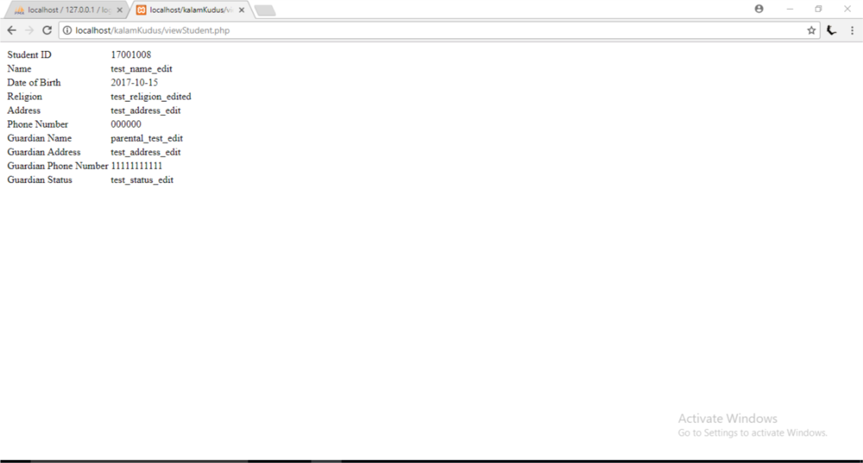

Testing the deleteStudent.php to test student can be deleted from the database

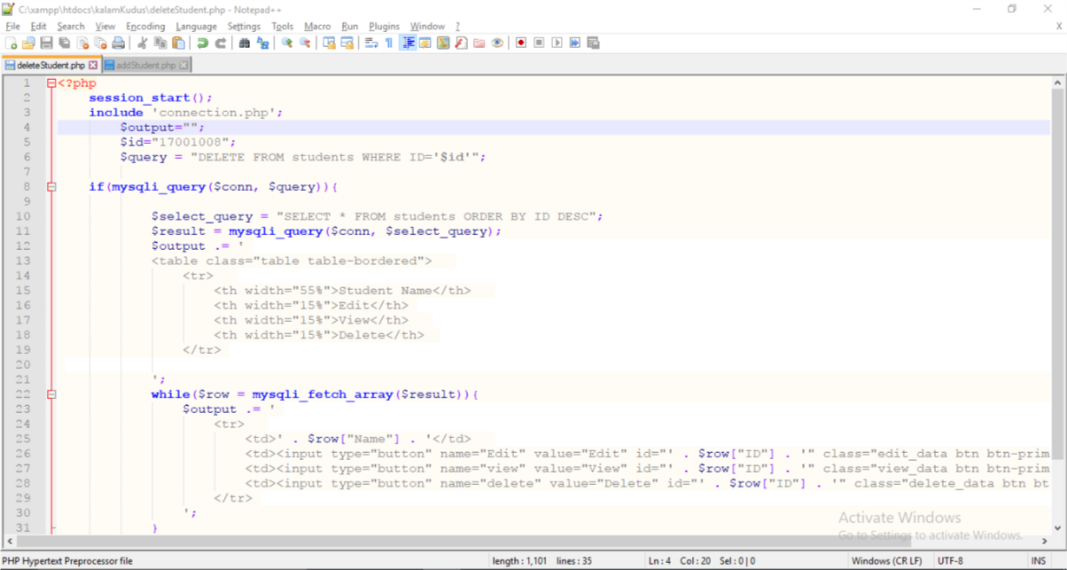

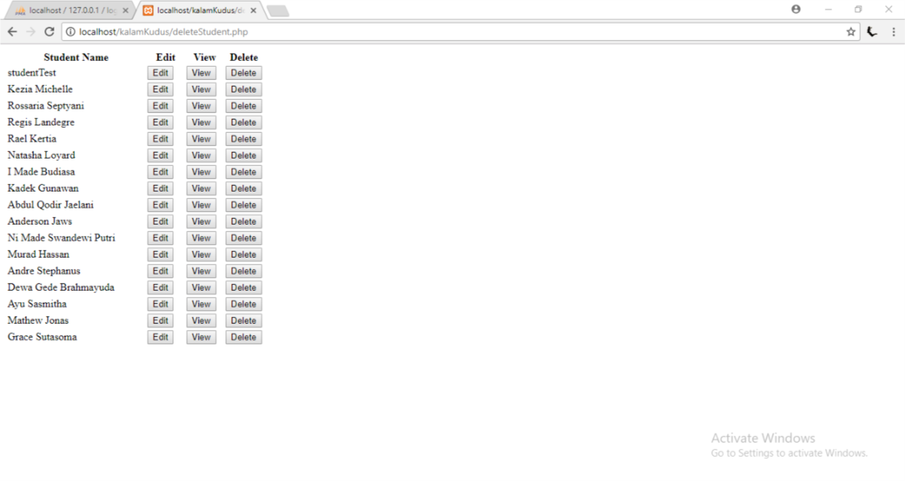

A student with name ‘test_name_edit’ has been deleted

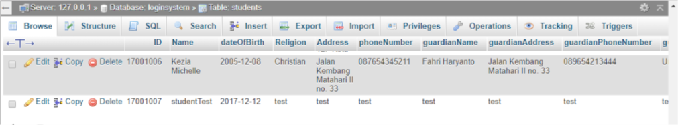

Testing the addTeacher.php to test that adding teacher to the database is successful

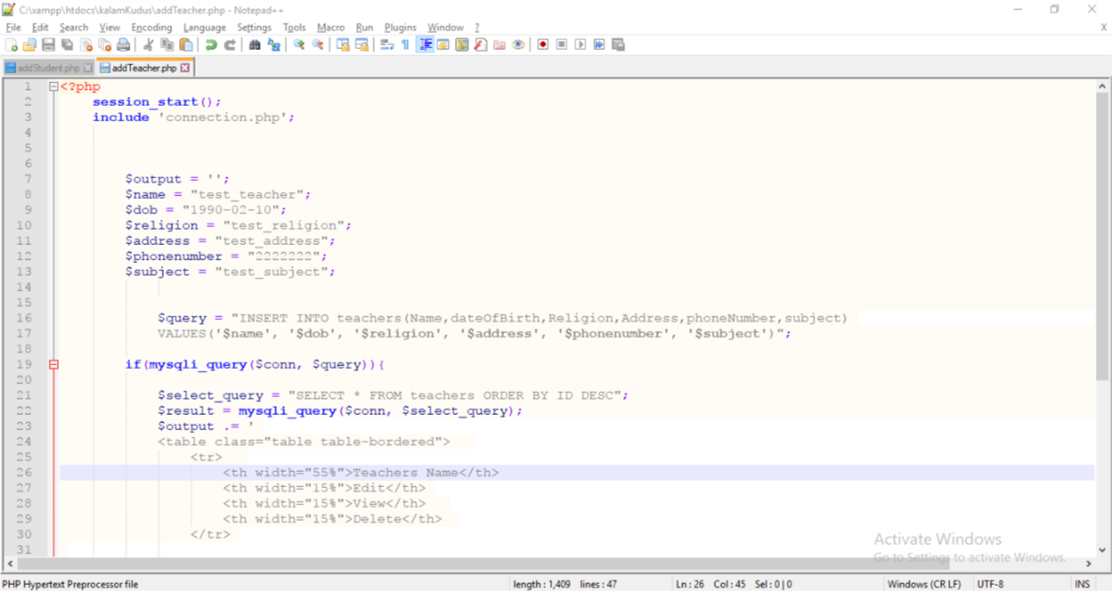

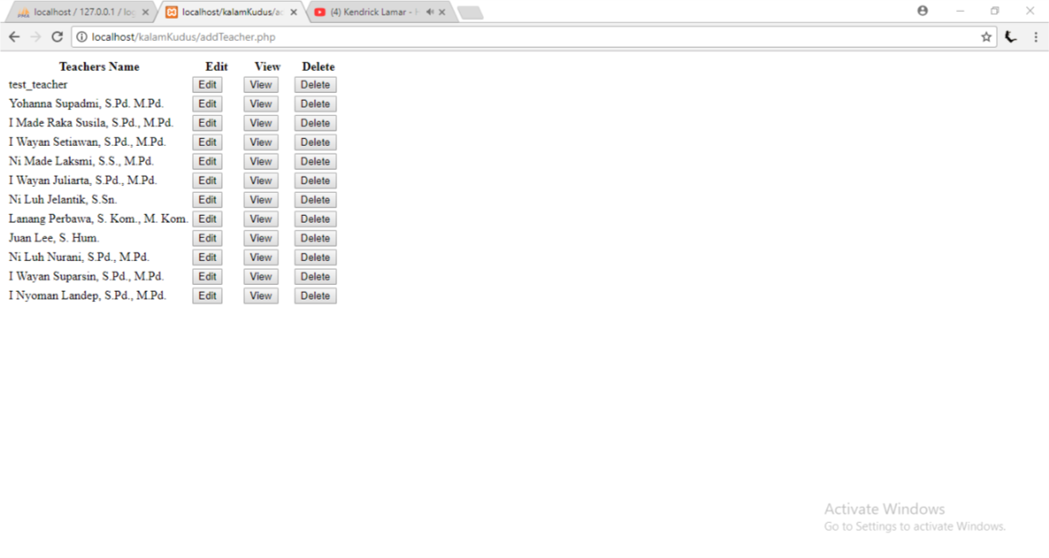

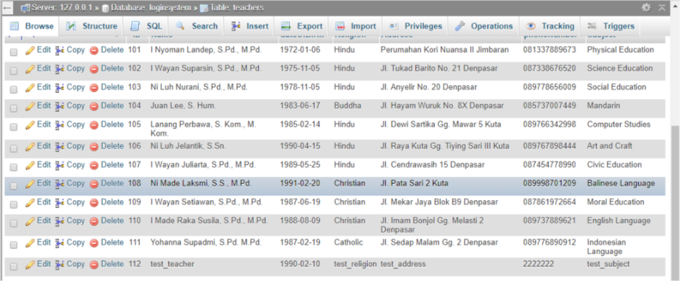

Testing the addTeacher.php to test that update existing teacher in the database is successful

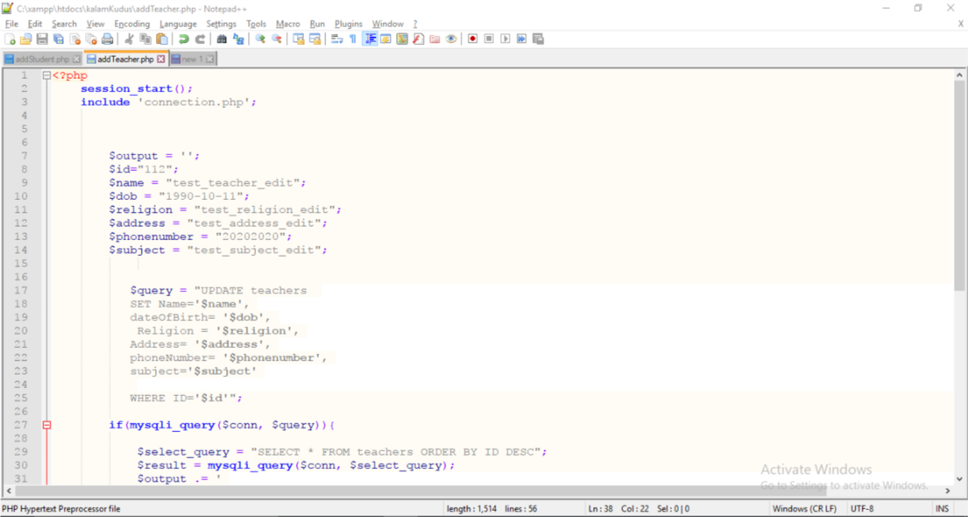

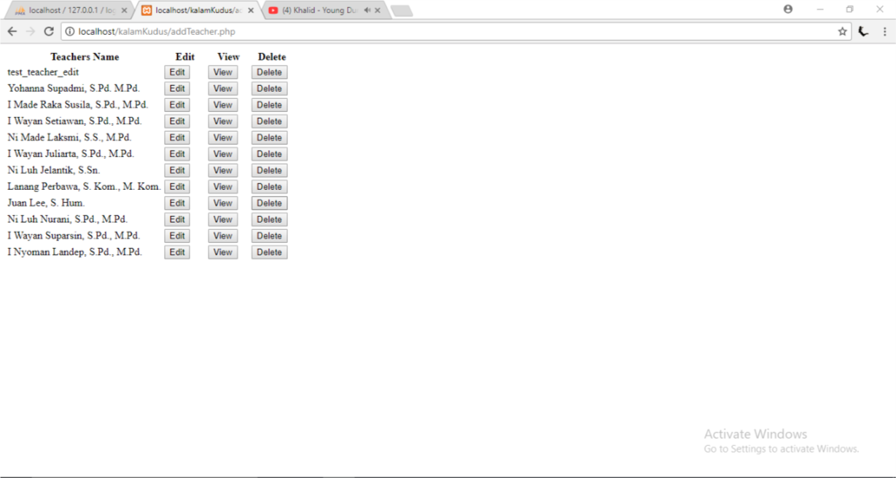

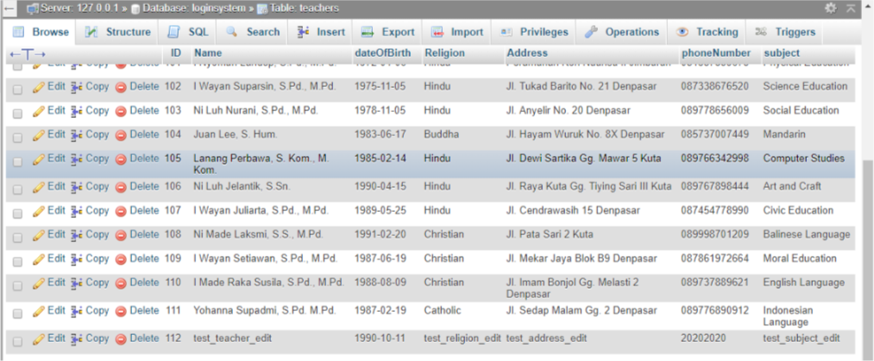

Testing the viewTeacher.php to test existing teacher’s detail can be shown

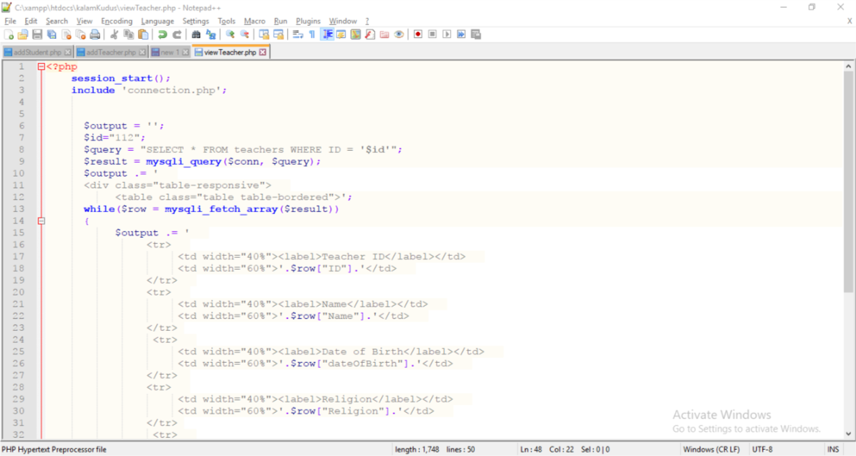

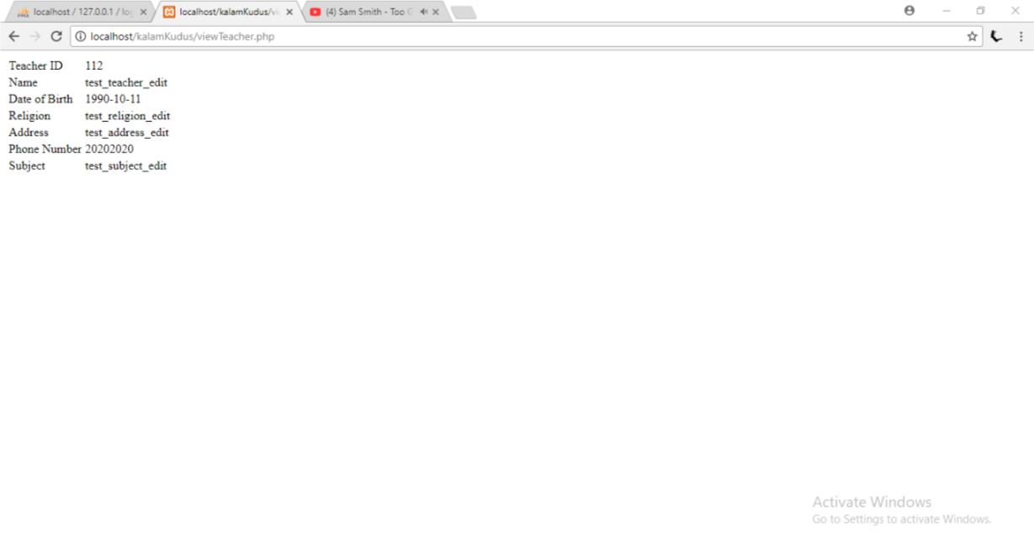

Testing the deleteTeacher.php to test teacher can be deleted from the database

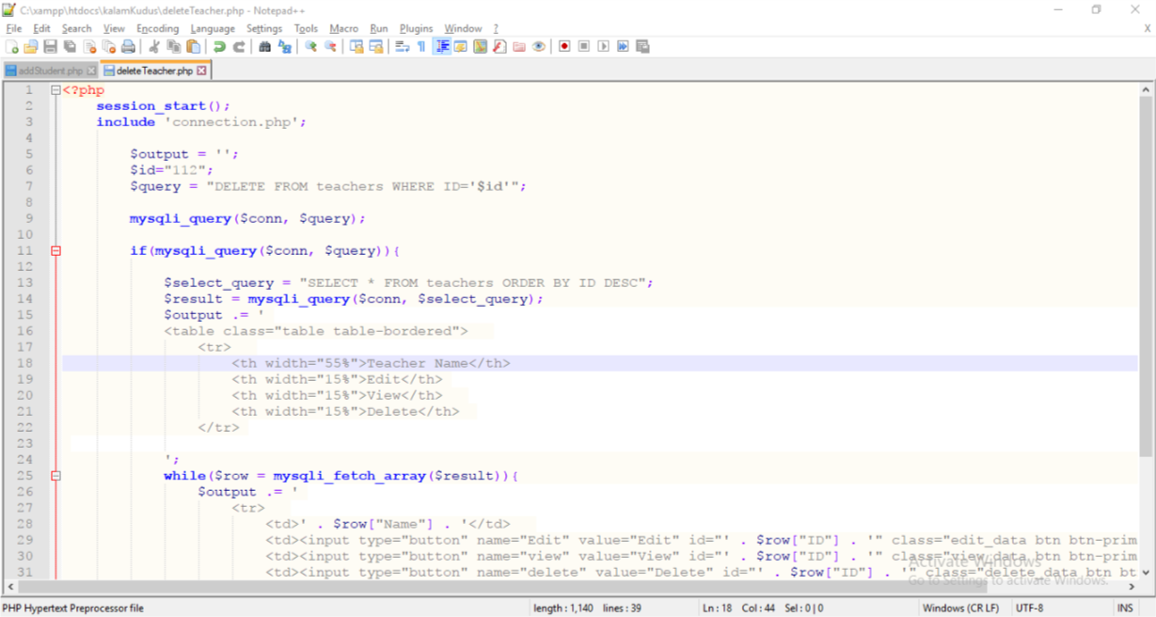

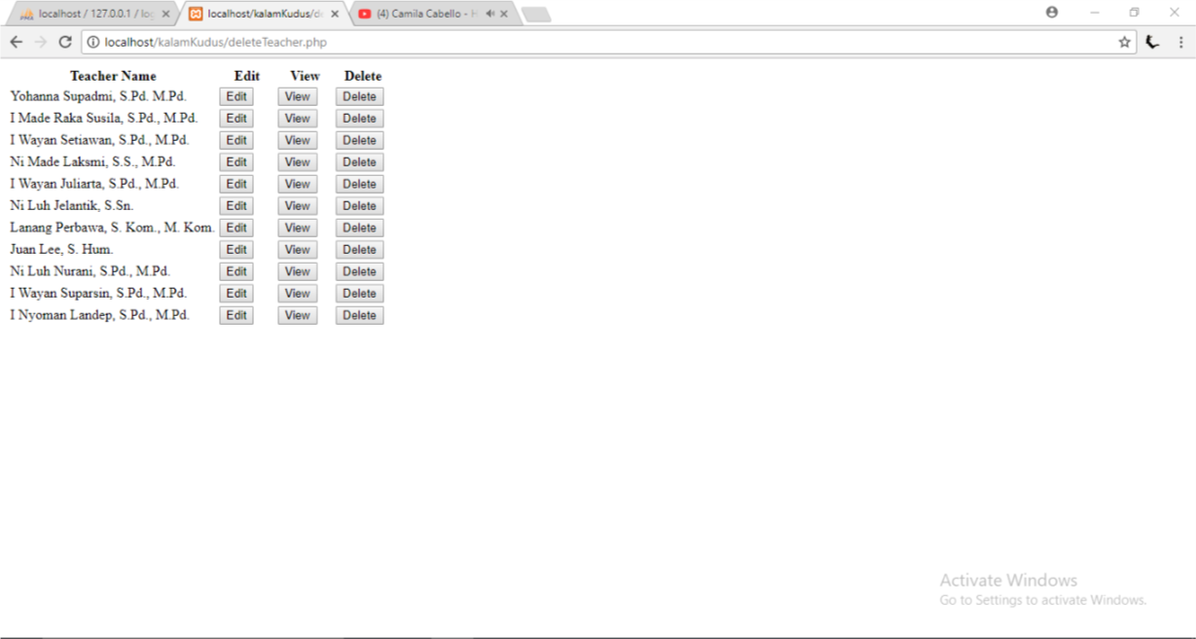

A teacher with name ‘test_teacher_edit’ has been deleted

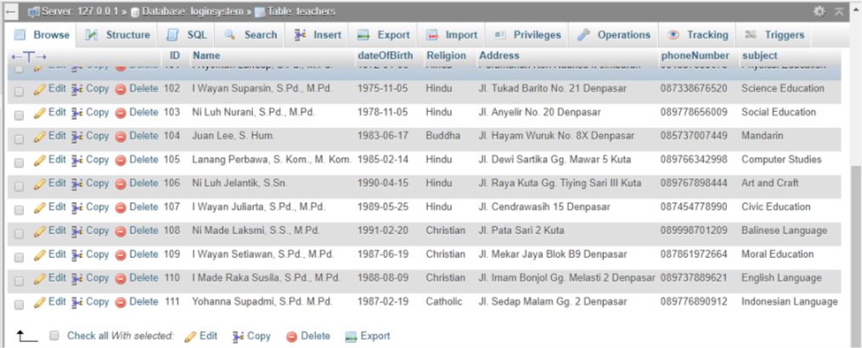

Testing the addSubject.php to test that adding subject to the database is successful

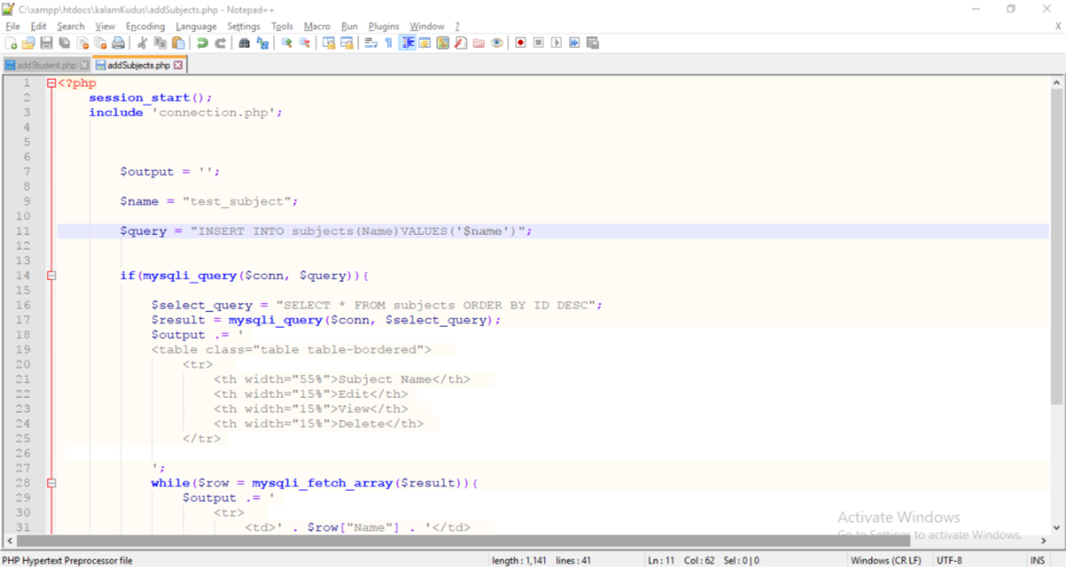

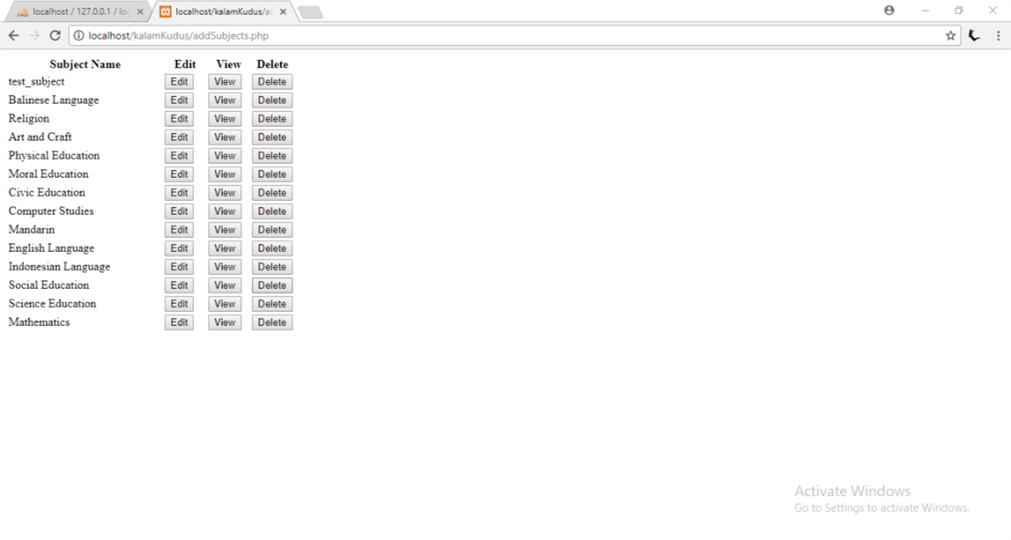

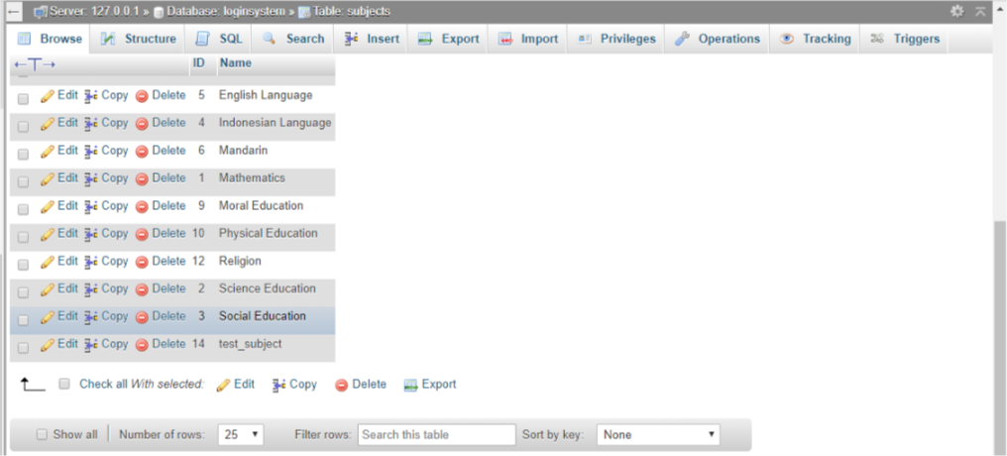

Testing the changeSubjectName.php to test that update existing subject in the database is successful

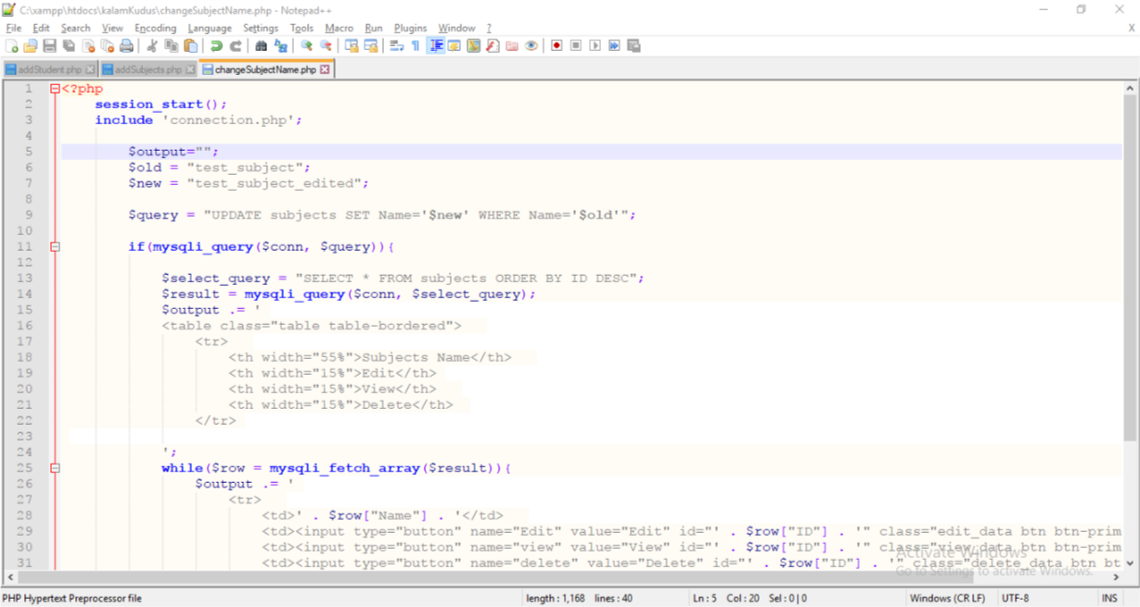

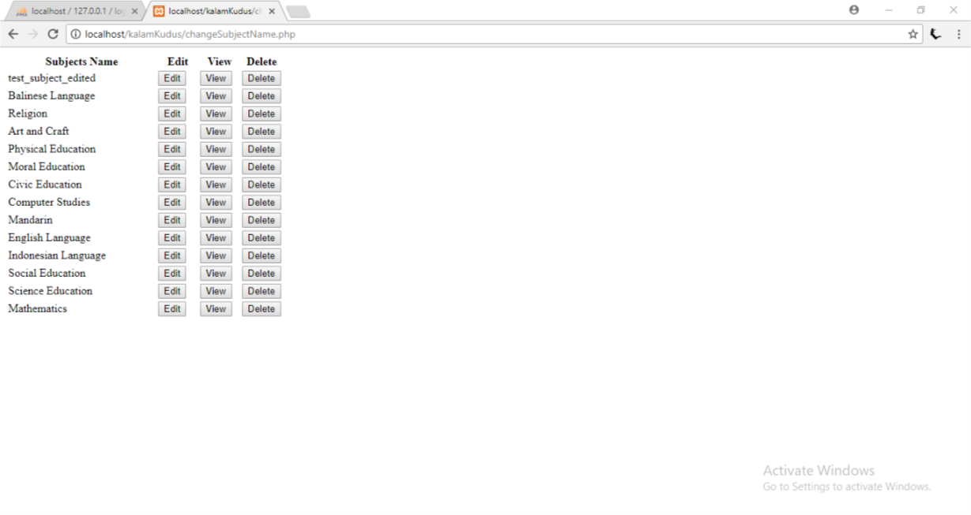

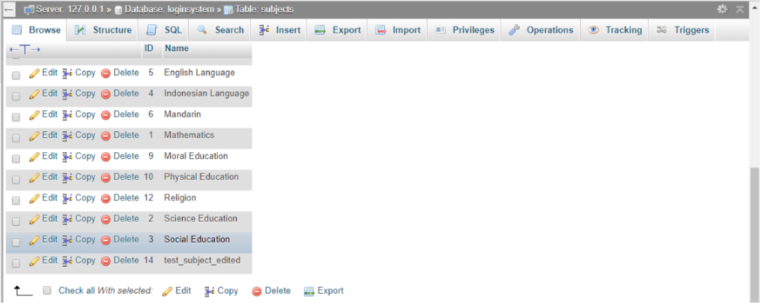

Testing the deleteSubject.php to test subject can be deleted from the database

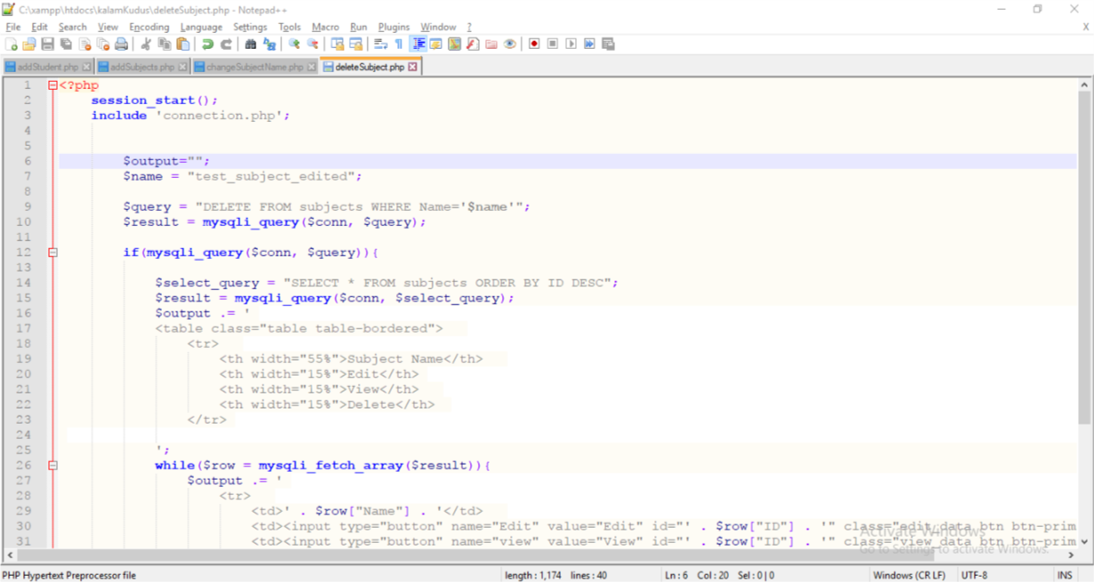

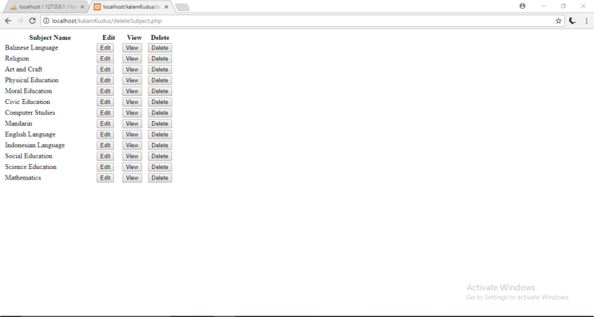

A subject with name ‘test_subject_edit’ has been deleted

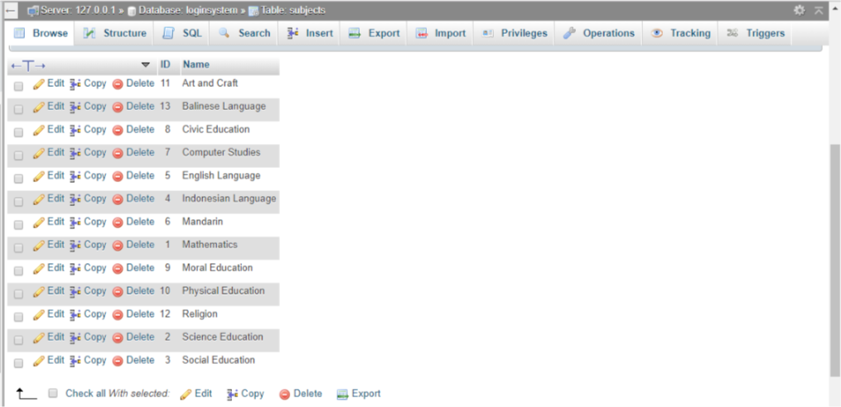

Testing the addClass.php to test that adding class to the database is successful

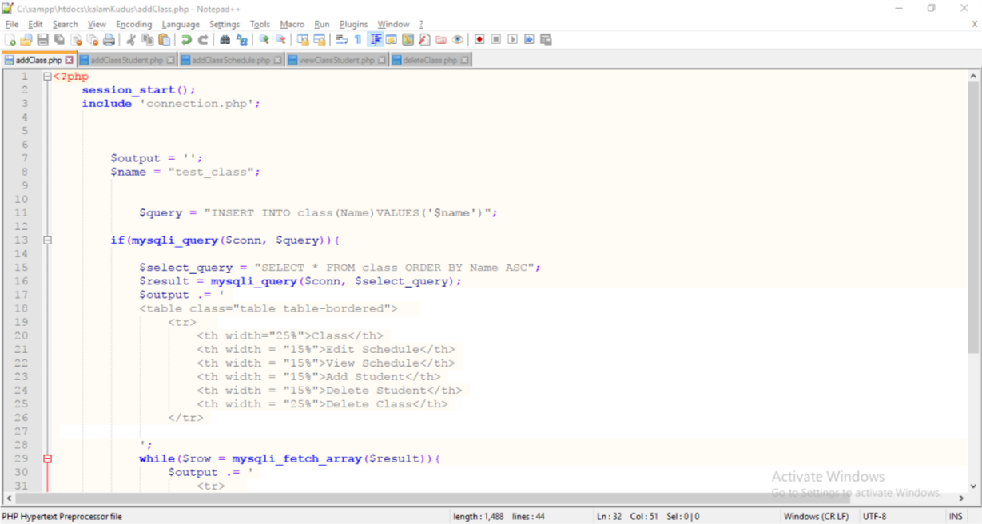

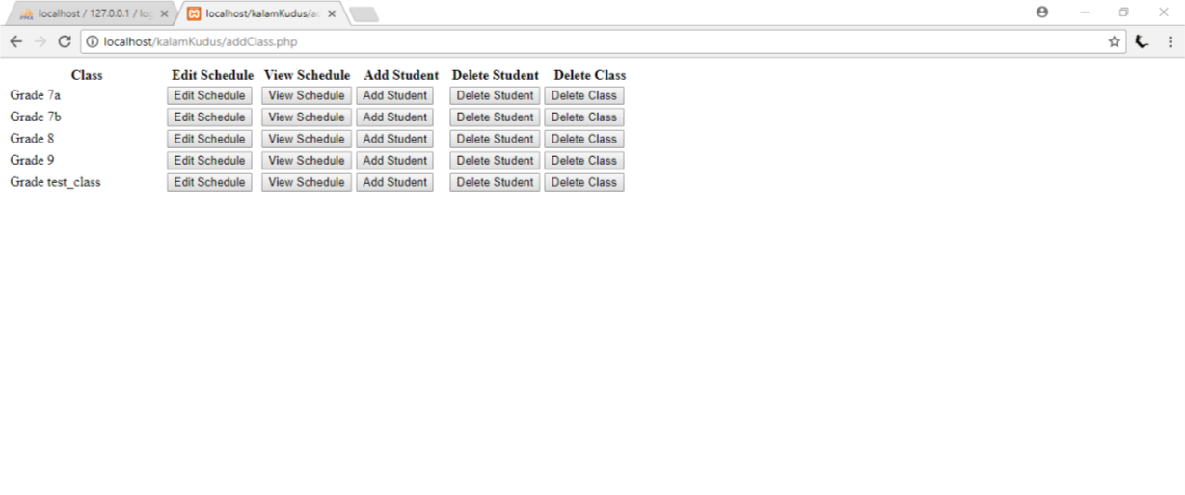

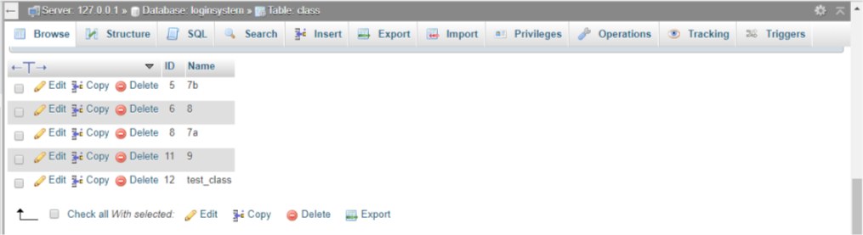

Testing the addClass.php to test that update existing class in the database is successful

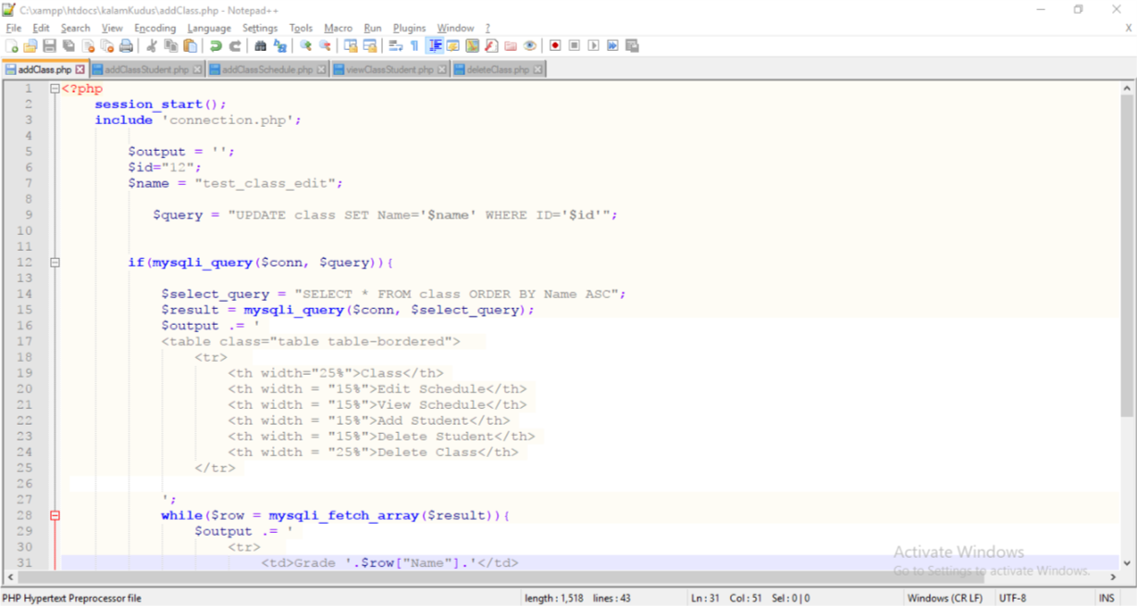

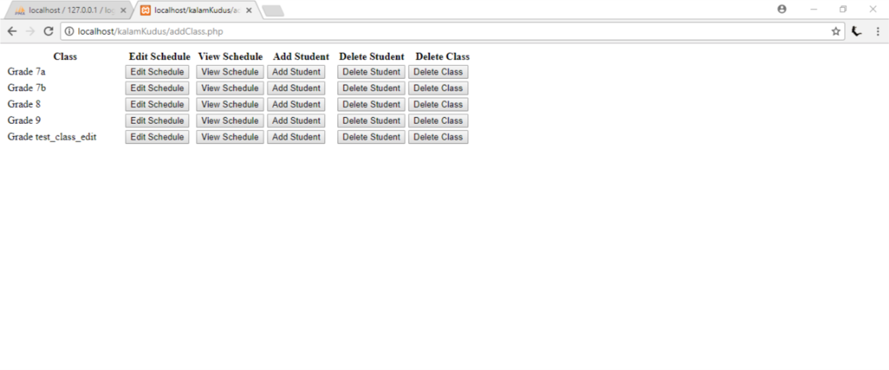

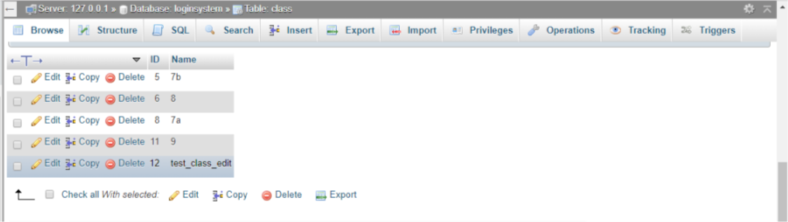

Testing the addClassStudent.php to test that adding student to class to the database is successful

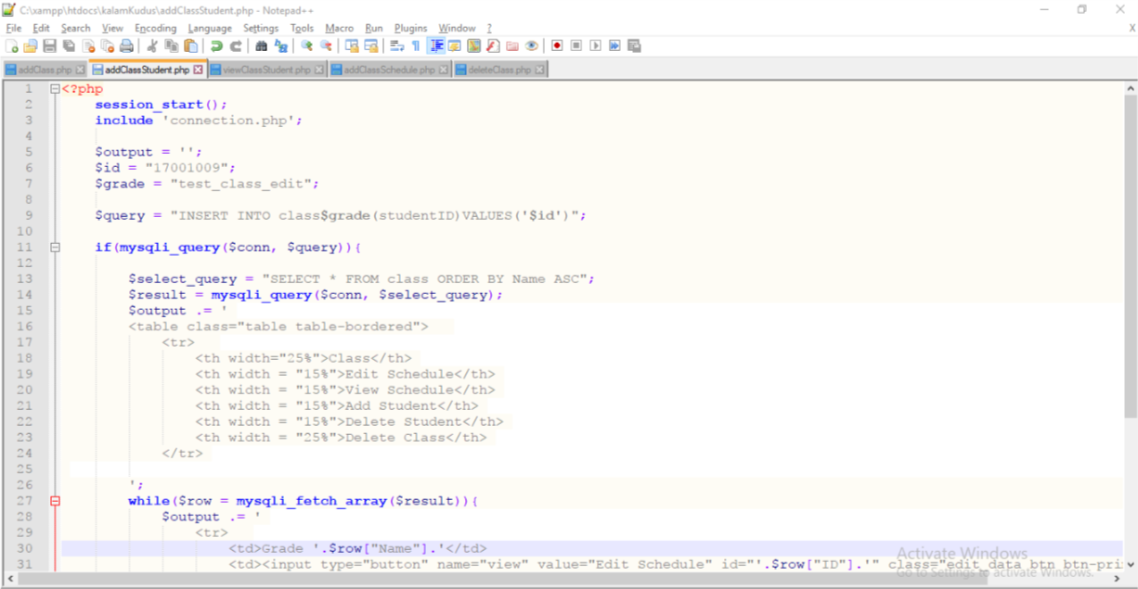

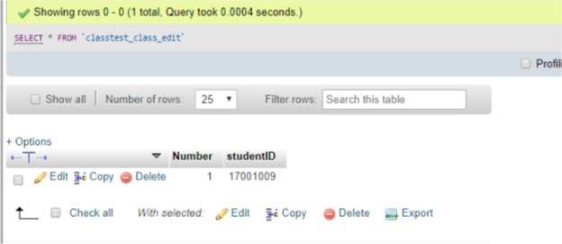

Testing the addClassSchedule.php to test that adding schedule to class to the database is successful

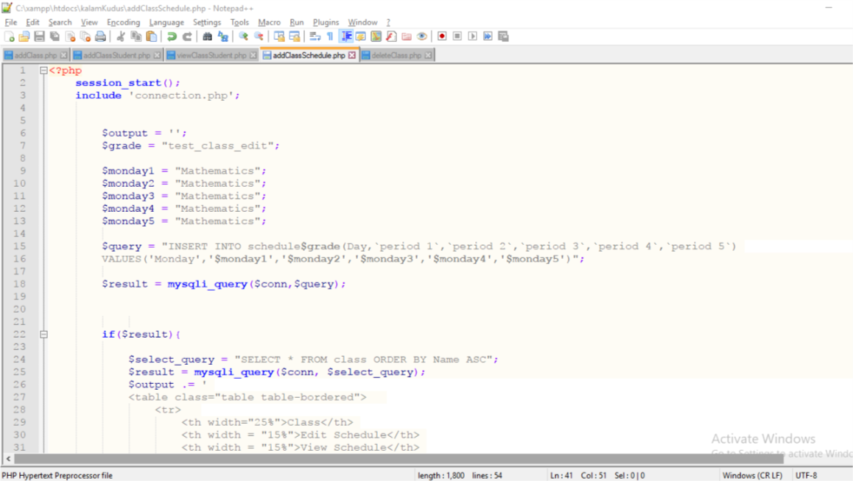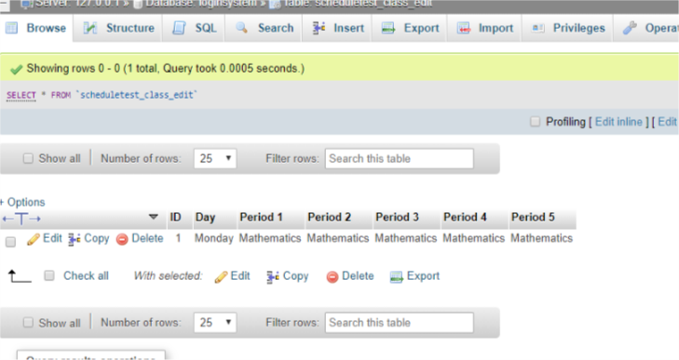

Testing the viewClass.php to test existing class’s student detail can be shown

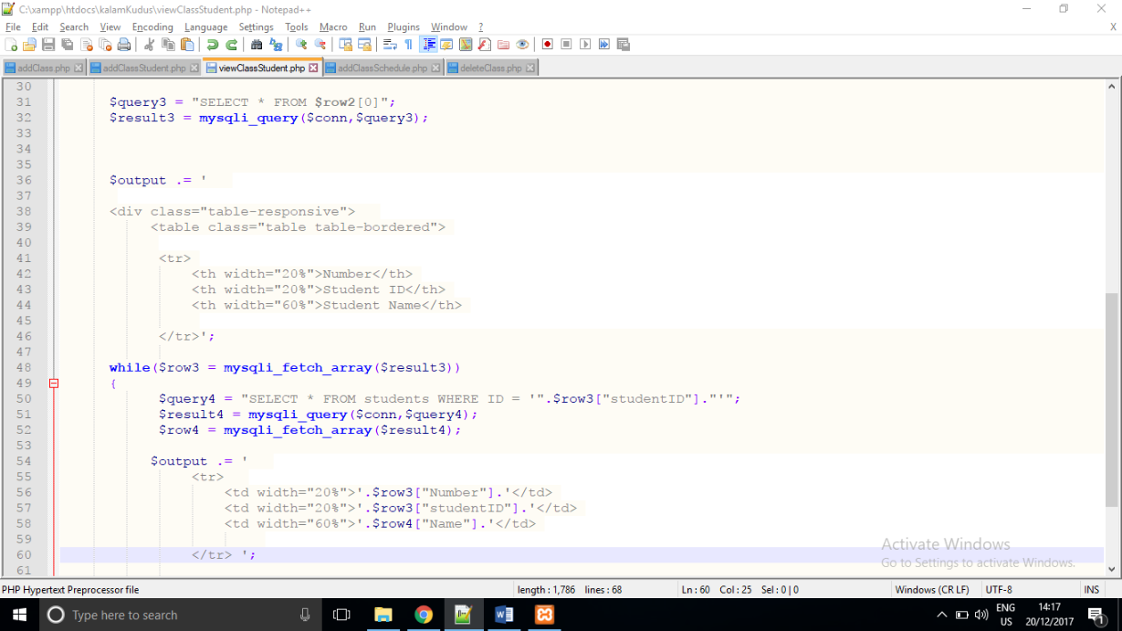

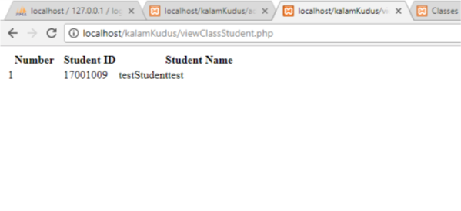

Testing the viewSchedule.php to test existing class’s schedule detail can be shown

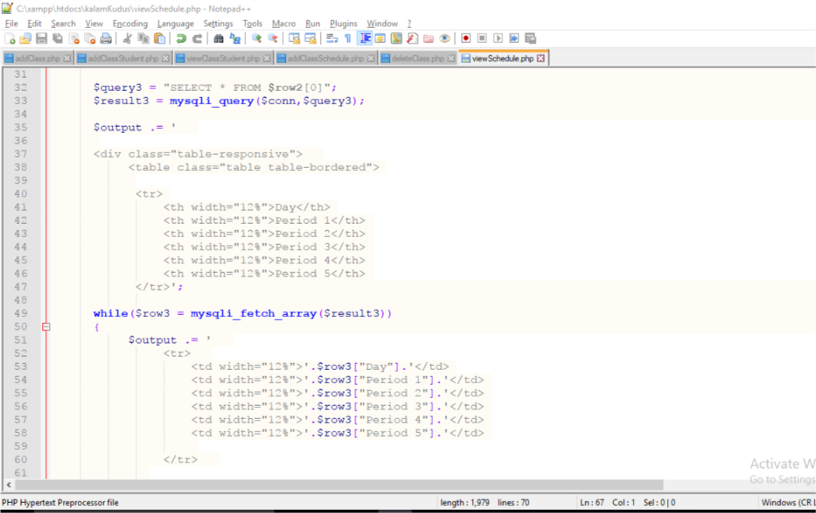

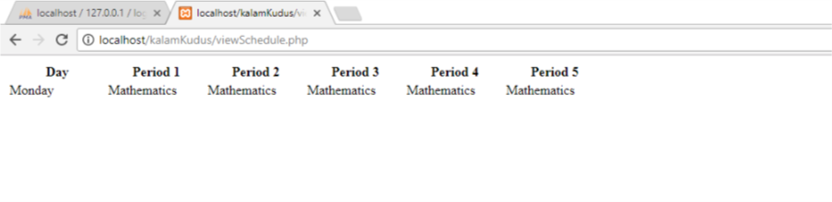

Testing the deleteClass.php to test class can be deleted from the database

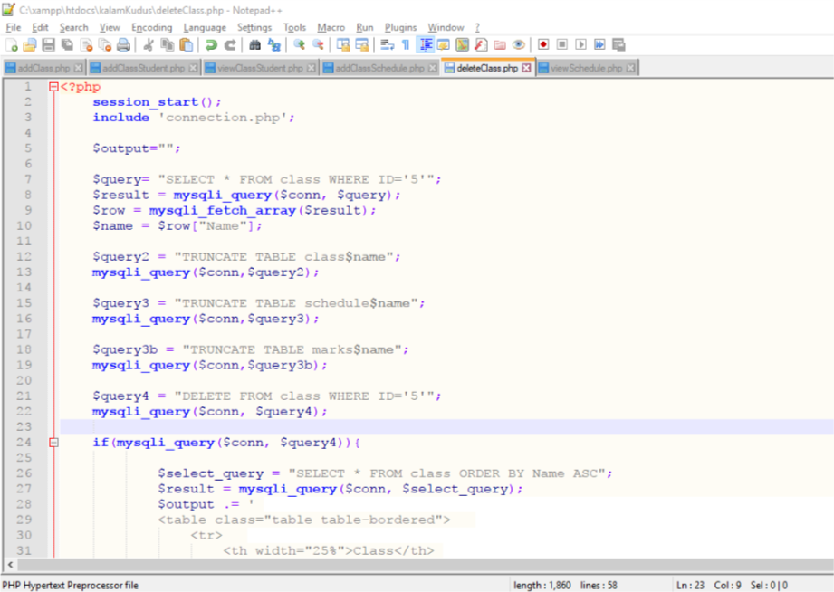

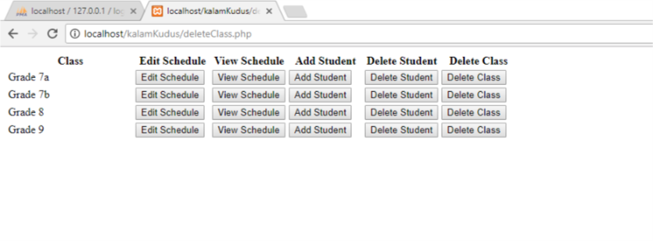

Class with name “test_class_edit” has been deleted

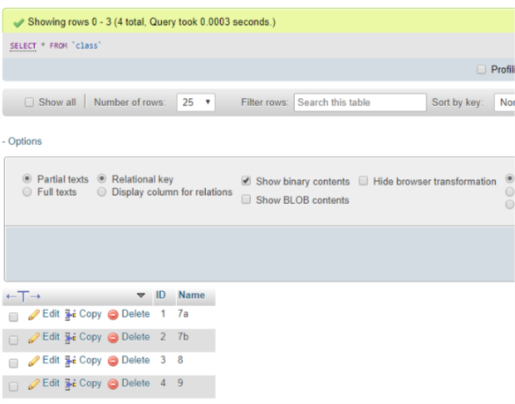

Testing the addMarks2.php to test that add marks in the database is successful

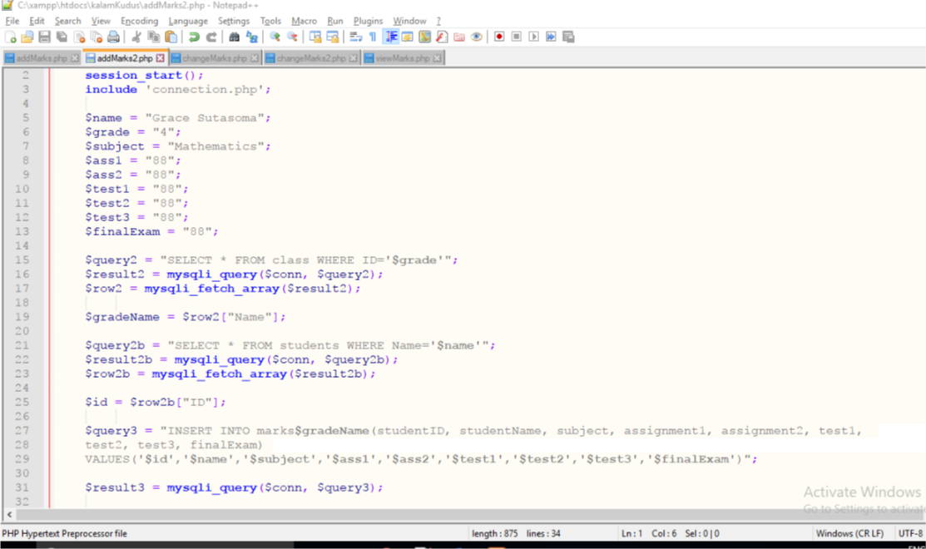

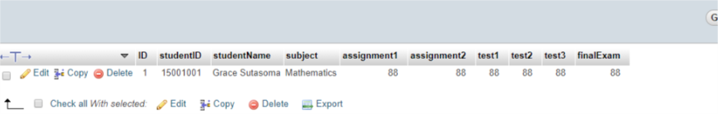

Testing the changeMarks2.php to test that update existing marks in the database is successful

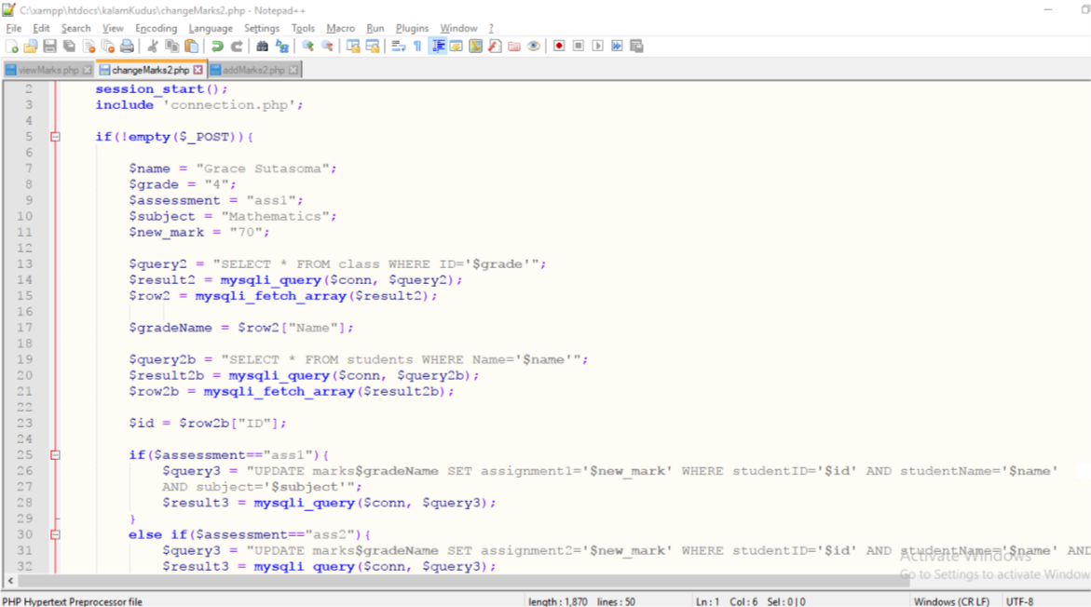

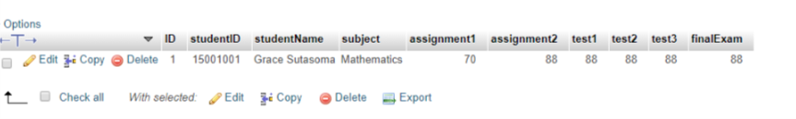

Testing the viewMarks.php to test that marks’ details in the database can be viewed successfully

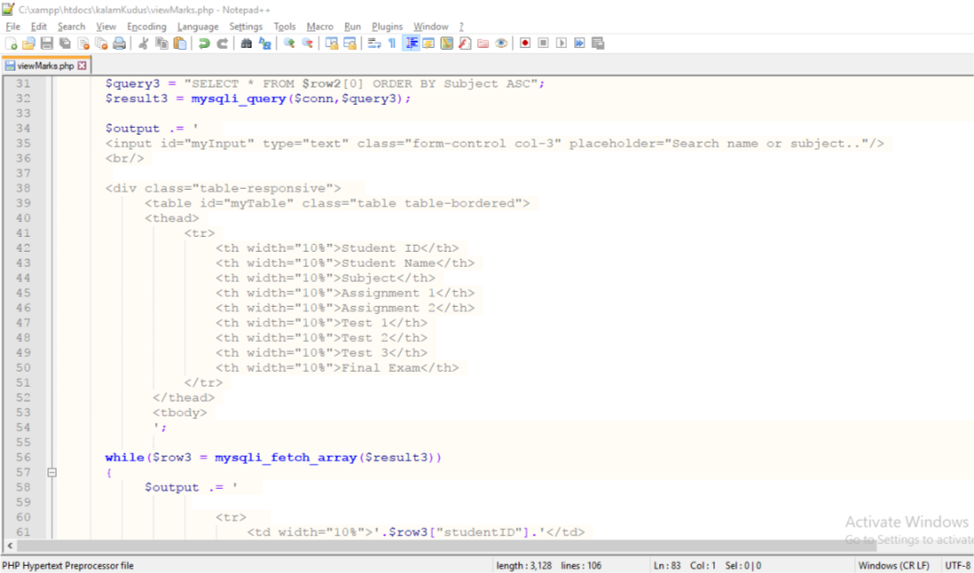

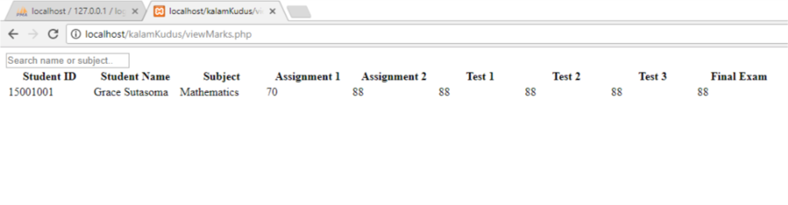

Testing the addAnnouncement.php to test that add schedule to the database is successful

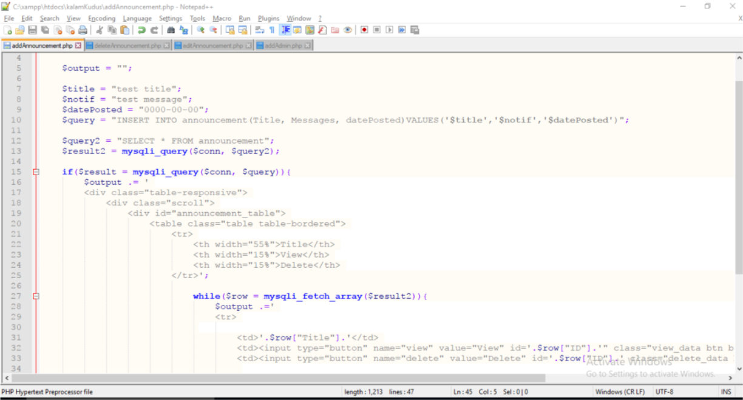

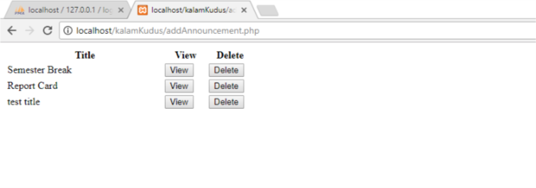

Testing the viewAnnouncement.php to test that announcement’s details from the database is successfully displayed

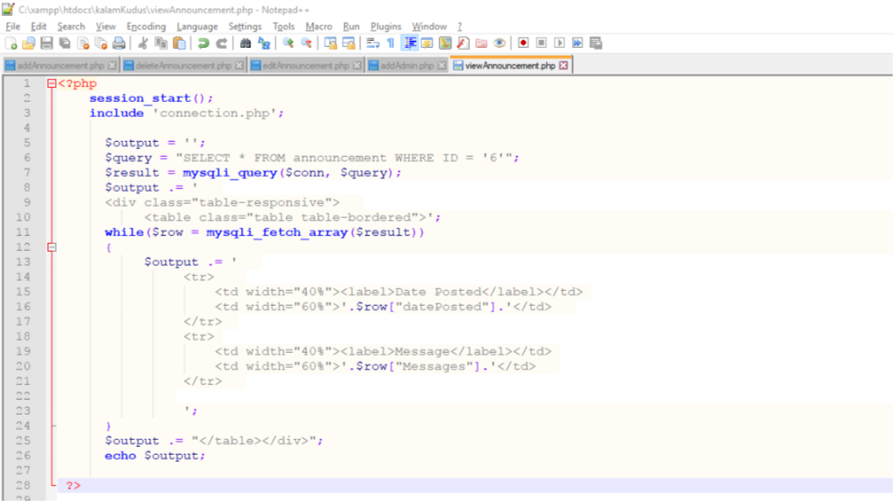

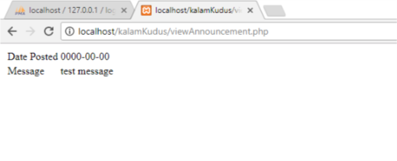

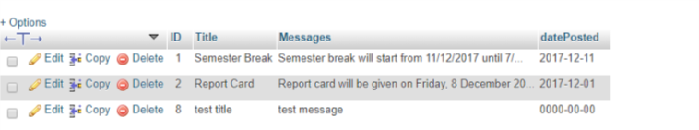

Testing the deleteAnnouncement.php to test that delete announcement from the database is successful

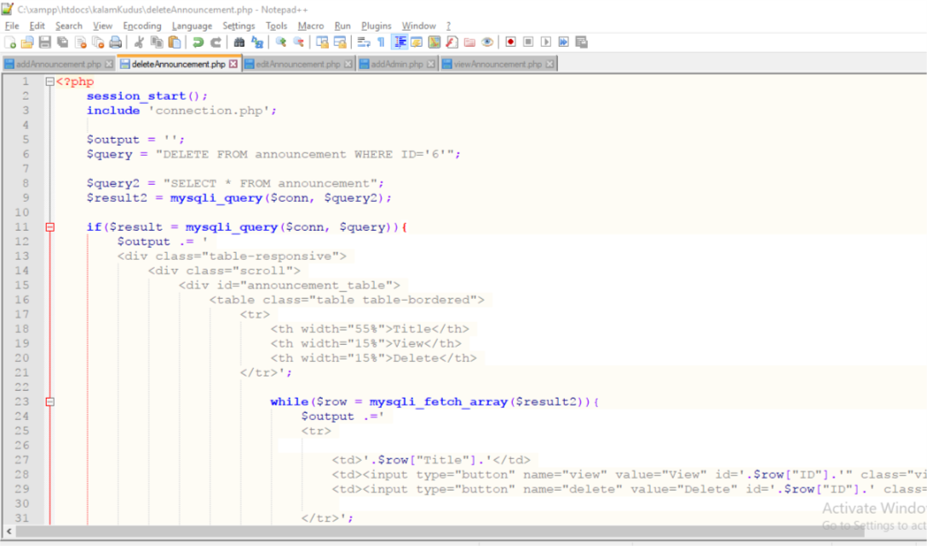

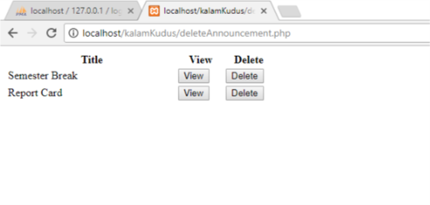

announcement with test title has been deleted

Testing the addMessage.php to test that add message to the database is successful

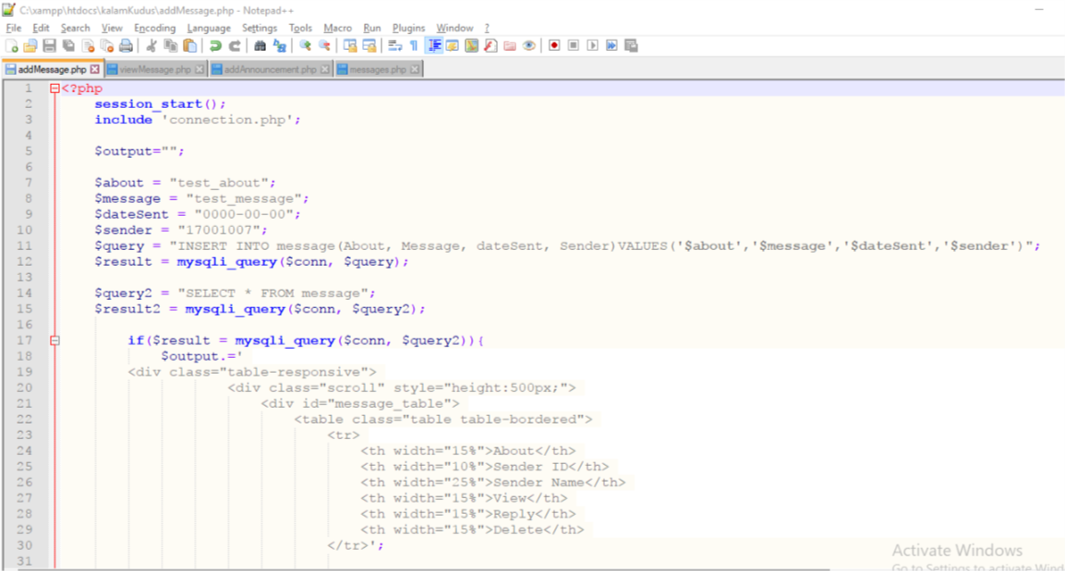

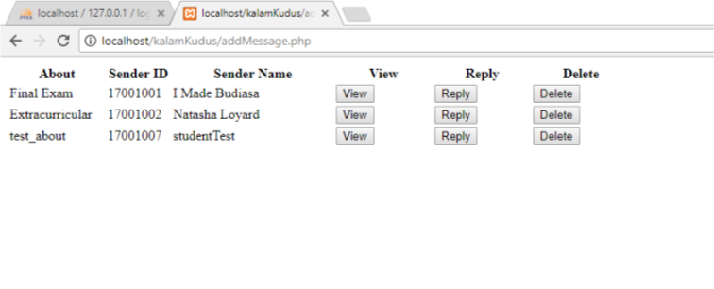

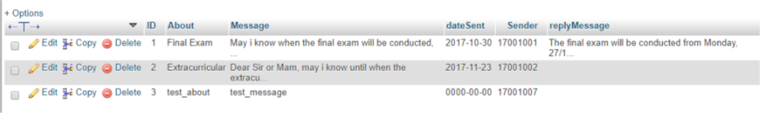

Testing viewMessage.php to view message’s details from the database successfully

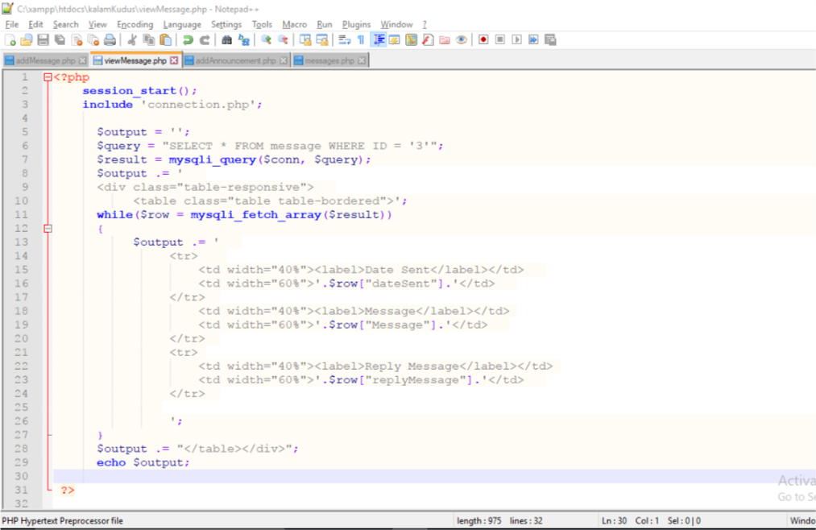

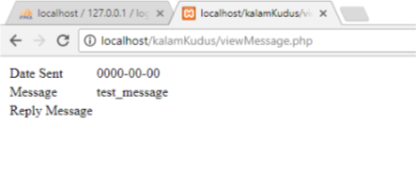

# System Testing

Testing the validation of login form, click ‘OK’ and it will direct back to index.php (login form)

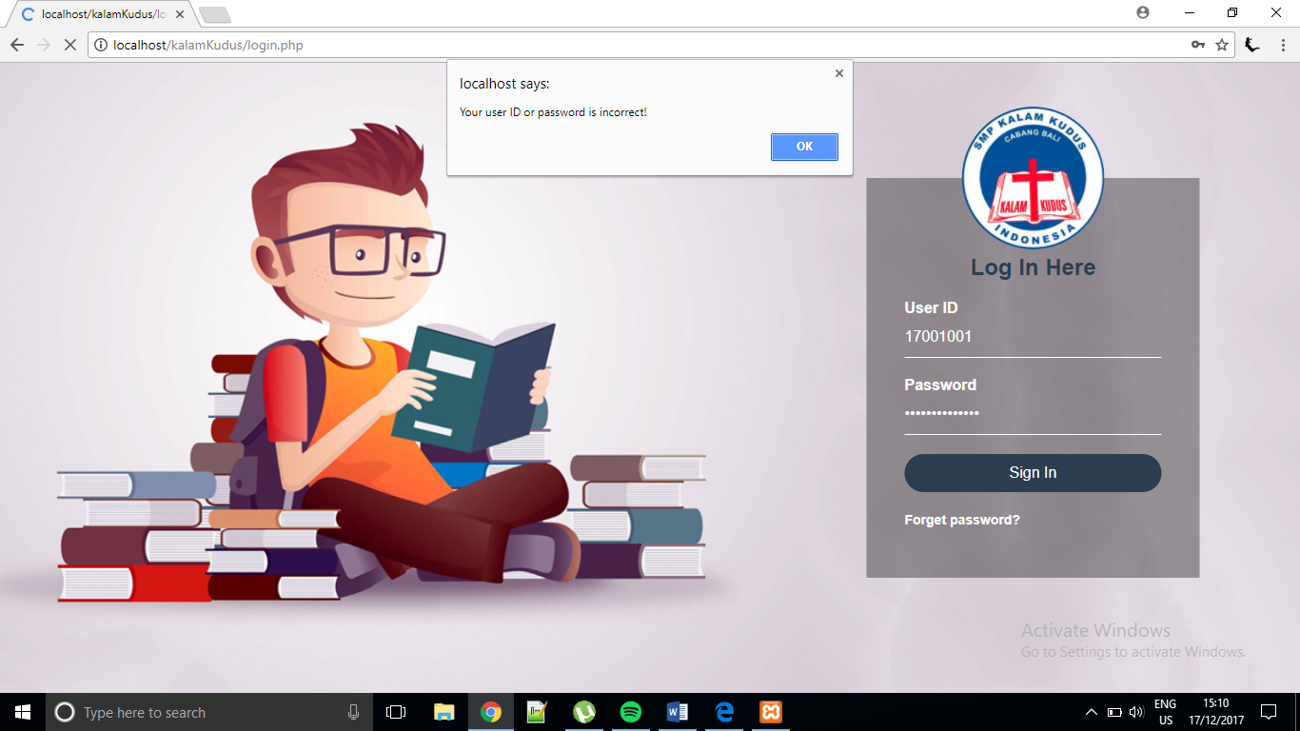

If the password is correct, continue to the home page. The system will check whether the User ID is admin ID or student ID. In this case, the User ID is student ID so it is directed to the student home page.

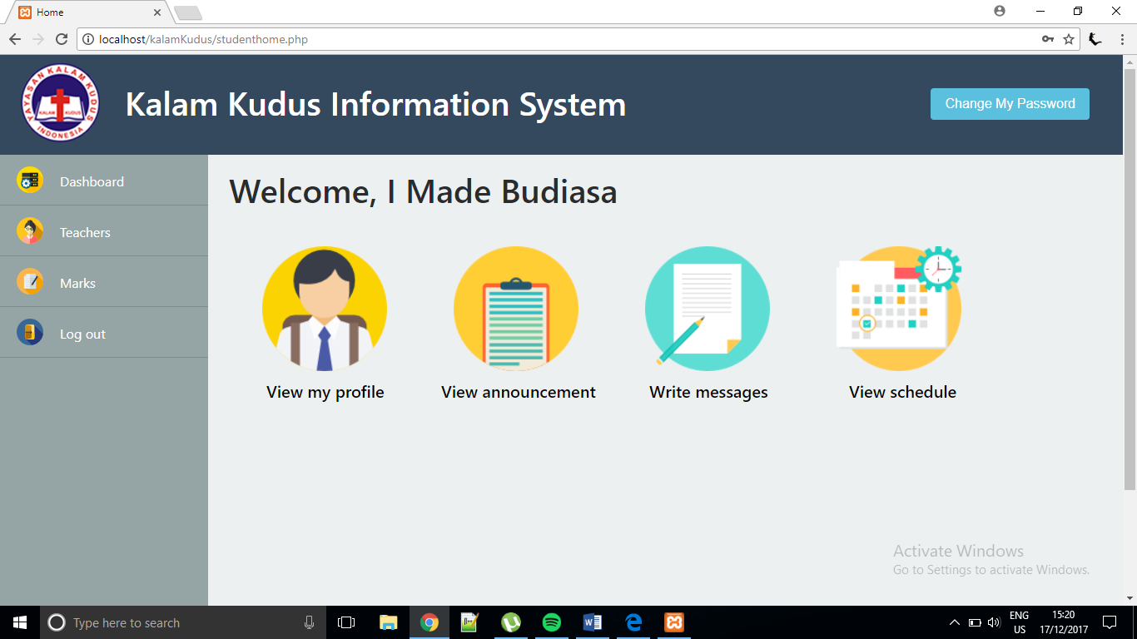

If student select view my profile, it will continue to studentProfile.php that display student’s own information. He can edit his personal information except the student ID.

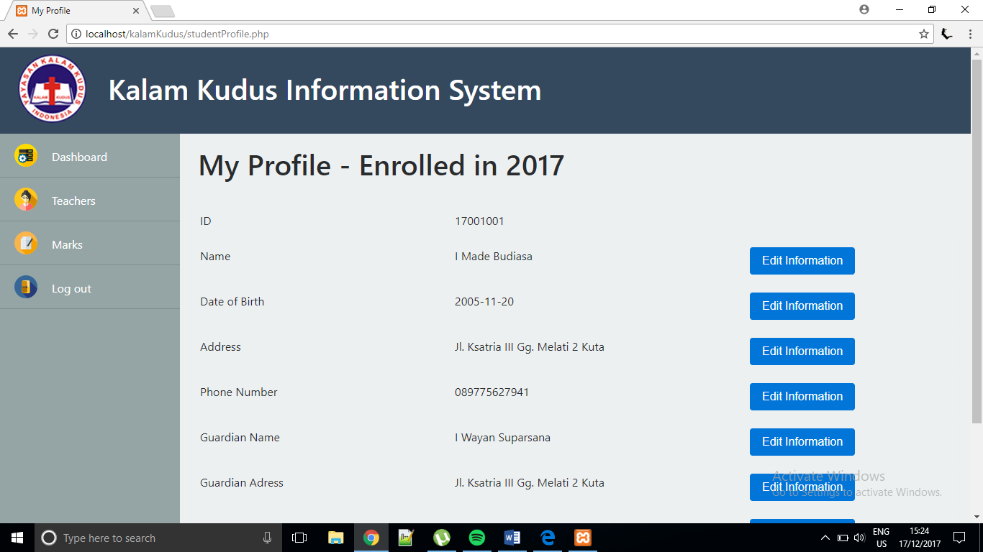

This modal box will appear if student select to edit information. The modal input format and title will differ depend on which data want to be edited. If student click ‘Save’, information in the database will be updated and data will be changed.

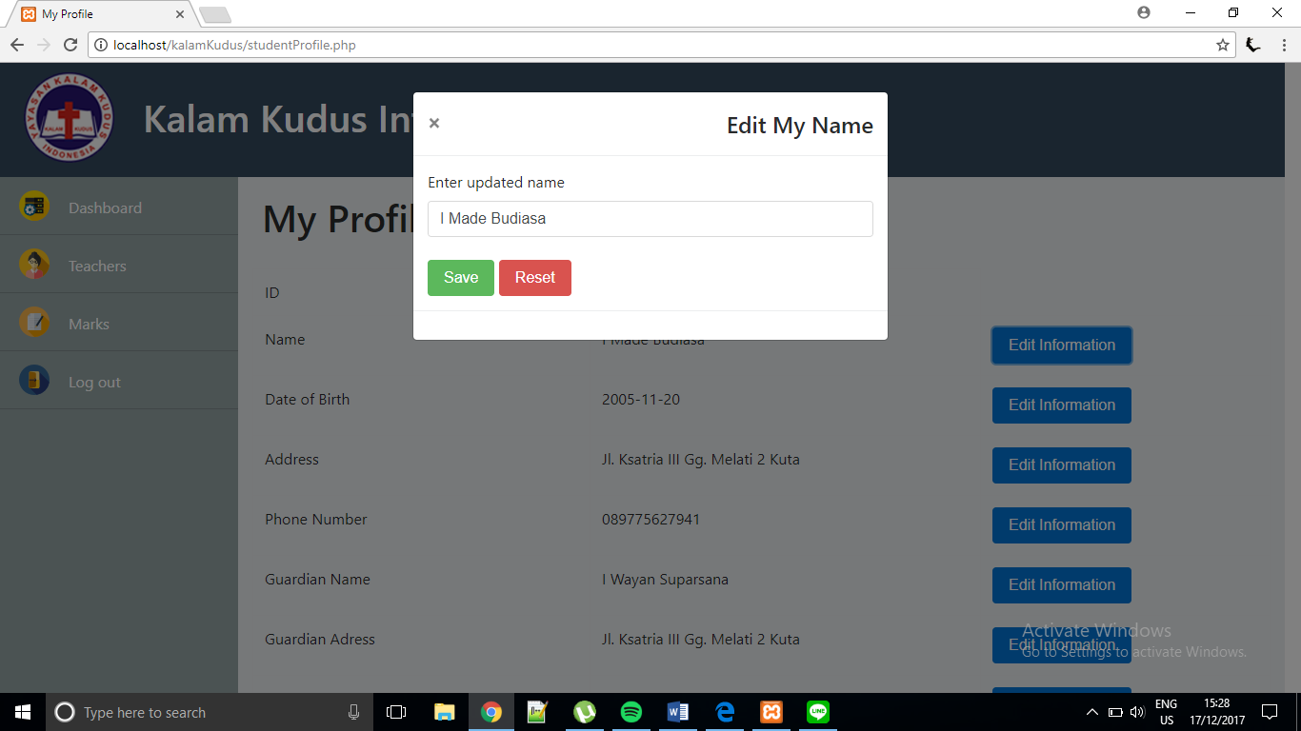

If student select view announcement, it will continue to studentViewAnnouncement.php that display announcements, sorted by date in descending order. Student can only view the announcement.

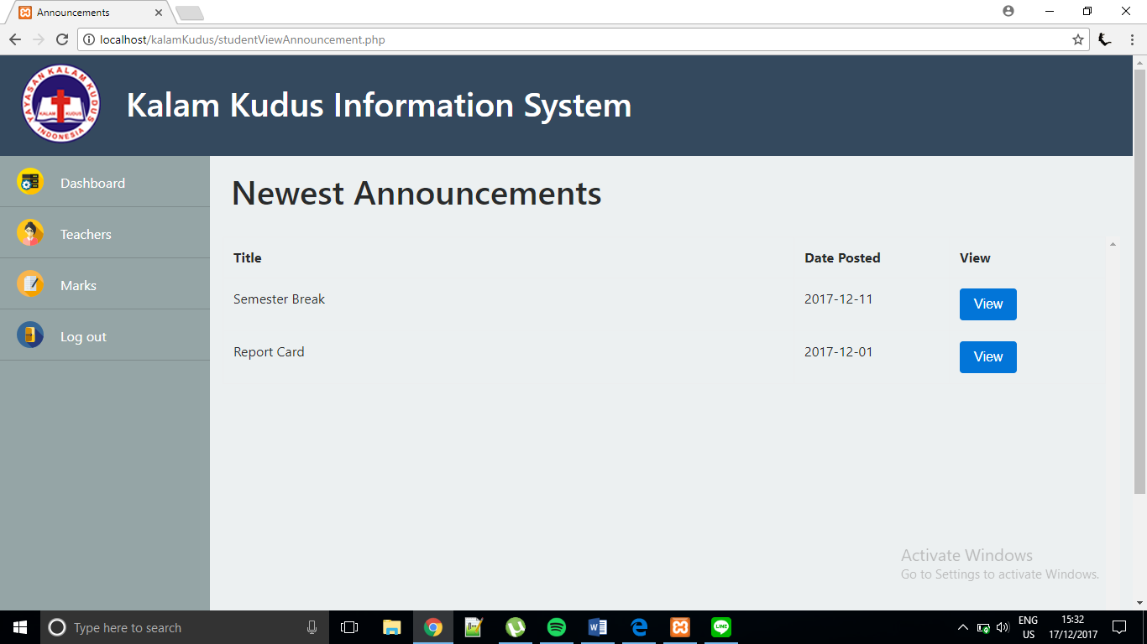

If the student clicks ‘View’ button, a modal box will appear and display the announcement detail.

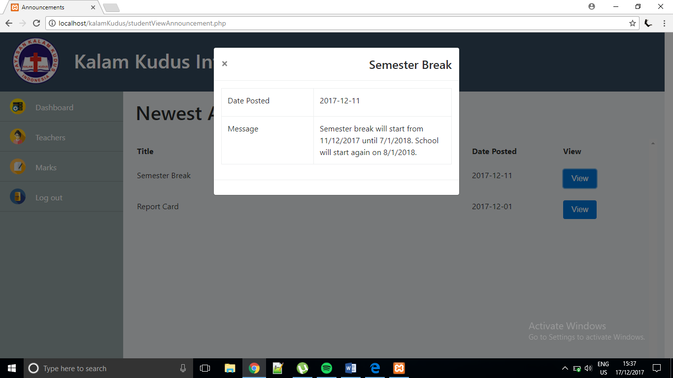

If student select write message, it will continue to studentWriteMessage.php that display form that student can fill and send. The message will be send to admin and admin will access it from admin home page and reply to the message. At the bottom of the page, student can view only the messages that he had sent previously and checked if it has been replied. This student cannot view messages sent by other students.

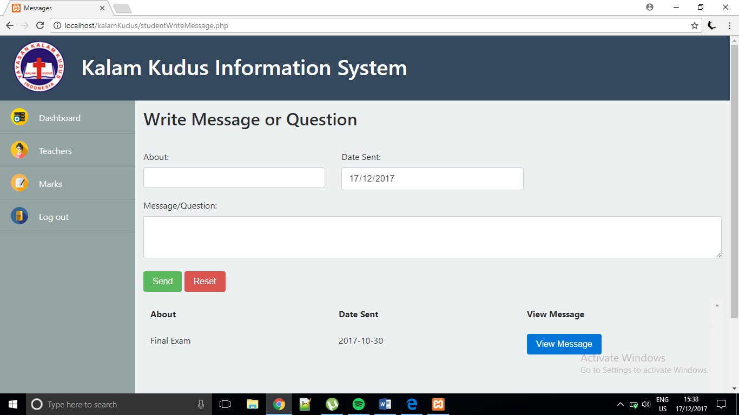

If the student clicks ‘View’ button, a modal box will appear and display the message detail.

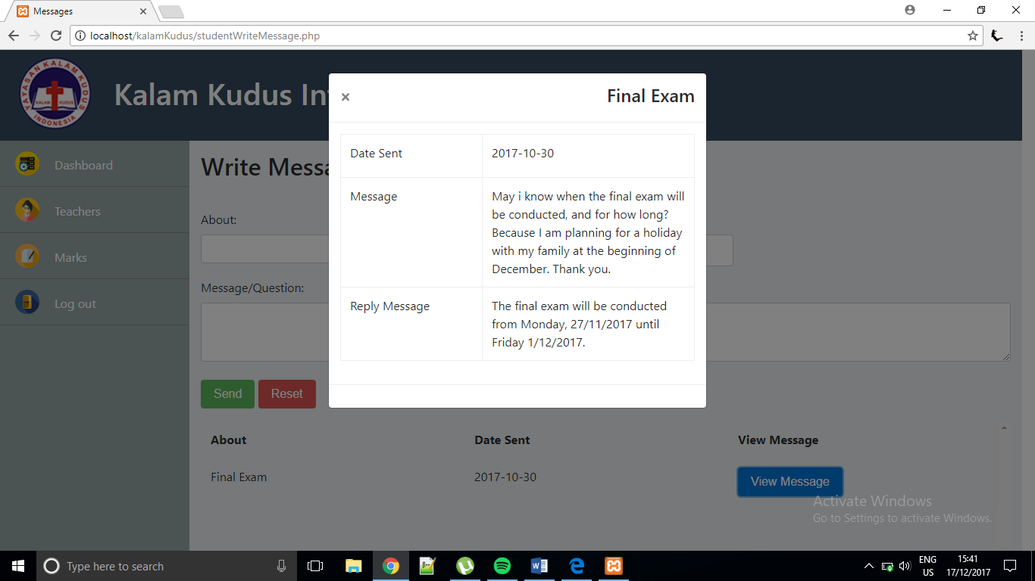

Testing add message – student fill the form and click ‘Send’. The date is automatically today’s date.

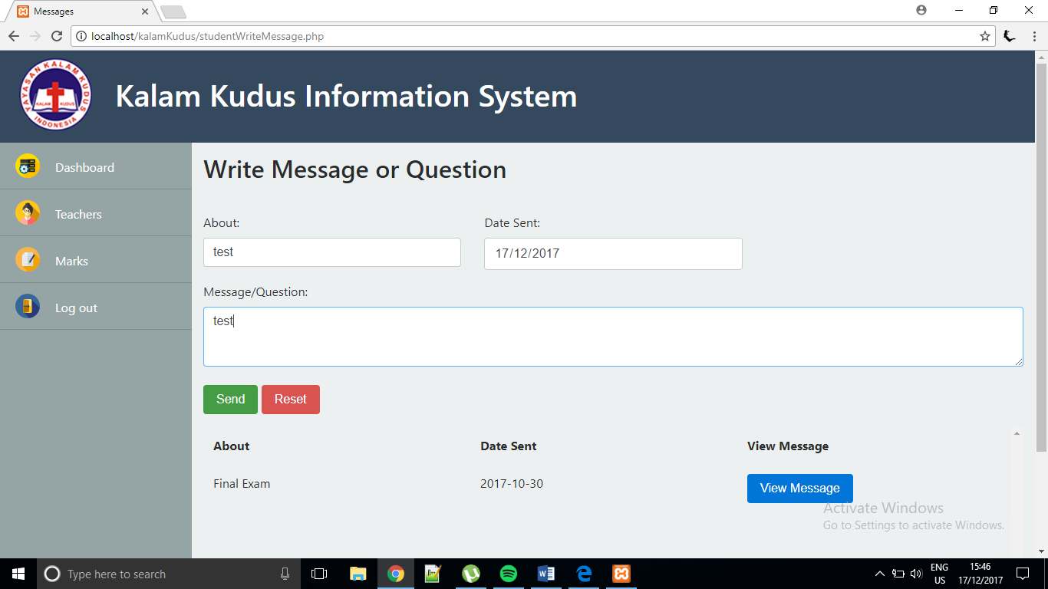

Notification that message has been sent

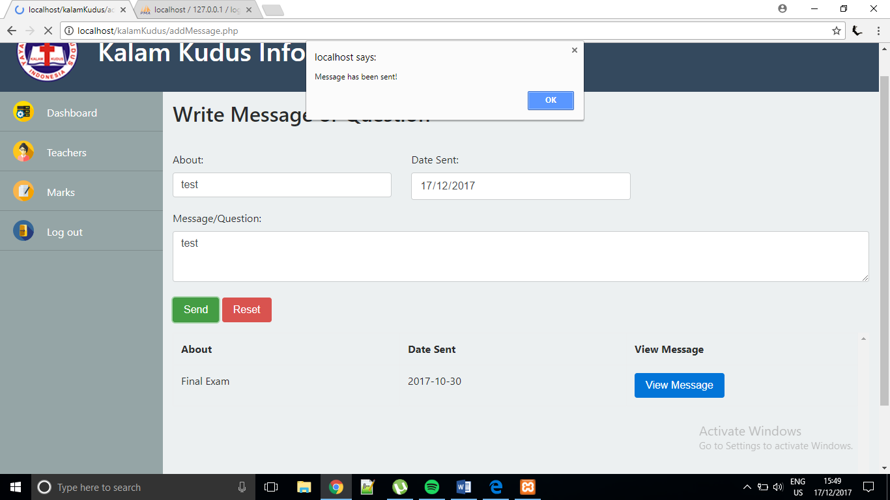

Message has been sent and student can see the message that he sent

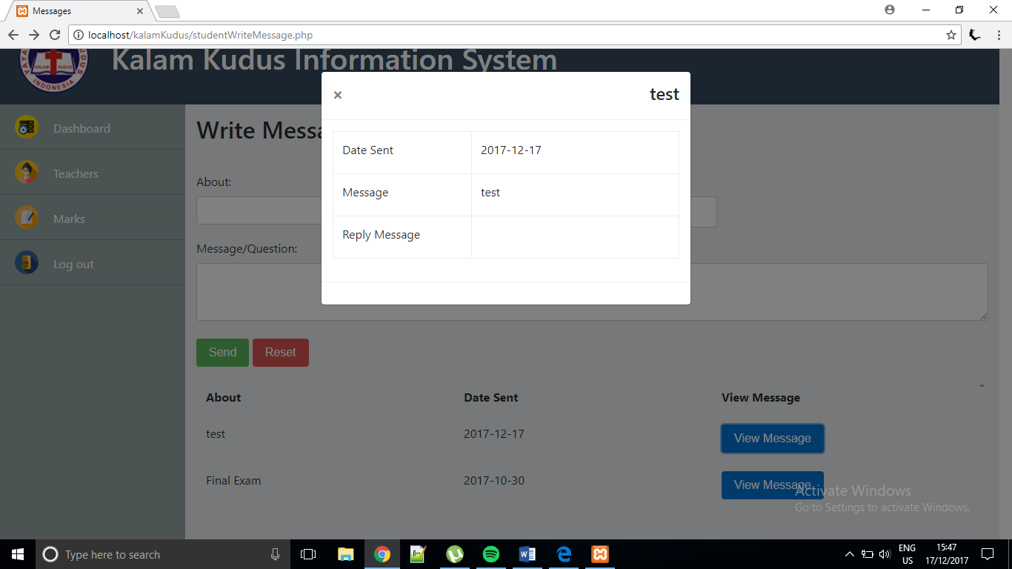

Newly added message

If student click view schedule, it will direct to studentViewSchedule.php that displays schedule only for the class which the student is enrolled in.

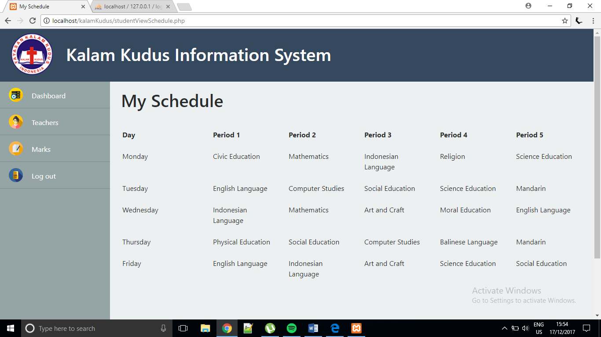

Teacher menu from the navigation bar, displays all teachers in the school.

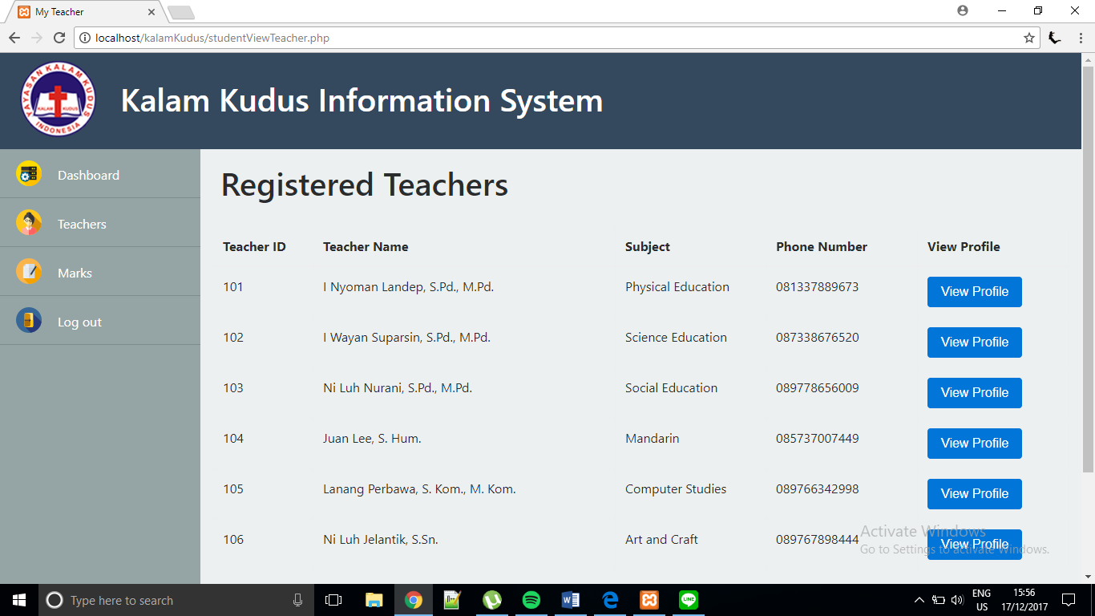

Student can click ‘View’ to see the complete profile of the teacher.

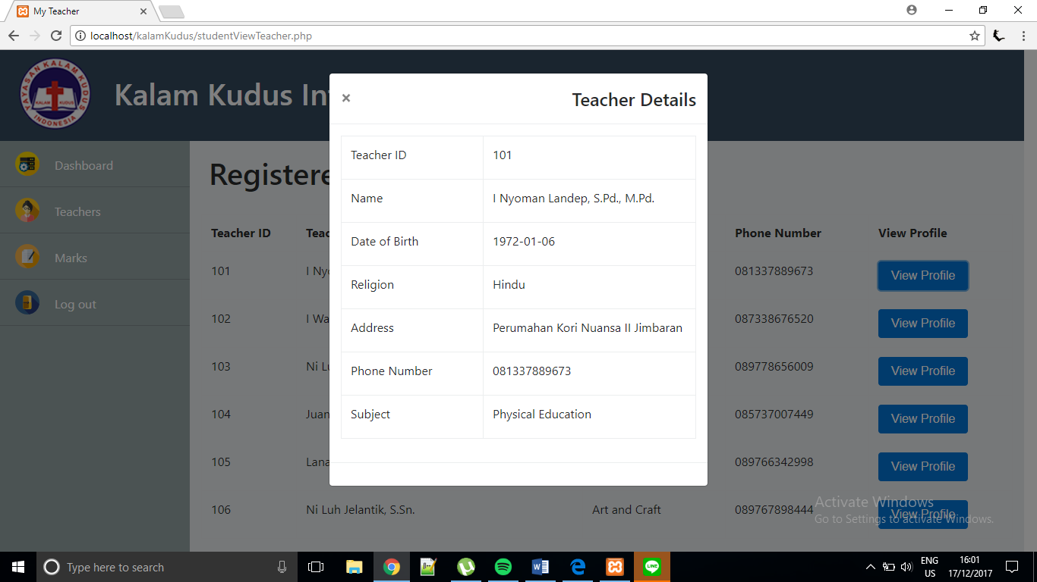

Marks menu from the navigation bar, displays all marks of the student.

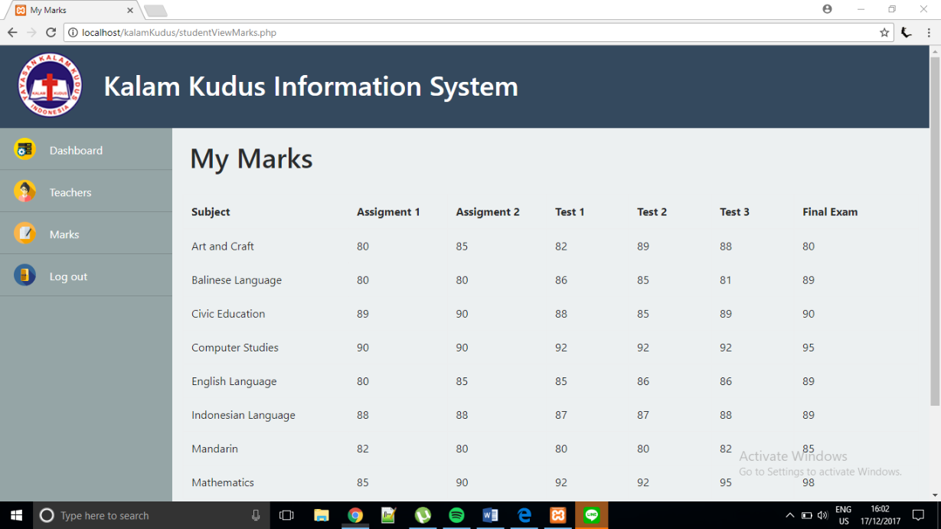

Student could change the password by clicking ‘Change My Password’ button at the top right corner of the page.

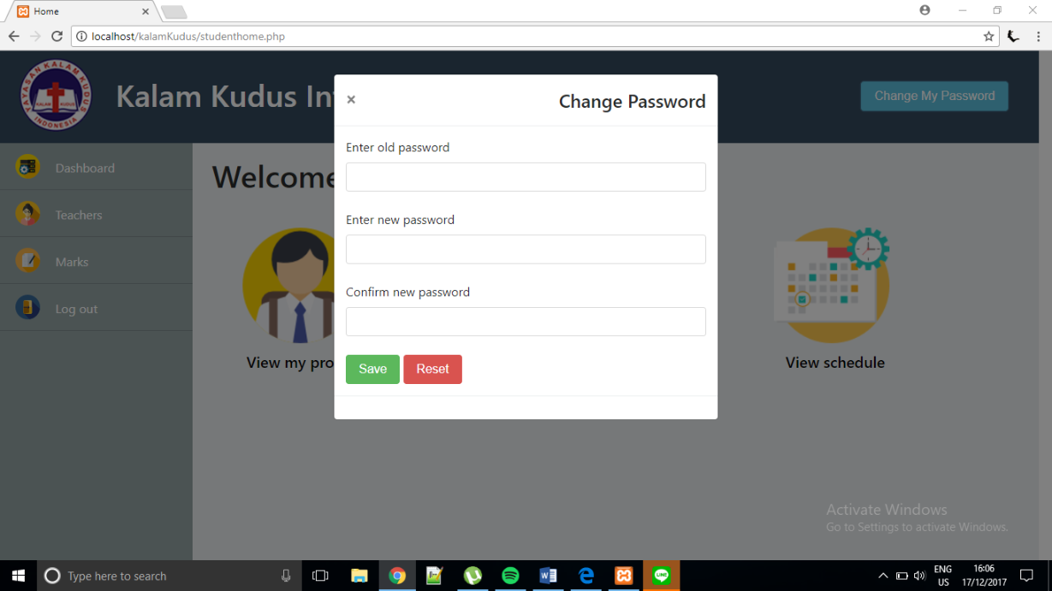

If the new passwords entered do not match, the system will notify the student and the password change is failed.

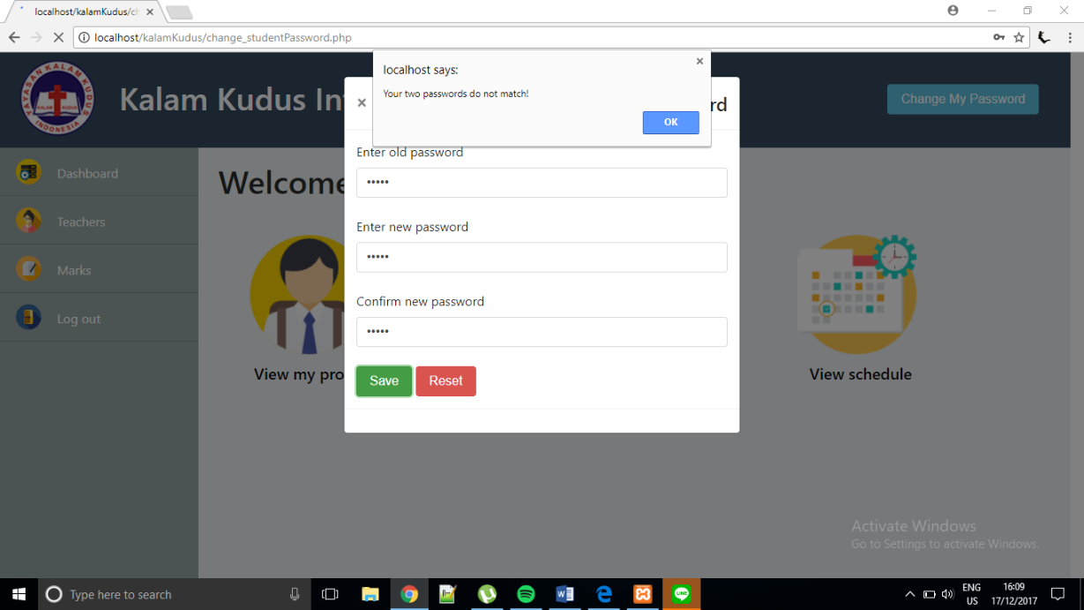

If the old password entered does not match with the current password, the system will notify the student and the password change is failed.

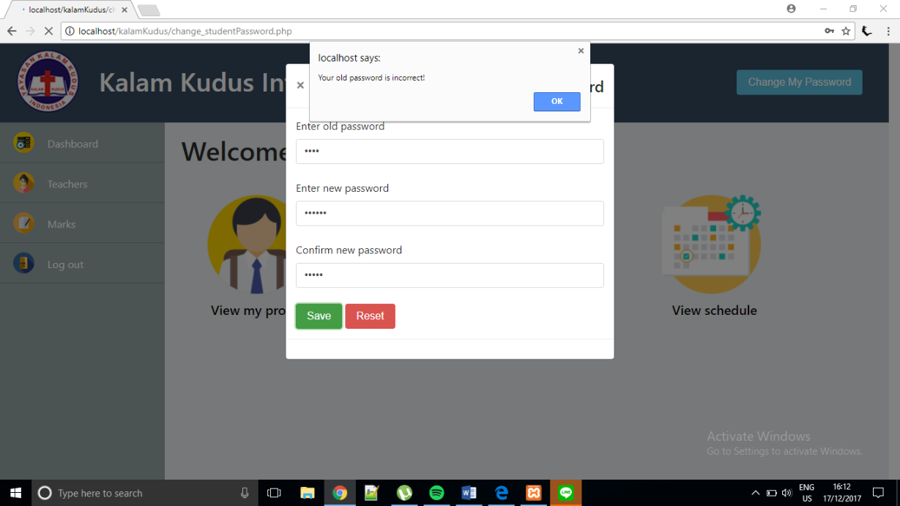

If the student wants to log out, the student must click the ‘Log out’ from the navigation bar. It would be directed to login form in index.php .

Now, we will test admin-related pages. First the admin has to log in the system by providing the correct user ID and password.

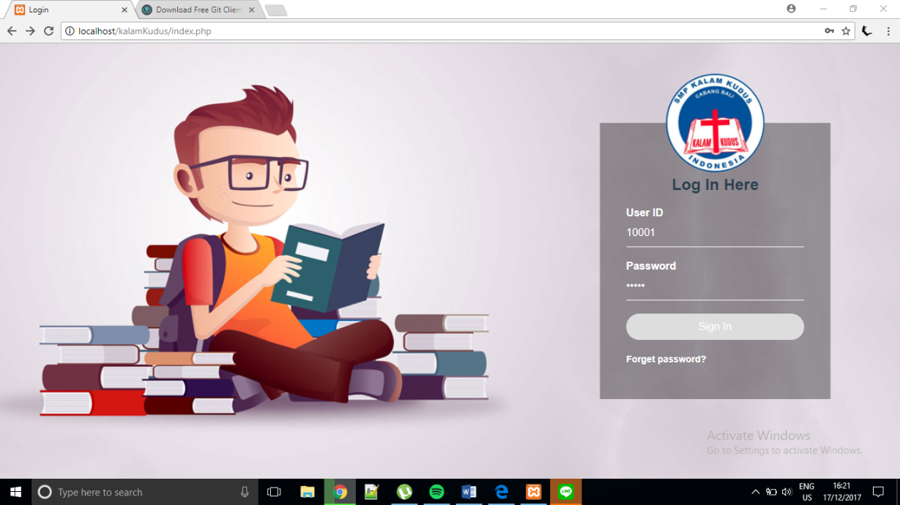

If the admin entered the wrong password, the system will notify the admin and he/she cannot continue to the home page.

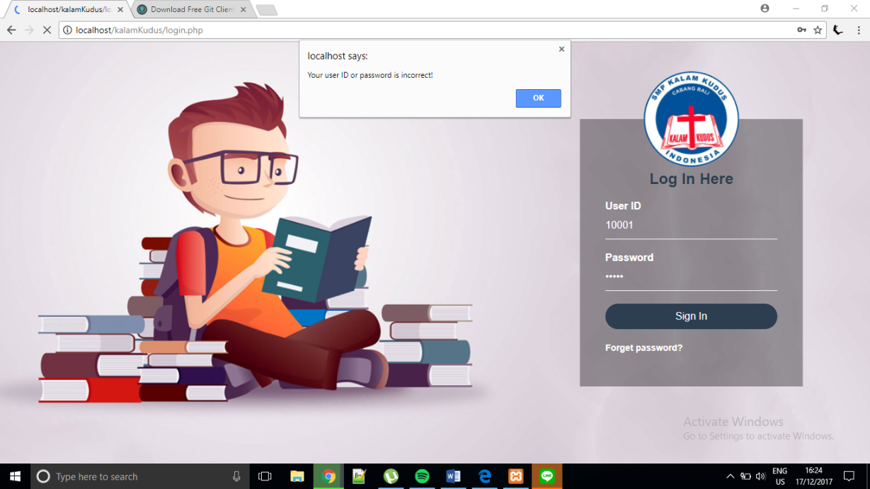

This is the home page of the admin.

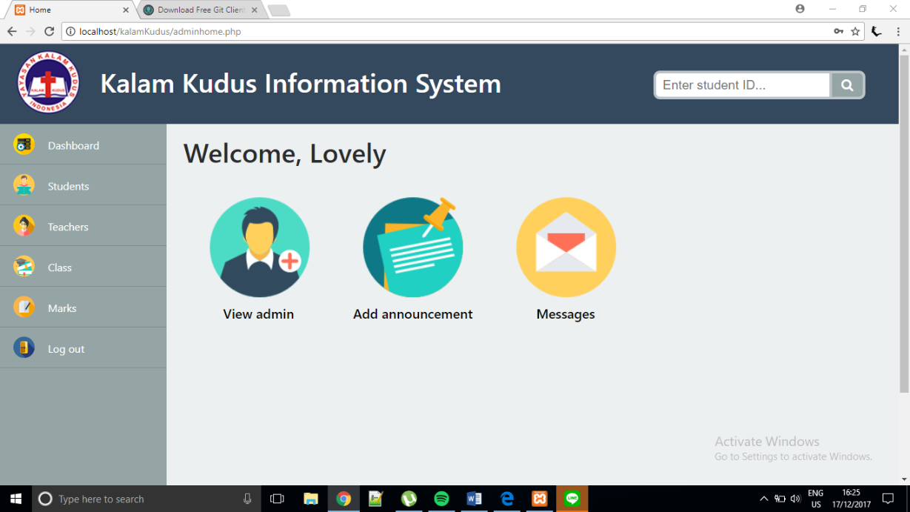

If admin selects View admin, it will direct to editAdmin.php. In this page, admin can view admin detail, add new admin, delete admin, edit admin’s name, and change password.

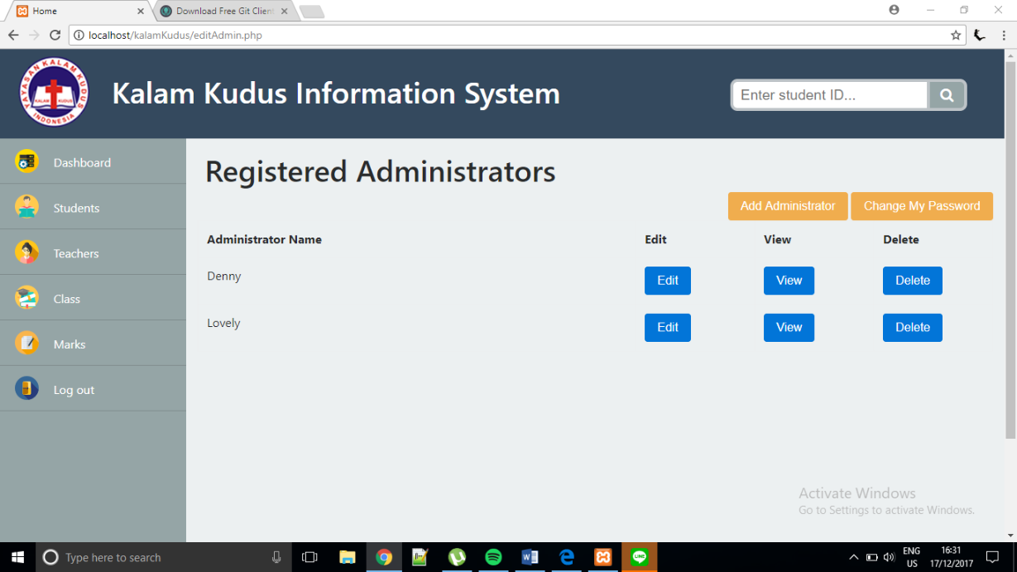

If admin clicks ‘Add Administrator’ button, the modal box will appear and new admin’s name should be entered. The admin ID does not have to be entered because it is auto increment.

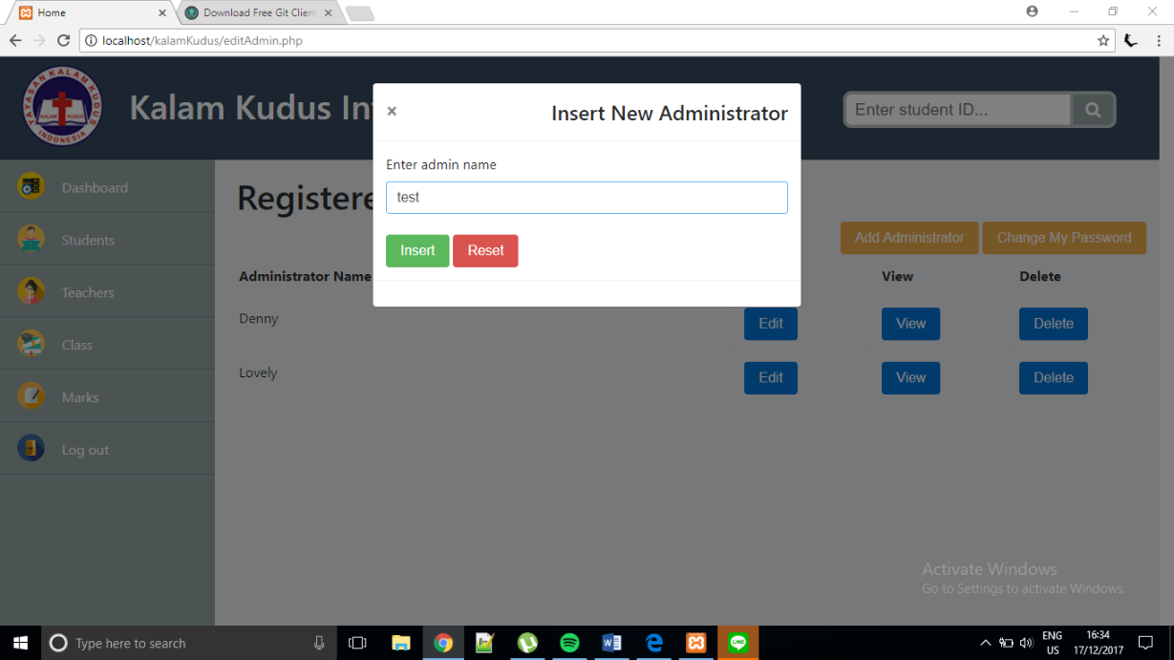

A new admin has been added as ‘test’.

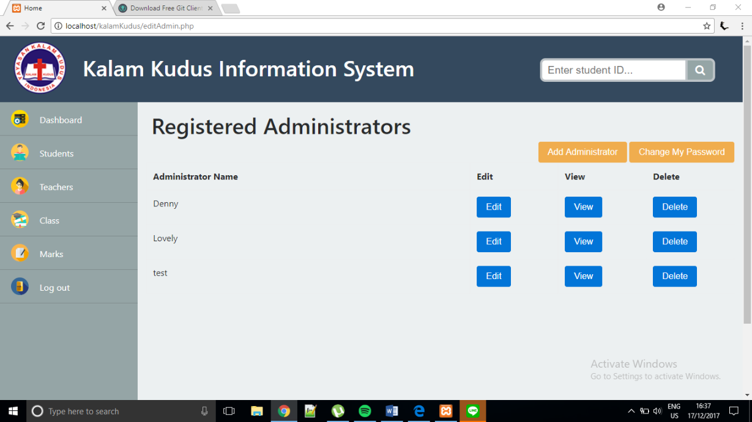

Newly added admin

If ‘View’ button is selected, it would display the admin’s ID and admin’s name.

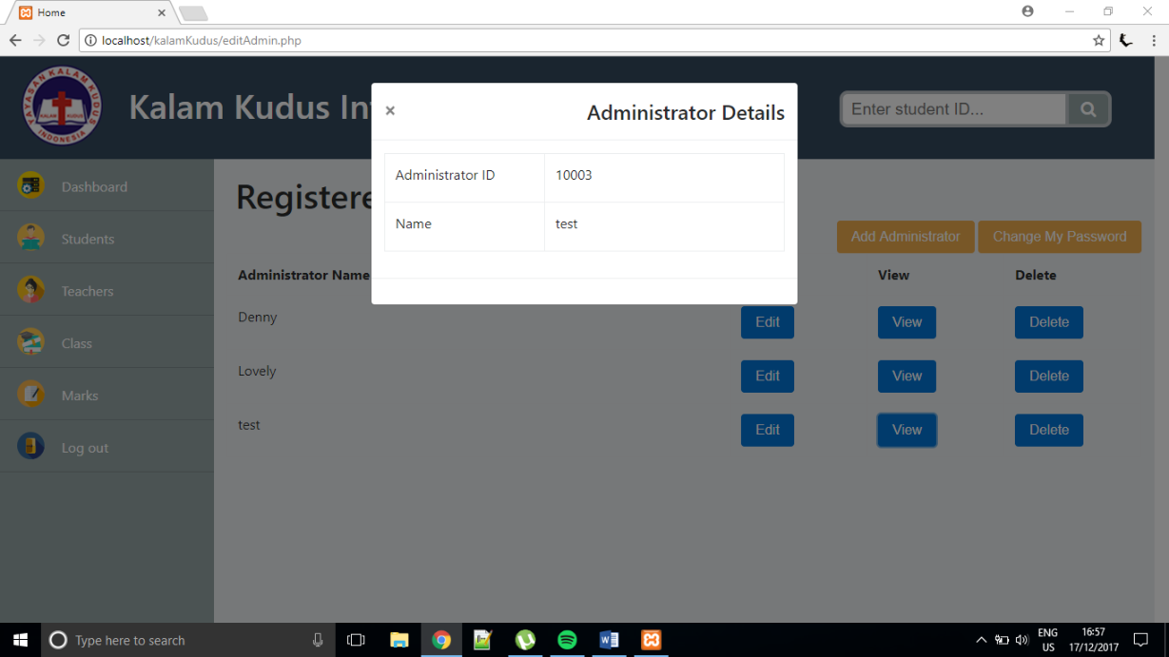

If ‘Edit’ button is selected, the admin can enter a new name and the name in the database will be updated.

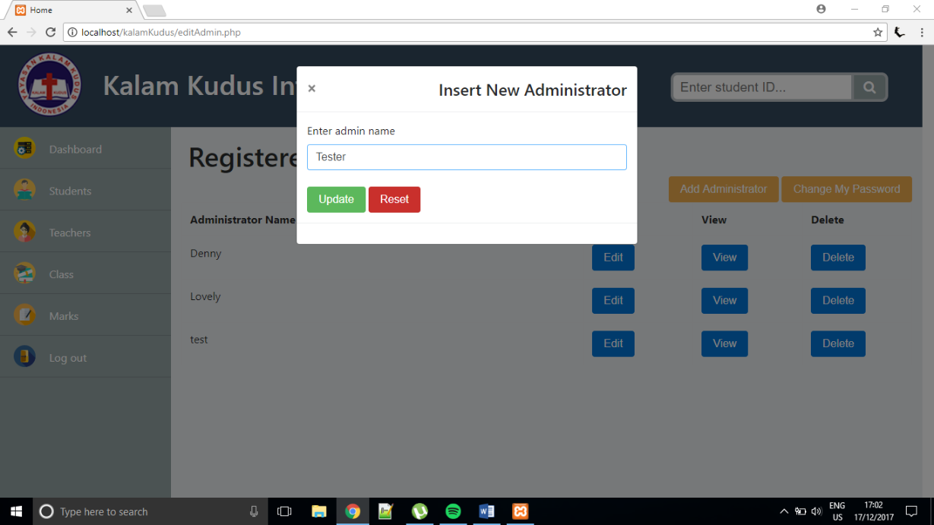

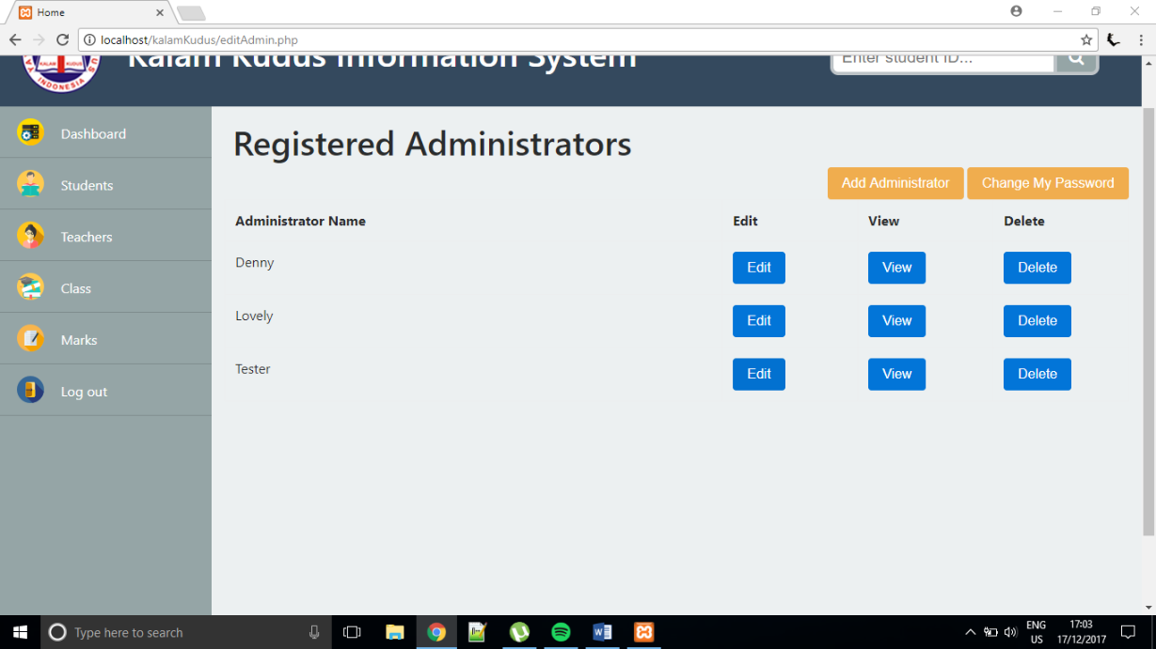

Name has been updated

If ‘Delete’ button is selected, the modal box will appear to confirm the delete process.

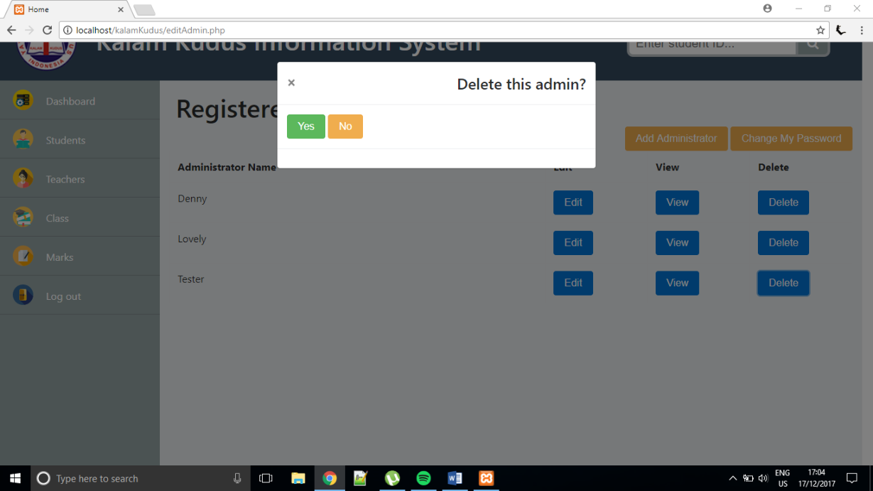

If admin clicks ‘No’, the data will not be deleted and it will return to editAdmin.php. If admin clicks ‘Yes’, the data will be deleted from the table and database, then return to editAdmin.php.

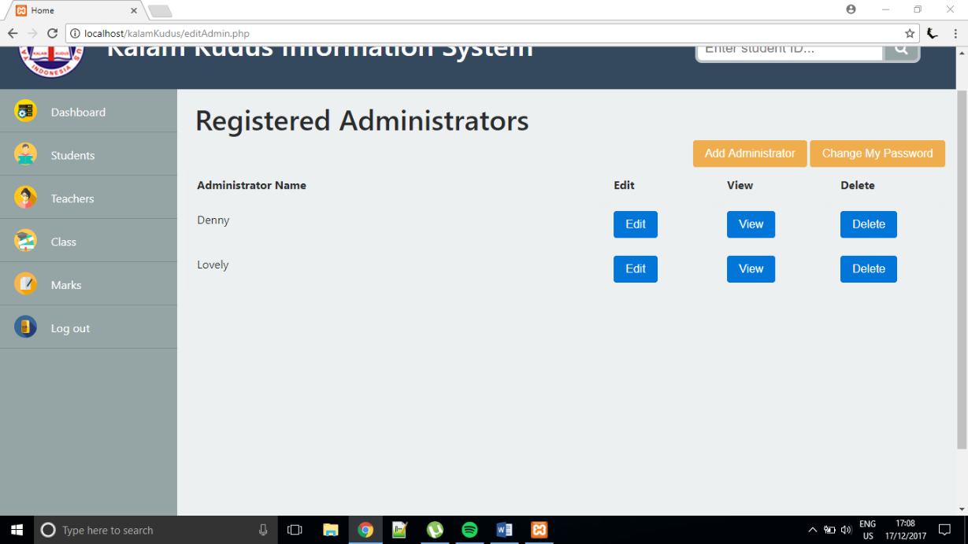

admin has been deleted

Admin could change the password by clicking ‘Change My Password’ button from the editAdmin.php. 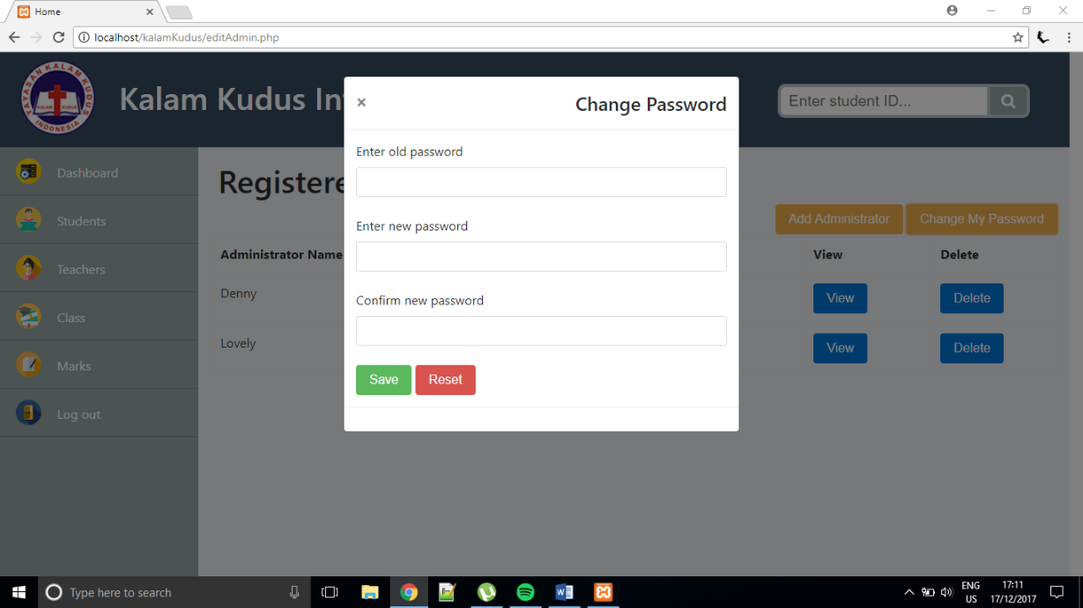

If the new passwords entered do not match, the system will notify the admin and the password change is failed.

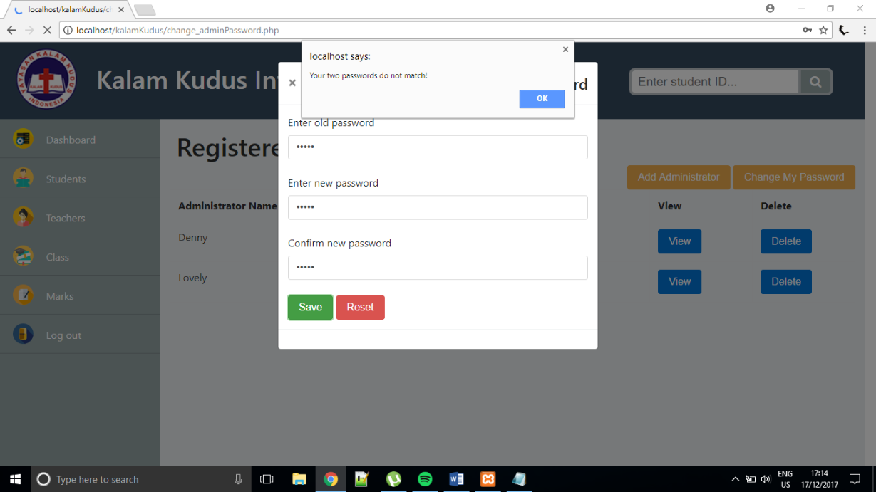

If the old password entered does not match with the current password, the system will notify the admin and the password change is failed.

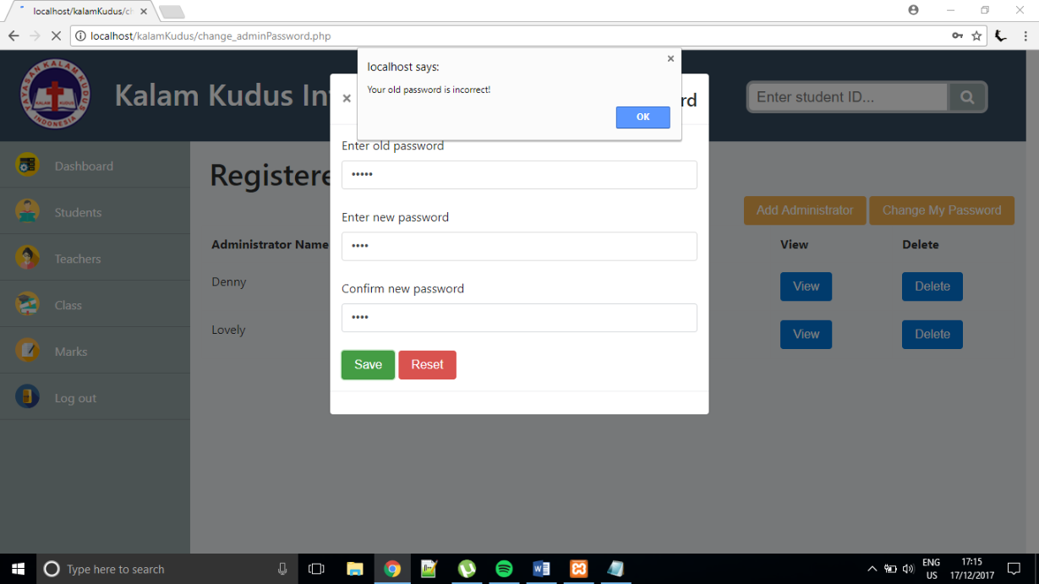

If admin selects ‘Add announcement’ from the Dashboard menu, it would direct to editAnnouncement.php.

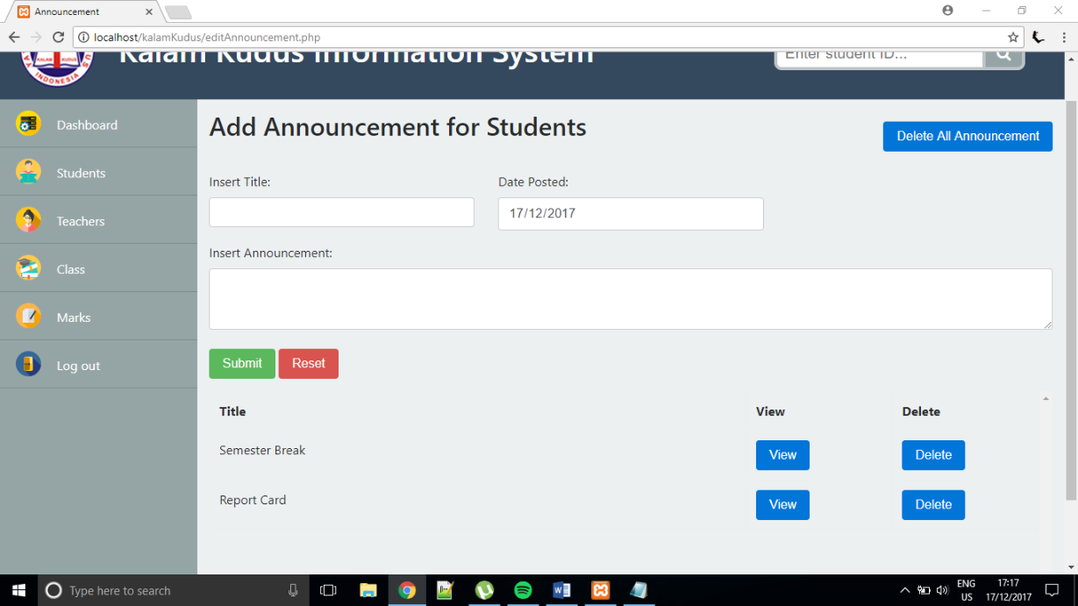

The admin must fill the form if wants to create a new announcement. The date will automatically be filled with the current date. The admin has to click submit to add the announcement.

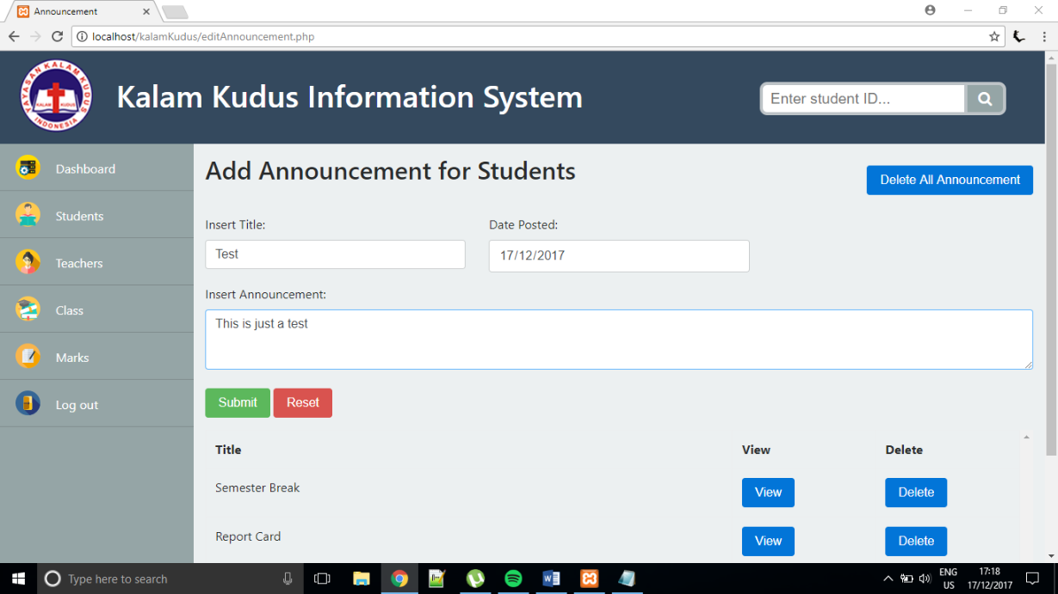

The new announcement will appear at the bottom of the page. The announcements are sorted according to the date in descending order.

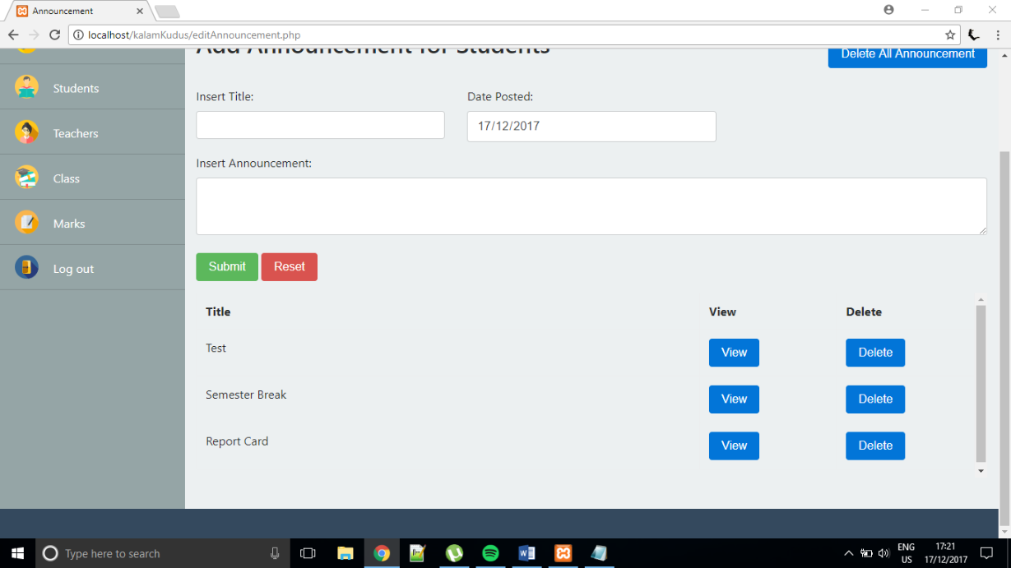

new announcement has been created

If admin clicks ‘Delete’ button, the modal box will appear to confirm the delete process.

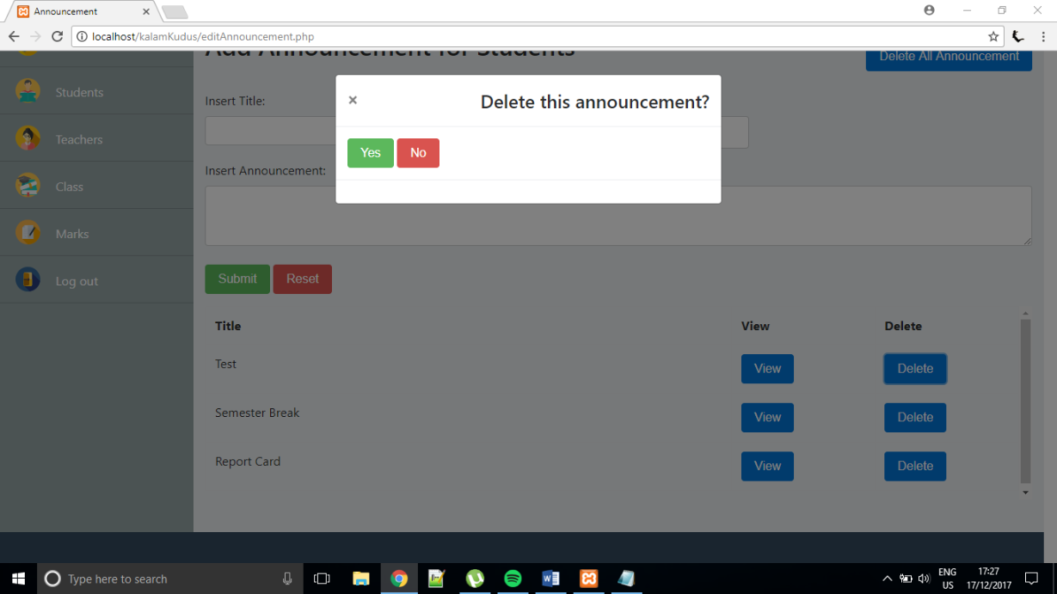

If admin clicks ‘No’, the announcement will not be deleted and it will return to editAnnouncement.php. If admin clicks ‘Yes’, the announcement will be deleted from the table and from database, then it will return to editAnnouncement.php.

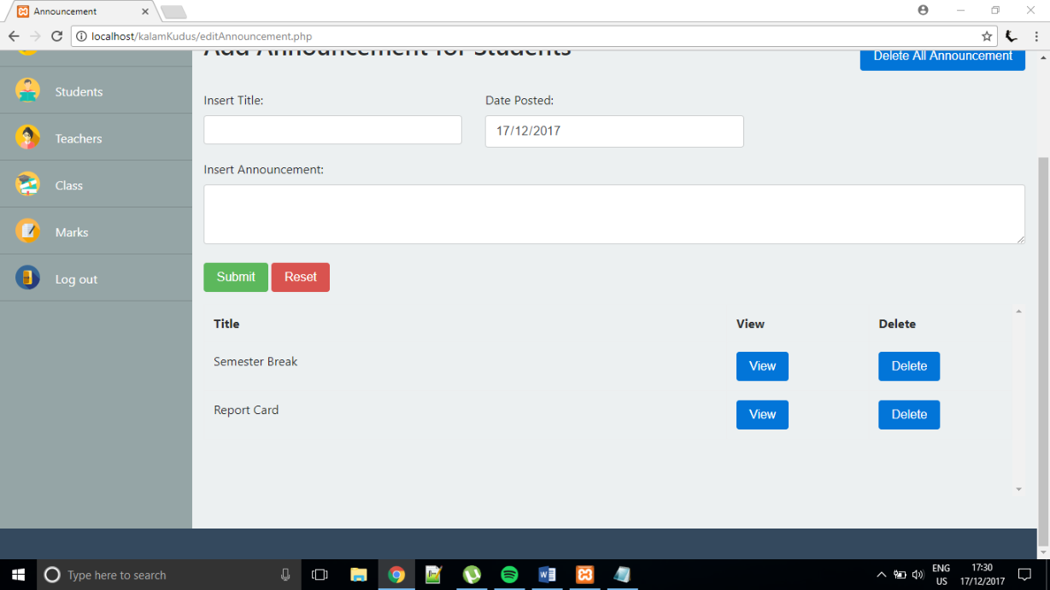

the announcement has been deleted

If the ‘View’ button is clicked, the modal box will appear and display the detail of the announcement.

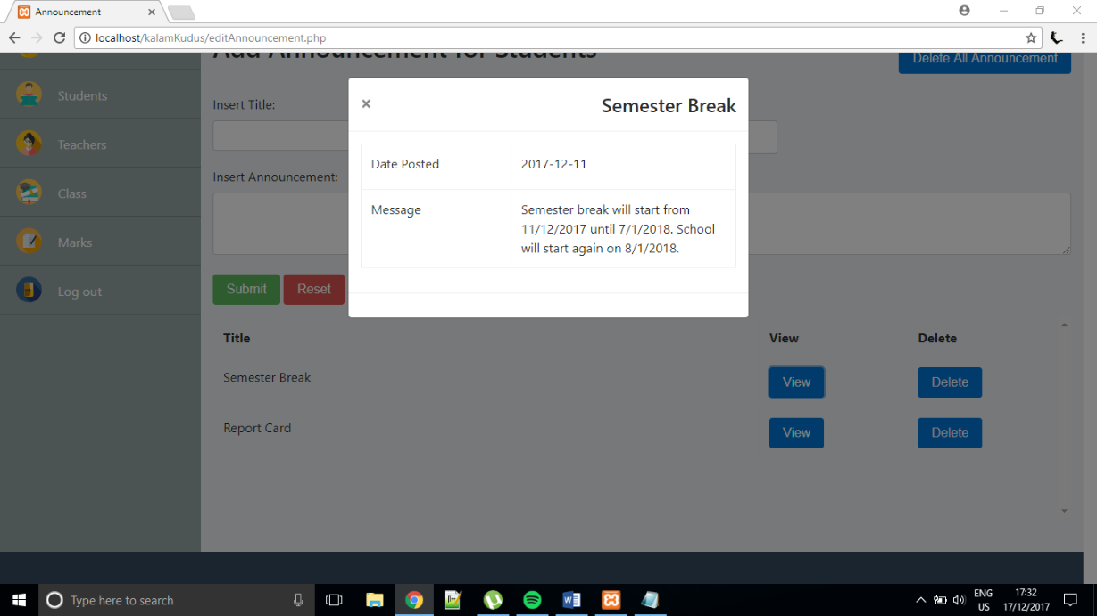

If the ‘Delete All Announcement’ button is clicked, modal box will appear to ask for confirmation if all announcements want to be deleted or not.

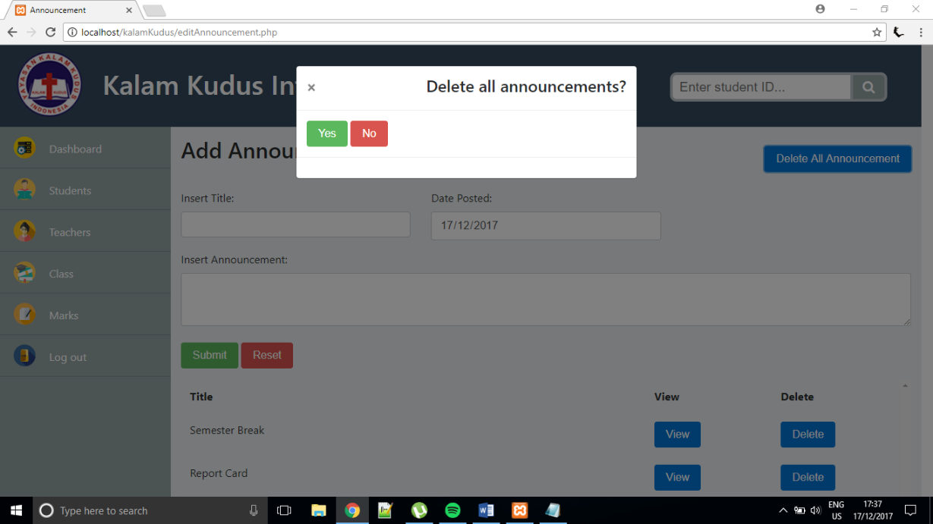

If admin selects ‘Messages’ from the Dashboard menu, it would direct to messages.php. In this page, admin can view messages sent by students, reply to the message, and delete message.

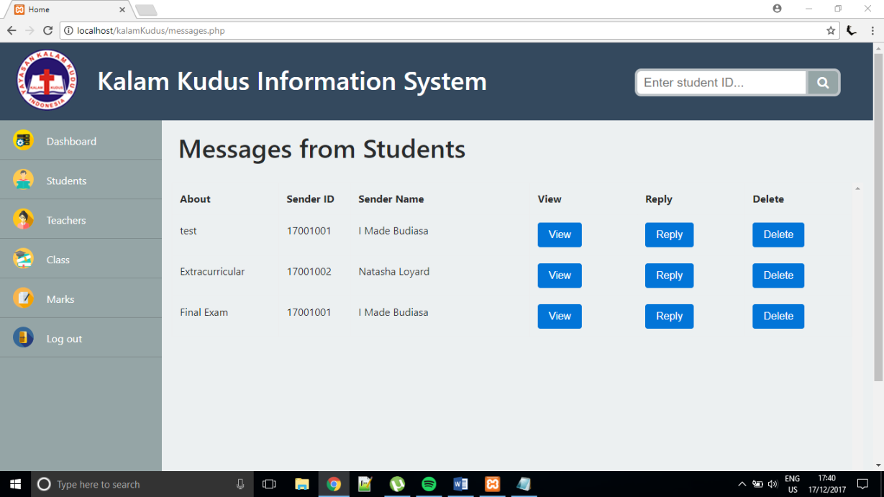

If ‘Reply’ button is clicked, a modal box will appear and admin can enter the answer to the message.

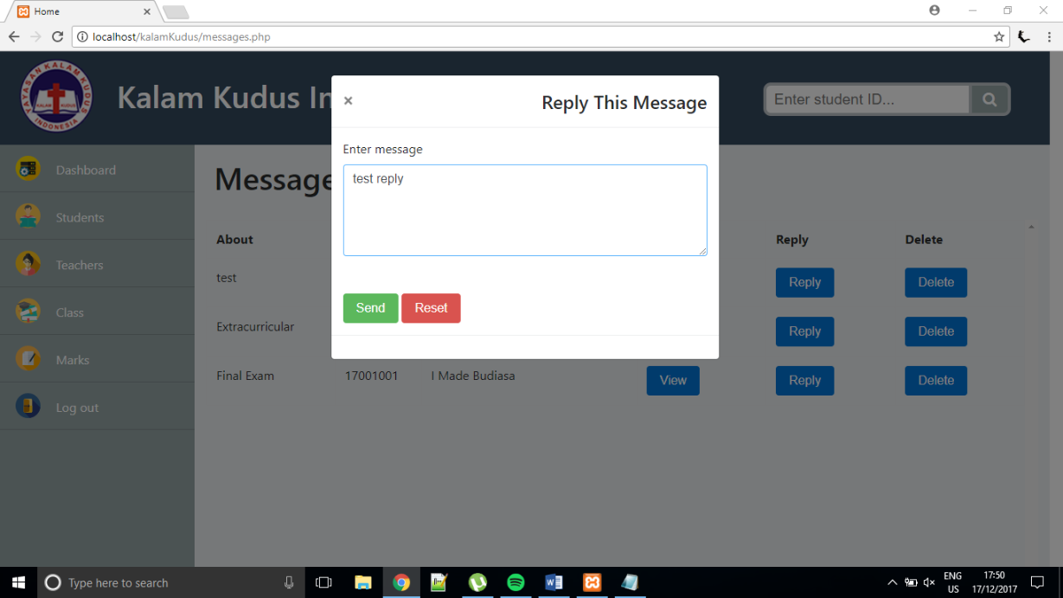

If ‘View’ button is clicked, a modal box will appear to display the message details.

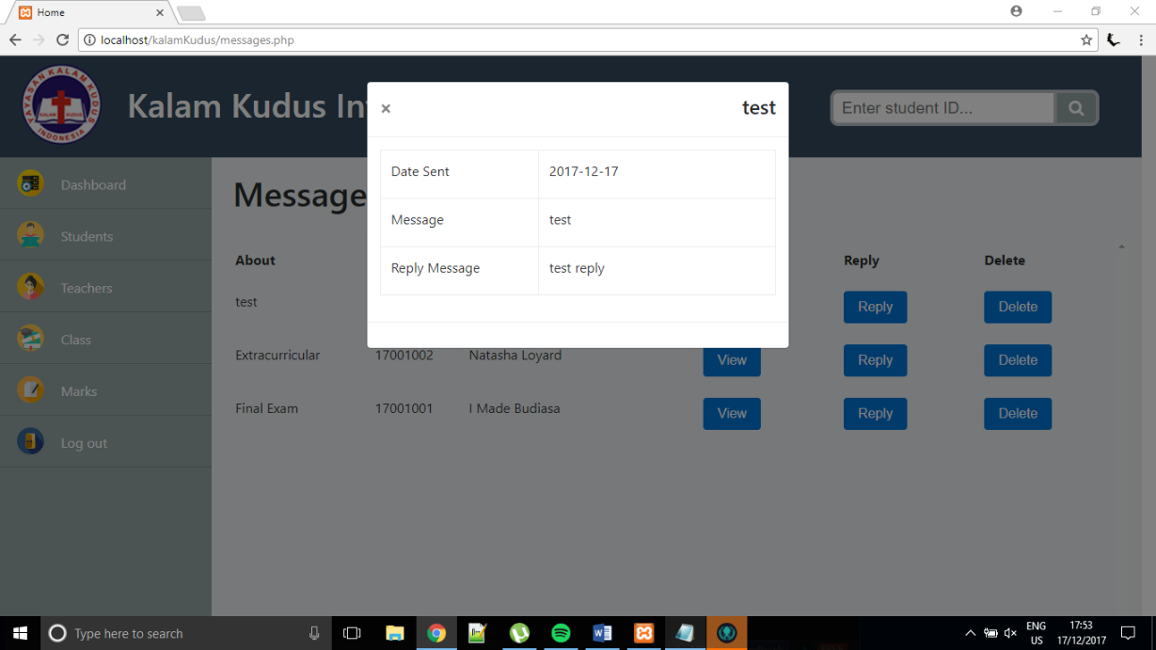

If ‘Delete’ button is clicked, a modal box will appear to confirm if the message really wants to be deleted.

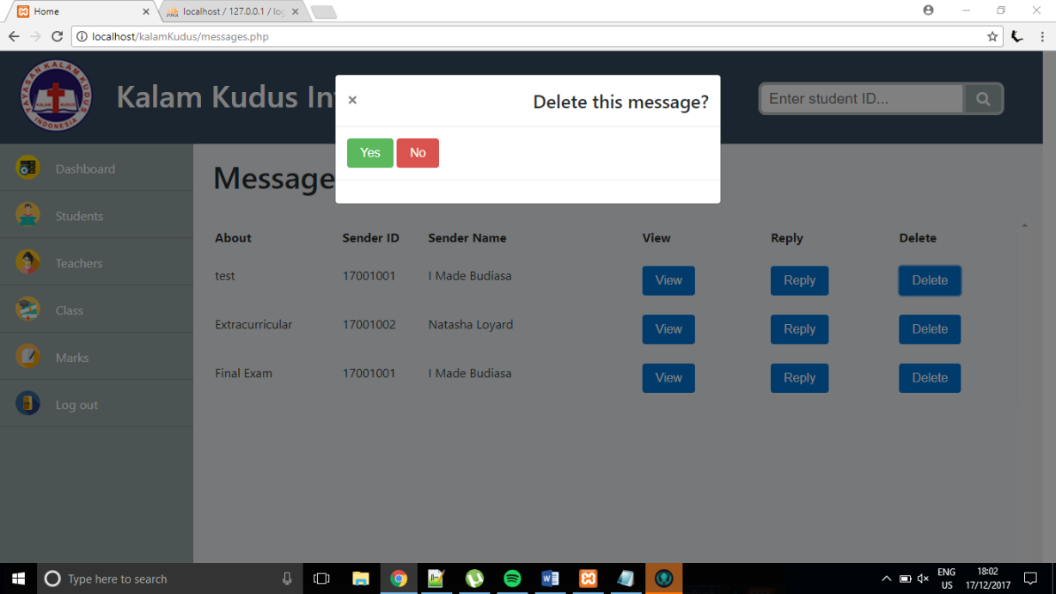

After confirm the delete modal, it will direct back to the messages.php

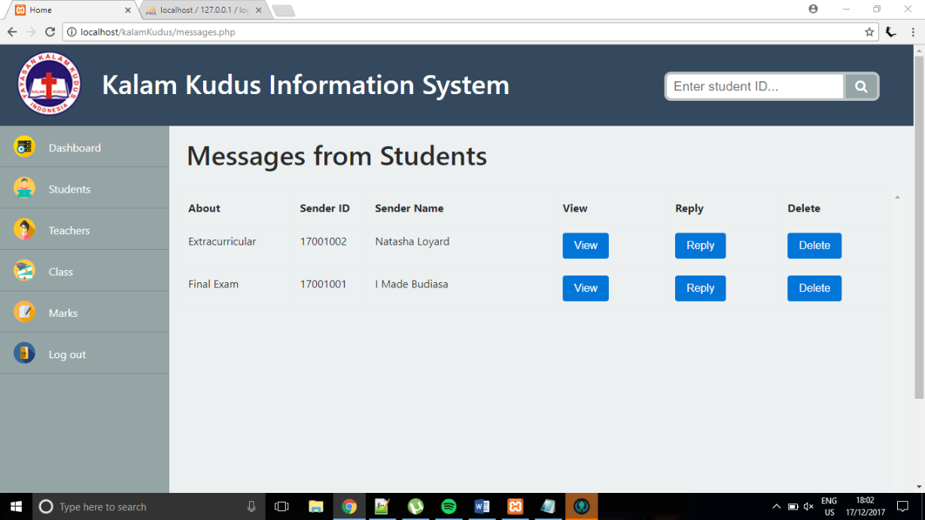

If admin selects ‘Students’ from the navigation bar, it will direct to editStudents.php. In this page, admin can add new student, edit student information, view student information, and delete student from the system. Because there are many students, they are divided into several pages and each page can only show maximum 6 students.

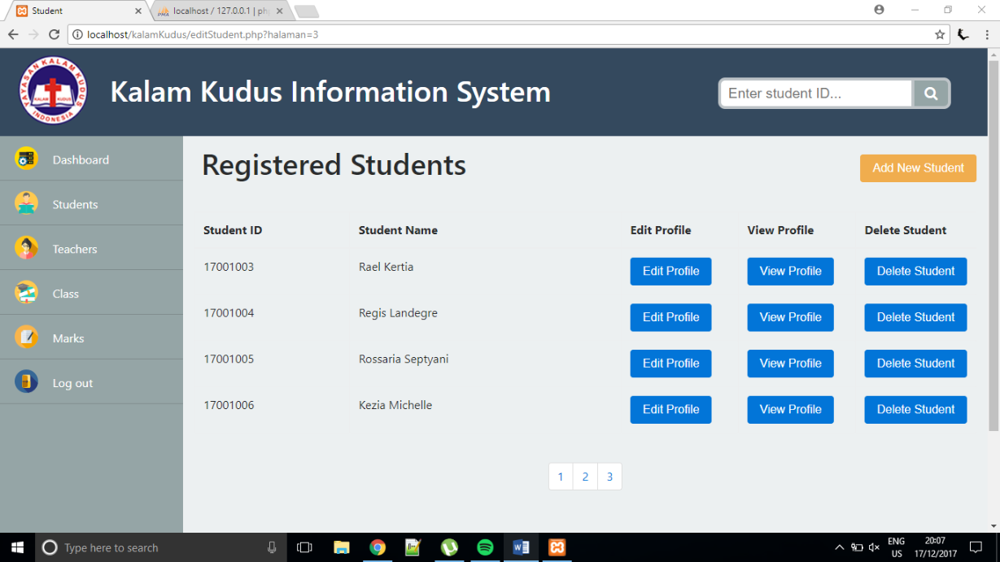

If admin clicks ‘Add New Student’, modal box will appear where admin can add information for new students. Student ID does not have to be entered because it is auto increment.

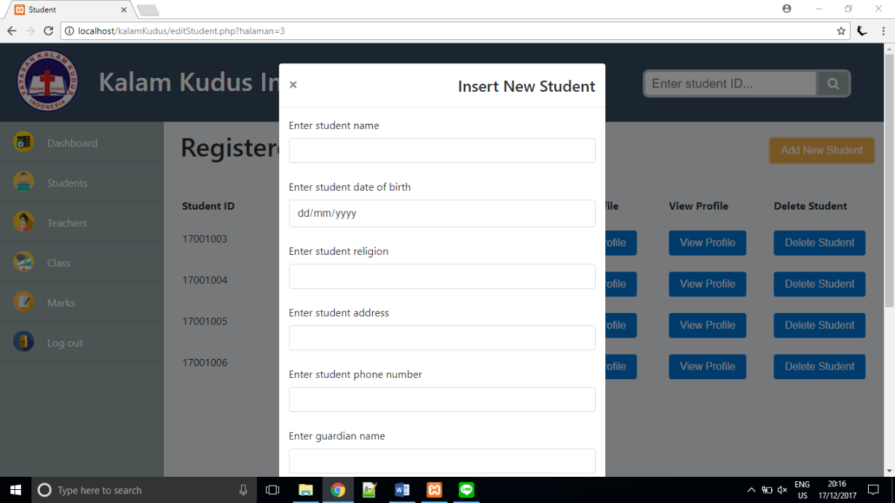

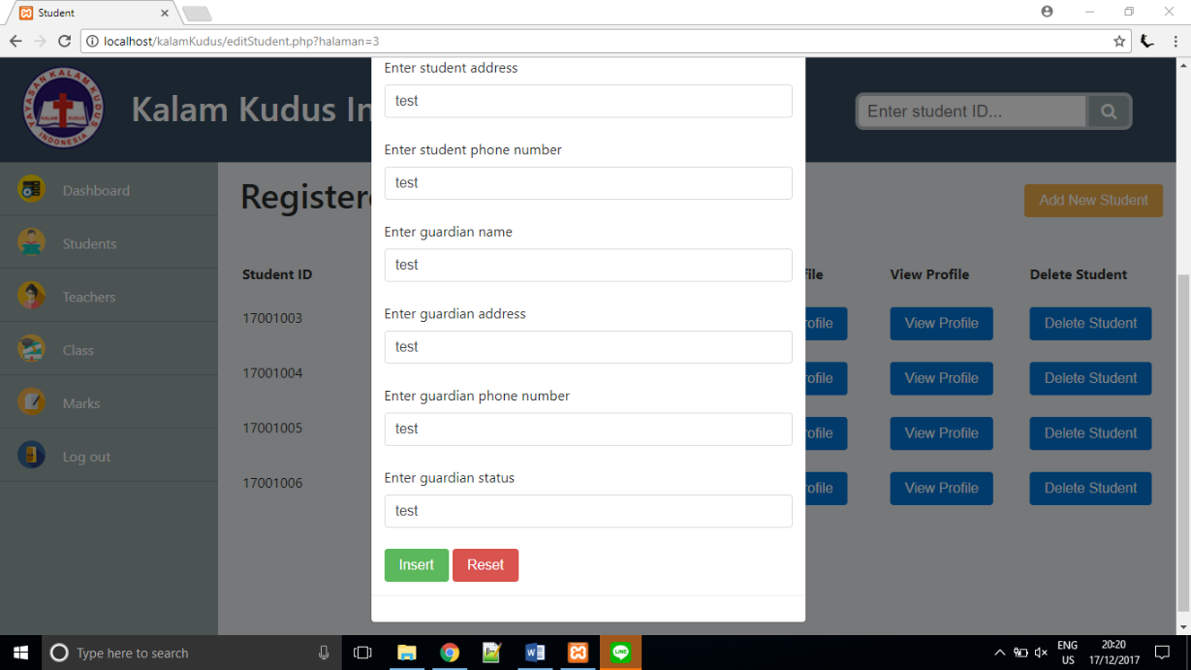

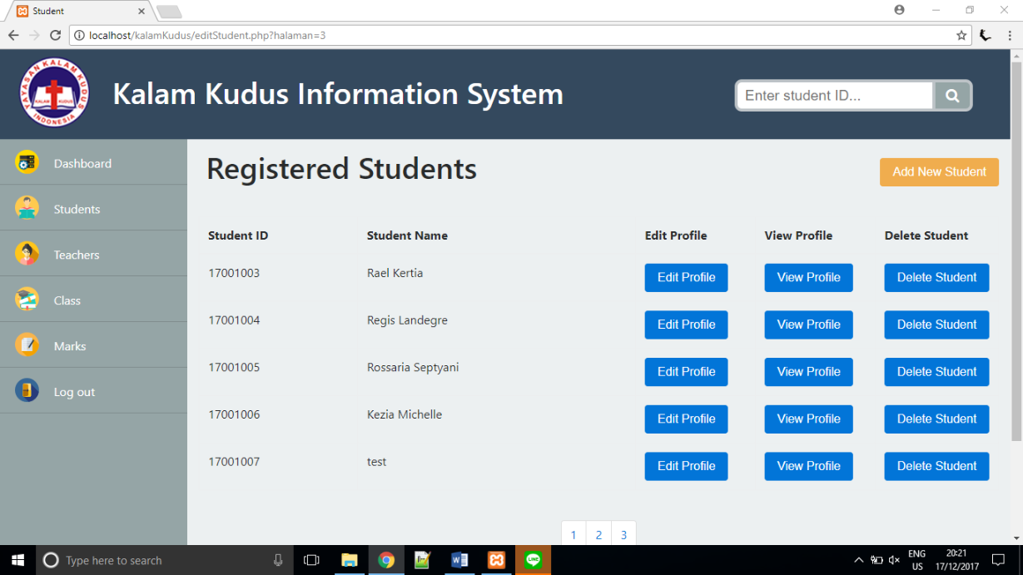

newly added student

If admin clicks ‘View Profile’ button, the modal box will appear and show the student details.

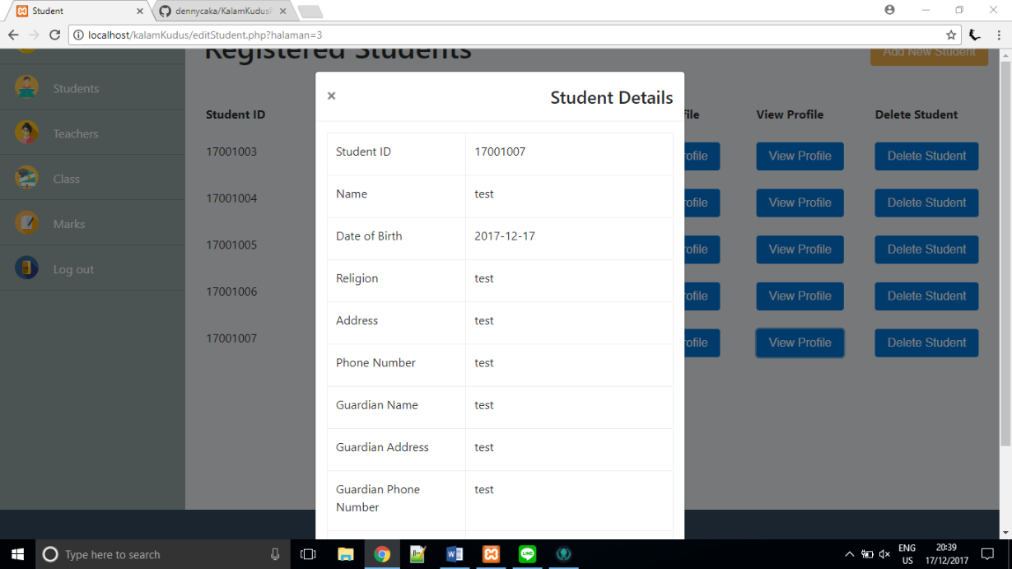

If admin clicks ‘Edit Profile’ button, the modal box will appear and admin can change the current student data to the newest one.

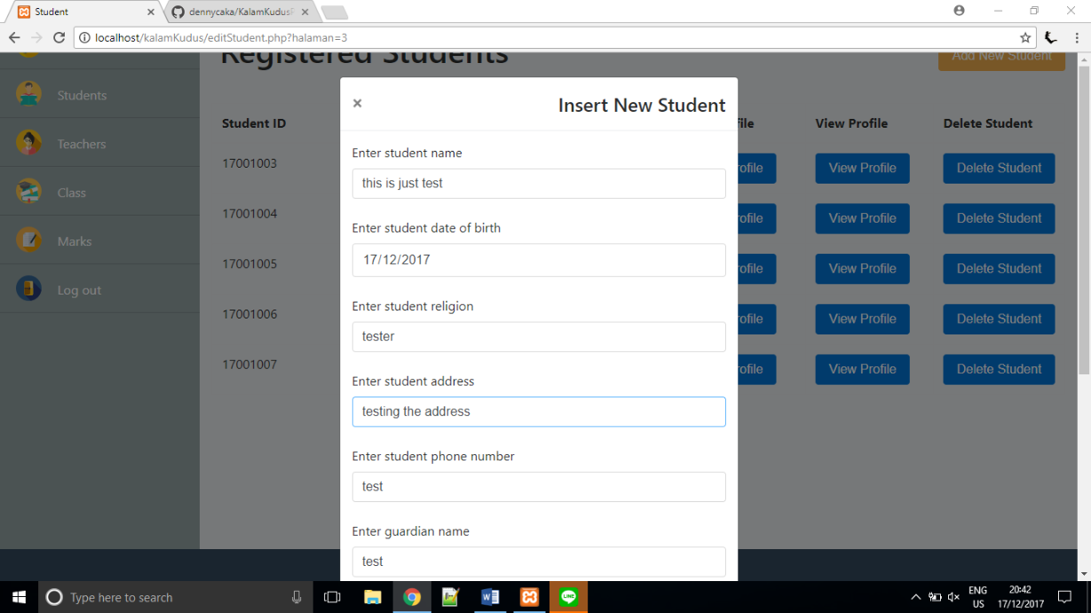

If admin clicks ‘Update’ button, the student data will be changed and the database will be updated.

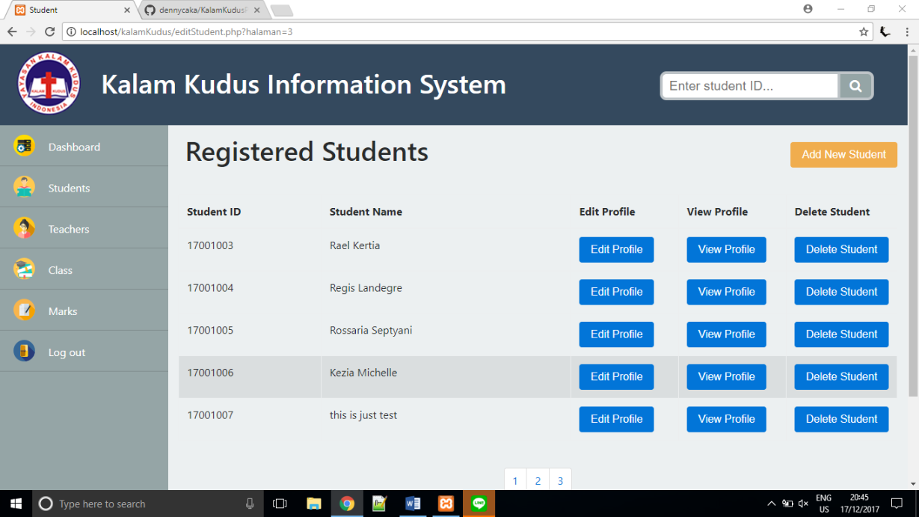

student has been successfully edited

If admin clicks ‘Delete Student’ button, the modal box will appear to confirm if the student is really wanted to be deleted. If admin chooses ‘Yes’ the student will be removed from the table and from the database, then return to editStudent.php. If admin chooses ‘No’ the student will not be deleted and return to editStudent.php.

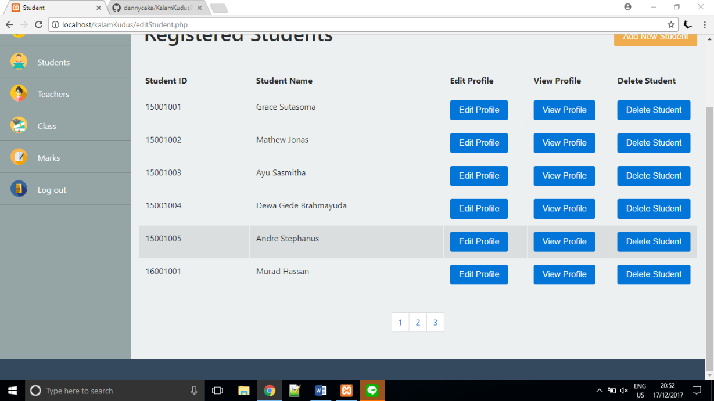

student has been successfully deleted

If admin selects ‘Teachers’ from the navigation bar, it will direct to editTeachers.php. In this page, admin can add new teacher, edit teacher information, view teacher information, and delete teacher from the system. Because there are many teachers, they are divided into several pages and each page can only show maximum 6 students.

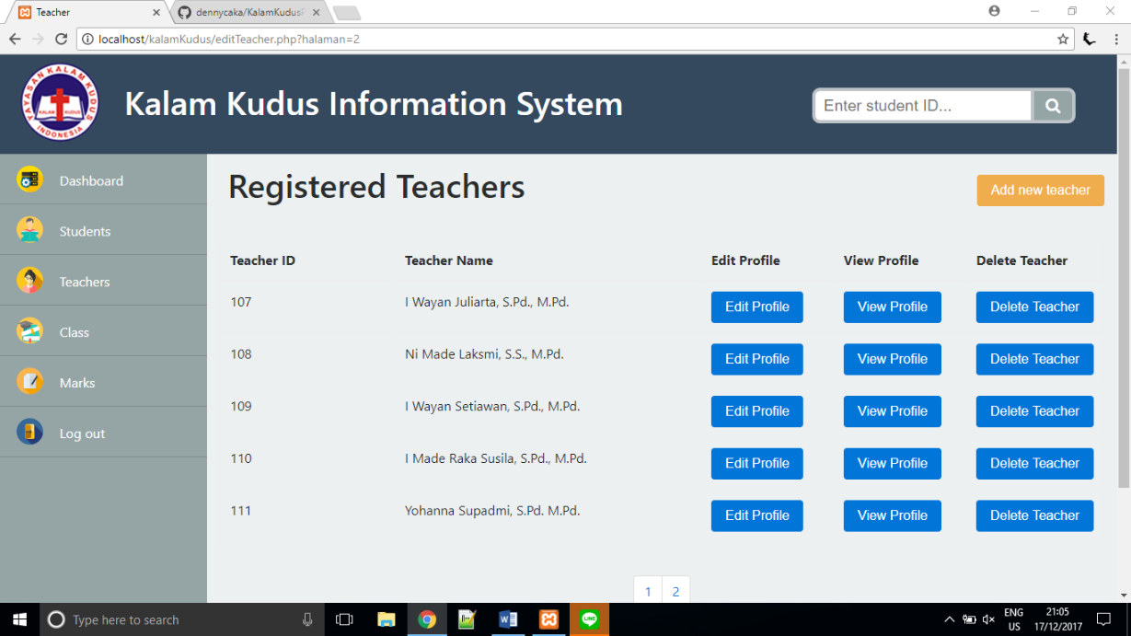

If admin clicks ‘Add New Teacher’, modal box will appear where admin can add information for new teachers. Teacher ID does not have to be entered because it is auto increment.

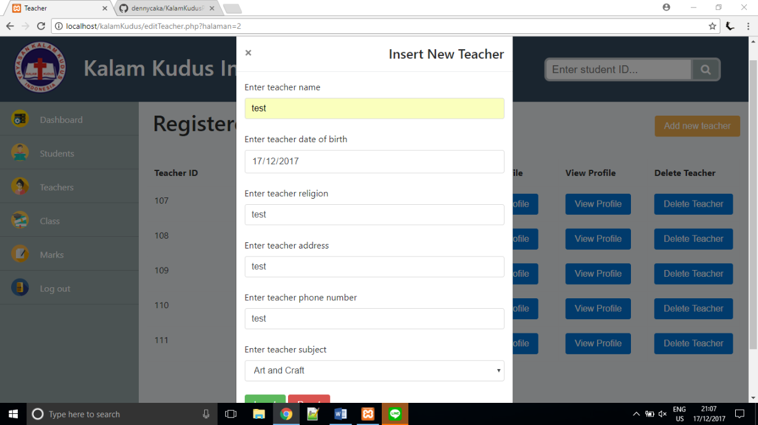

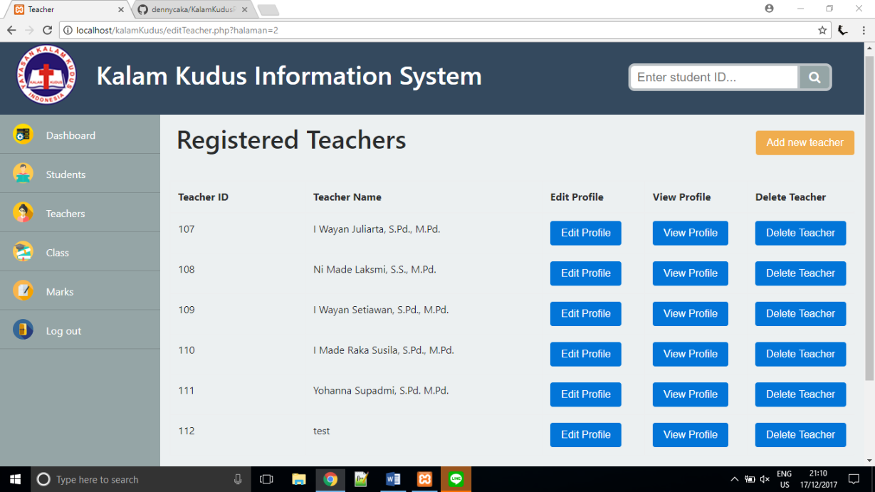

teacher has been added

If admin clicks ‘View Profile’ button, the modal box will appear and show the teacher details.

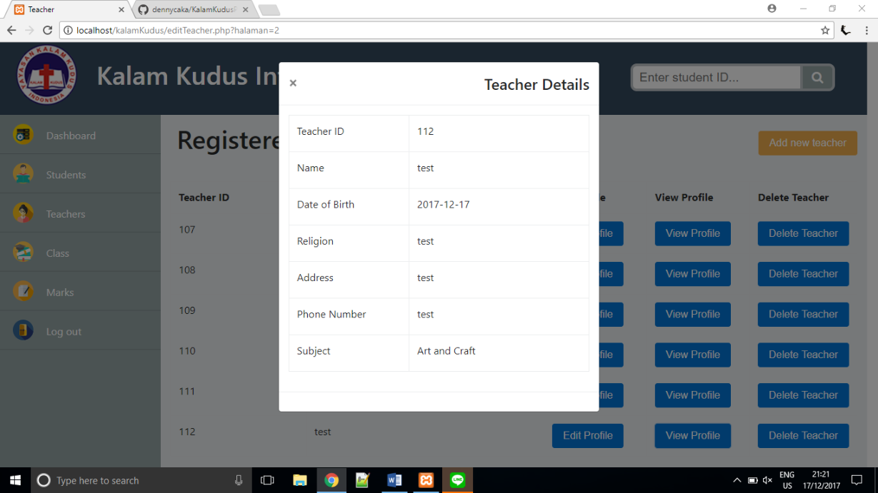

If admin clicks ‘Edit Profile’ button, the modal box will appear and admin can change the current teacher data to the newest one.

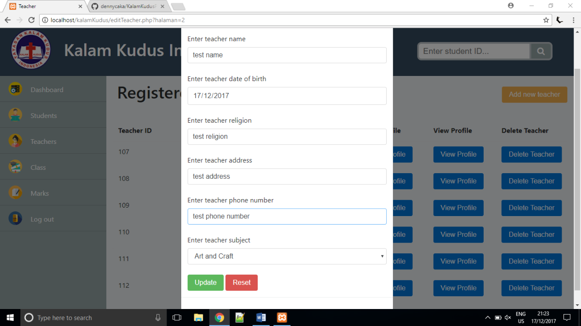

If admin clicks ‘Update’ button, the teacher data will be changed and the database will be updated.

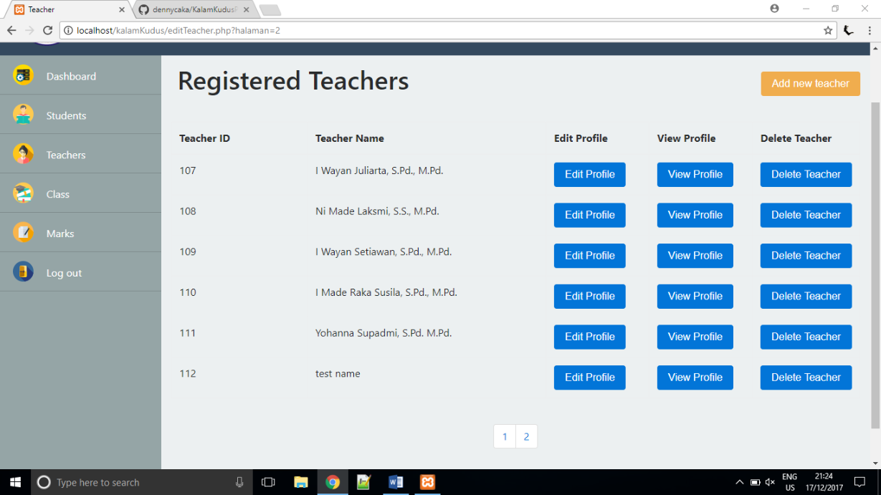

Teacher has been updated

If admin clicks ‘Delete Teacher’ button, the modal box will appear to confirm if the teacher is really wanted to be deleted. If admin chooses ‘Yes’ the teacher will be removed from the table and from the database, then return to editTeacher.php. If admin chooses ‘No’ the teacher will not be deleted and return to editTeacher.php.

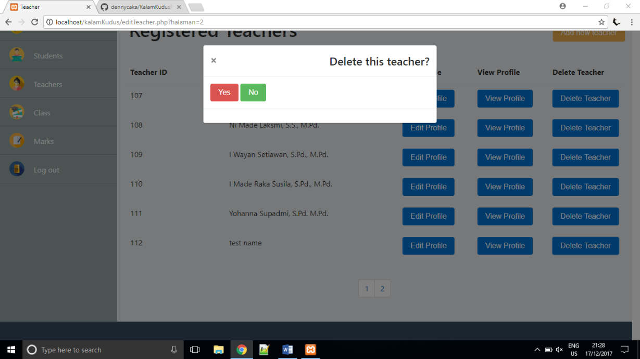

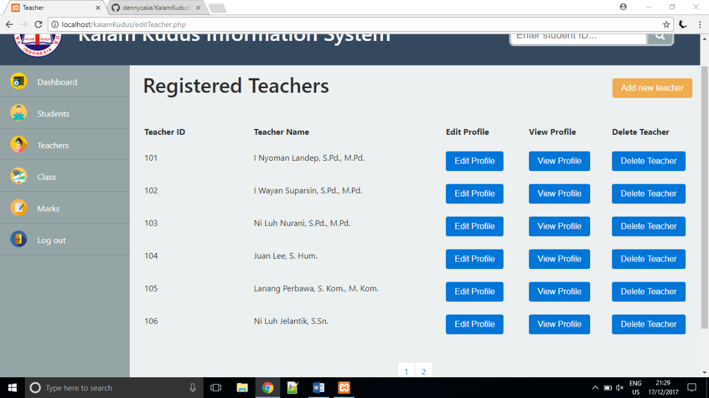

Teacher has been deleted

If admin selects ‘Class’ from the navigation bar, it will direct to editClass.php. In this page, admin can add new class, edit class name, add student to a class, view students in a class, add schedule based on the class, edit schedule and delete class from the system.

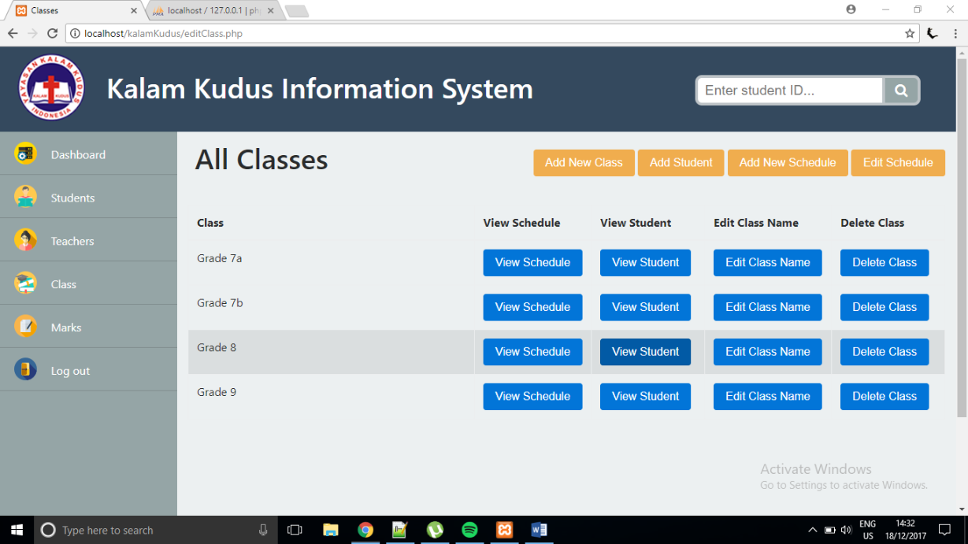

If admin clicks ‘Add New Class’ button, a modal box will appear and admin will input the new class’s name.

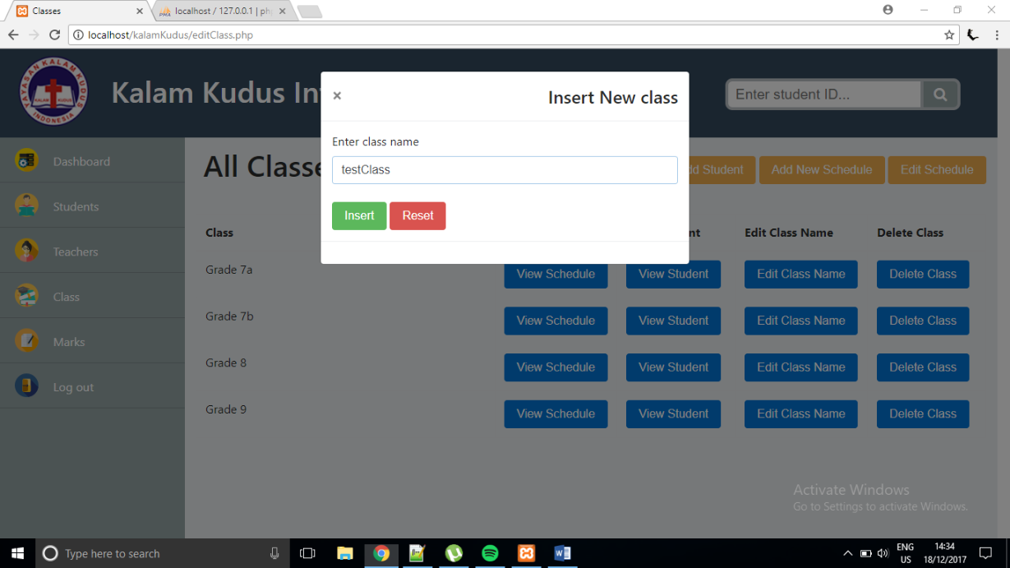

If admin clicks ‘Insert’ button, it will add the new class to the database and show it on the table.

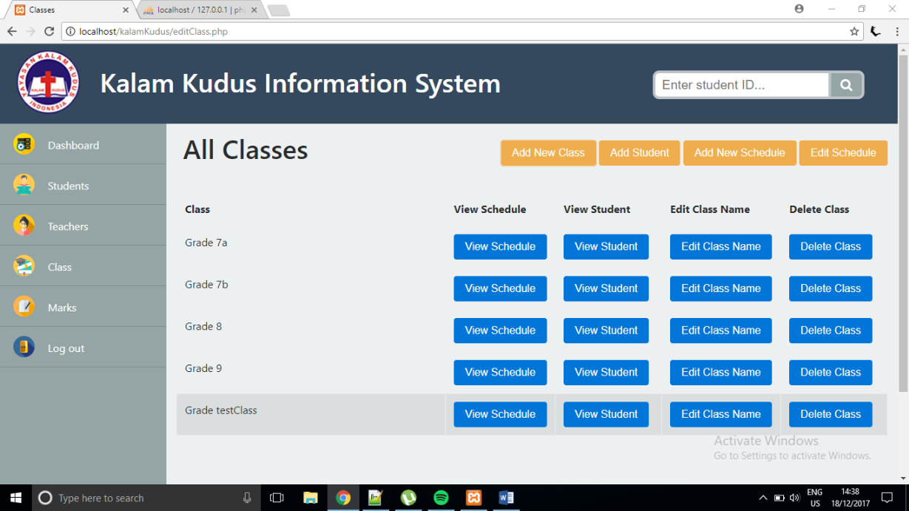

a new class has been added

If admin clicks ‘Add Student’ button, the modal box will appear where admin can choose which class to add student to and input the student ID.

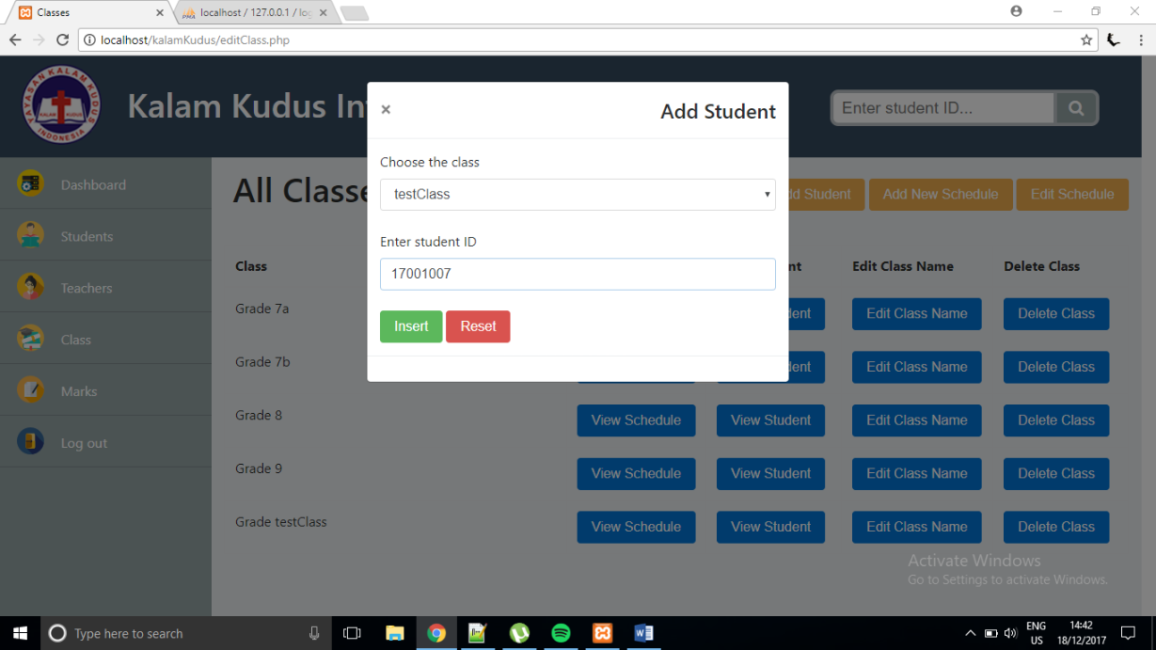

If admin clicks ‘Insert’ button, the student will be added to the class that has been chosen. To view the student in the class, admin can click ‘View Student’ button.

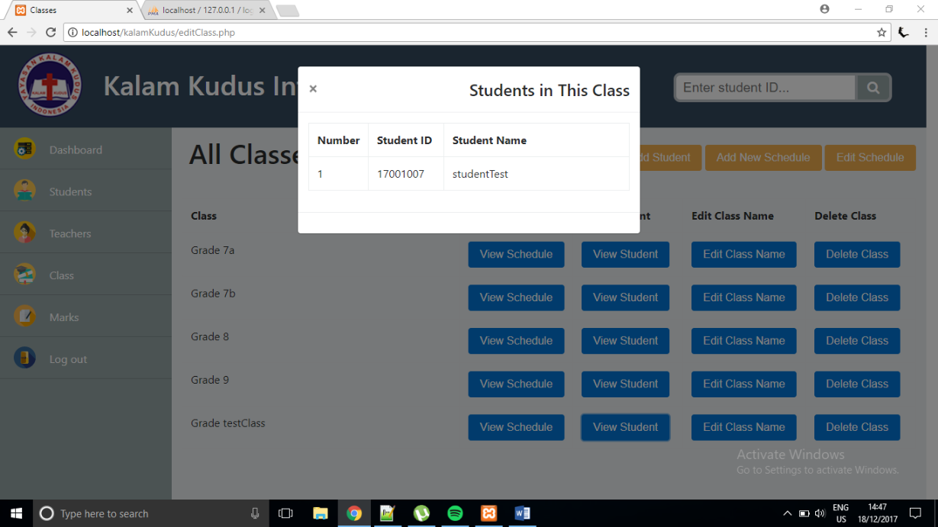

If admin clicks ‘Add New Schedule’ button, the modal box will appear and admin can choose which class to create the new schedule to.

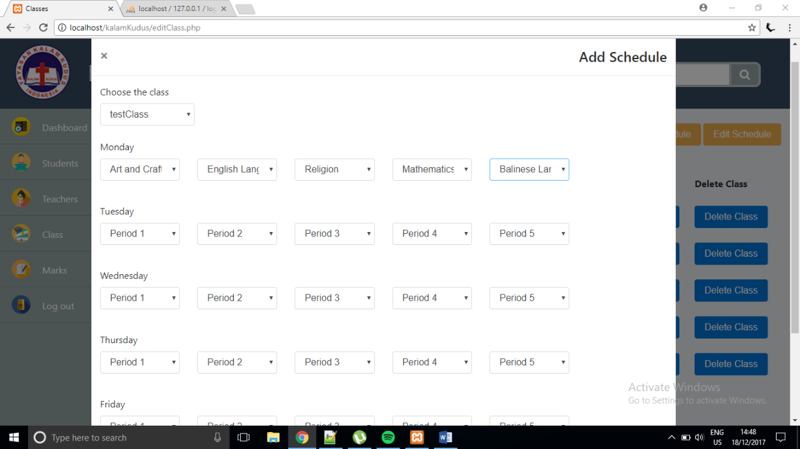

If admin clicks ‘Insert’ button, the new schedule will be saved to the database and the class will have a new schedule. To view the schedule of the class, admin can click ‘View Schedule’ button.

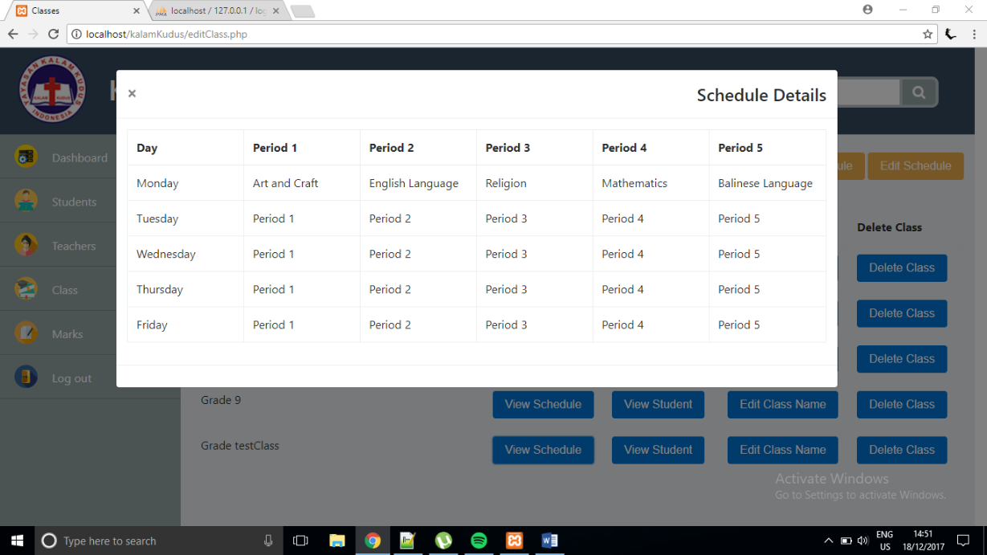

If admin clicks ‘Edit Schedule’ button, the modal box will appear and admin can choose which class, which day, which period, and what the new subject is.

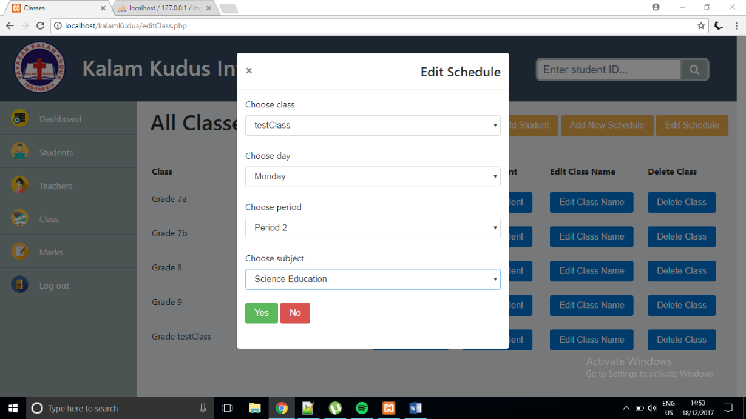

If admin clicks ‘Yes’ button, the new schedule will be saved to the class that has been chosen. To view the schedule, admin can click ‘View Schedule’ button.

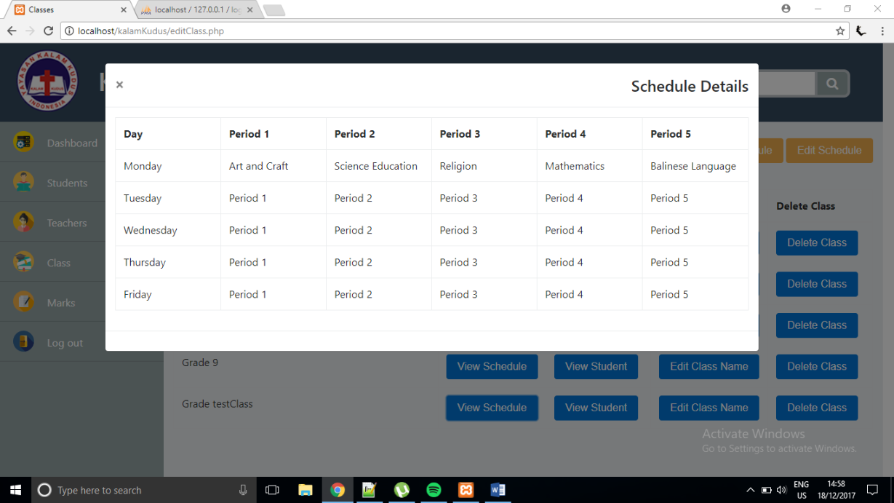

a new schedule has been edited.

If admin clicks ‘Edit Class Name’ button, the modal box will appear and admin can change the name of the class.

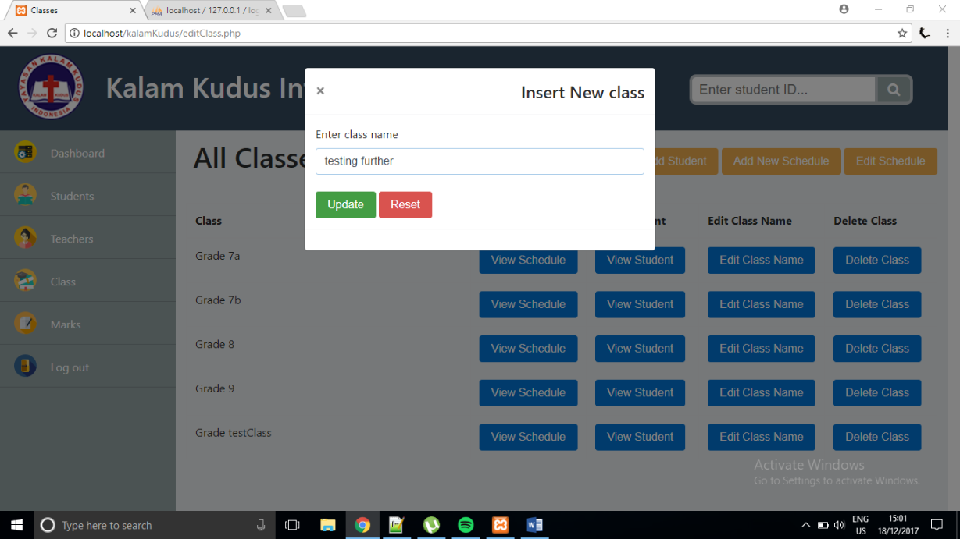

If admin clicks ‘Update’ button, the name of the class will be updated and the change is also applied to the database.

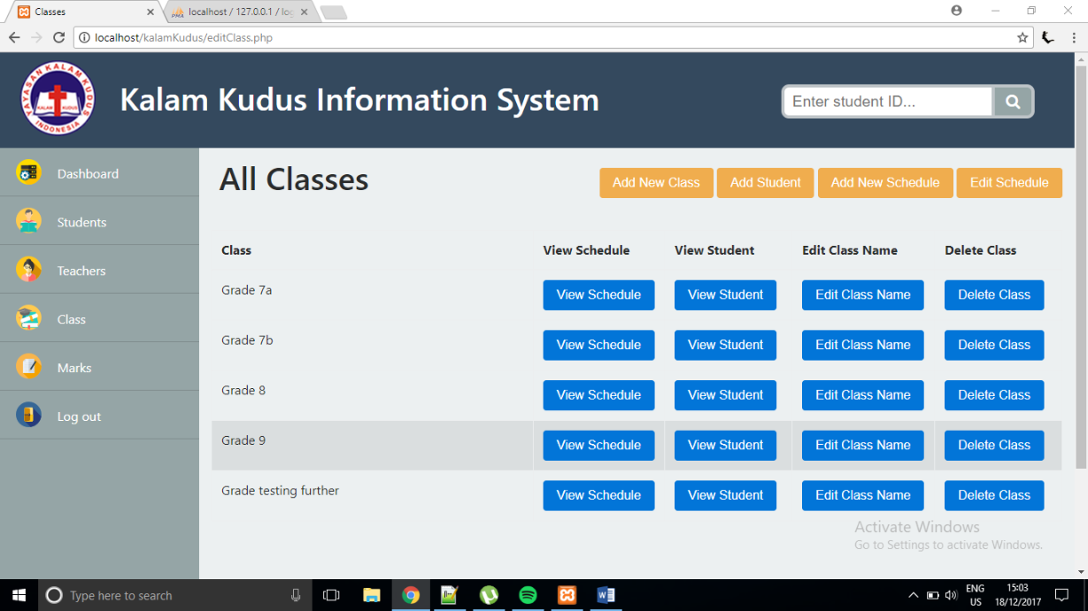

the class’s name has been changed

If admin clicks ‘Delete Class’ button, the modal box will appear to confirm if the class is really wanted to be deleted.

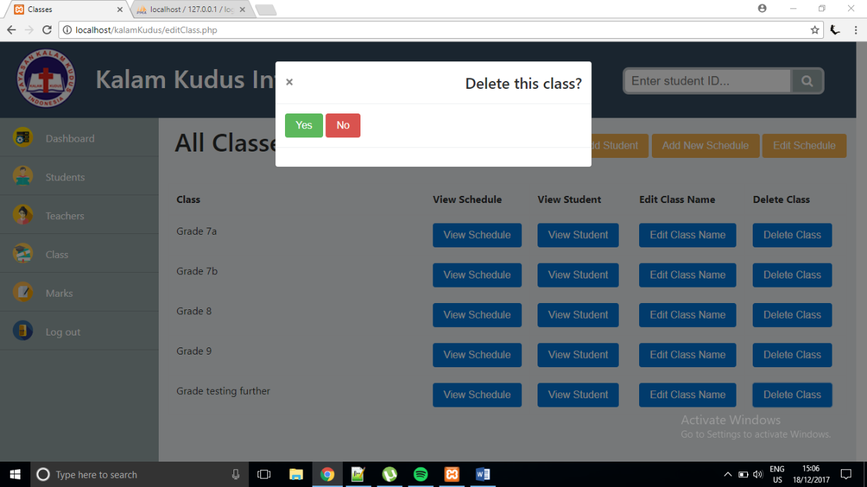

If admin clicks ‘No’ button, the class will not be deleted. If admin clicks ‘Yes’ button, the class will be deleted from the table and so from the database.

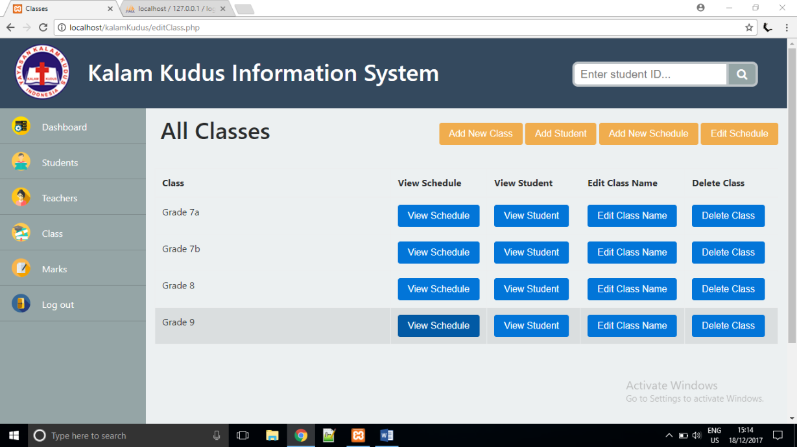

the class has been deleted

If admin clicks ‘Marks’ from navigation bar, it will direct to editMarks.php.

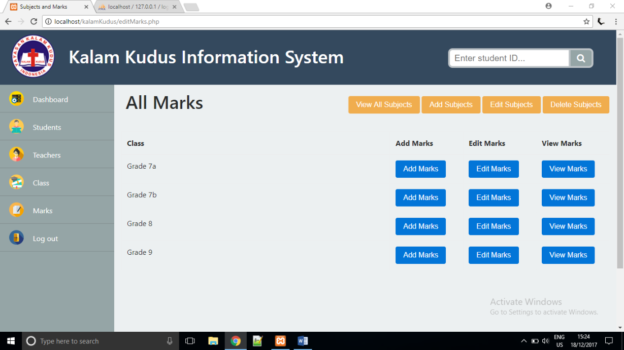

If admin clicks ‘View All Subjects’ button, a modal box will appear and display all of the subjects that exist in the database that are sorted according to ascending order.

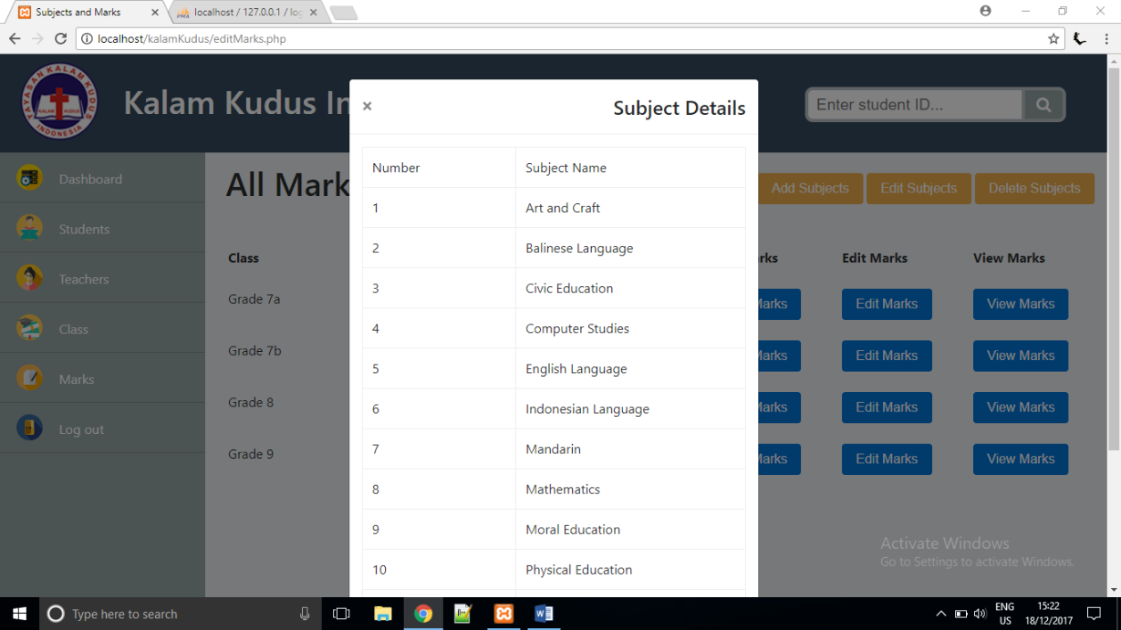

If admin clicks ‘Add Subjects’ button, a modal box will appear and admin can create a new subject by input the name of the subject.

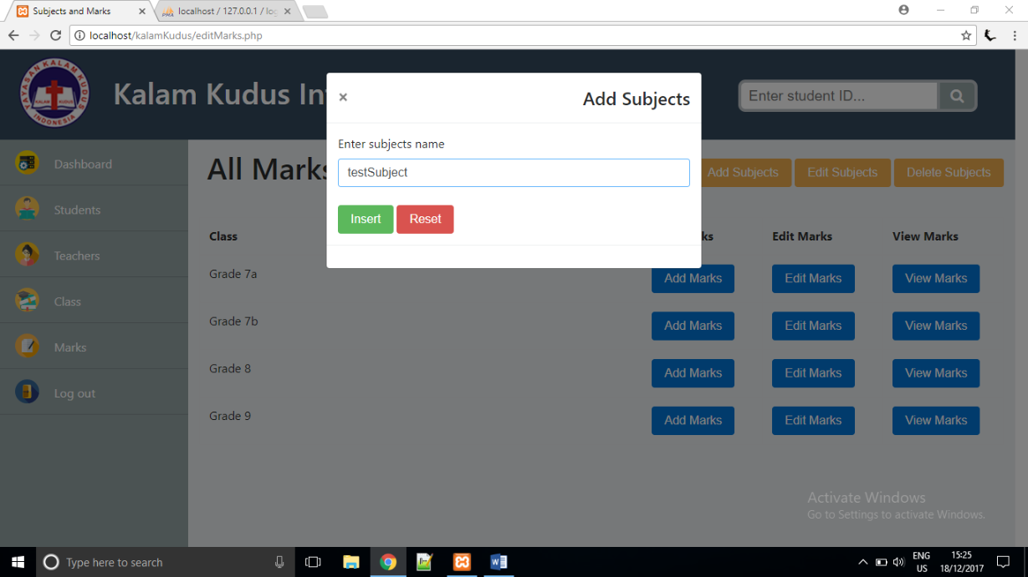

If admin clicks ‘Insert’ button, the new subject will be created and stored to the database. To view the subject, admin can click ‘View All Subjects’ button.

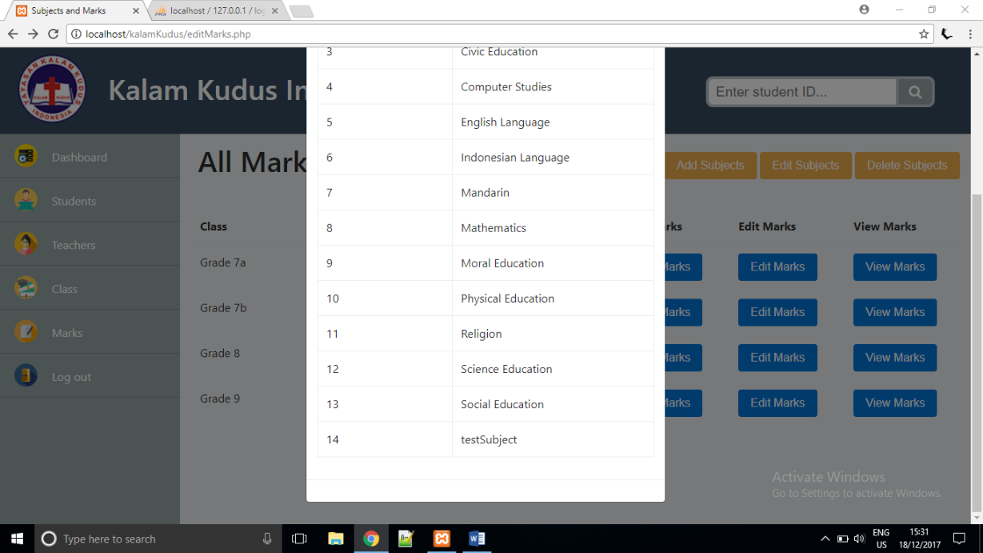

a new subject has been added

If admin clicks ‘Edit Subjects’ button, the modal box will appear and admin can choose which subject to be edited to.

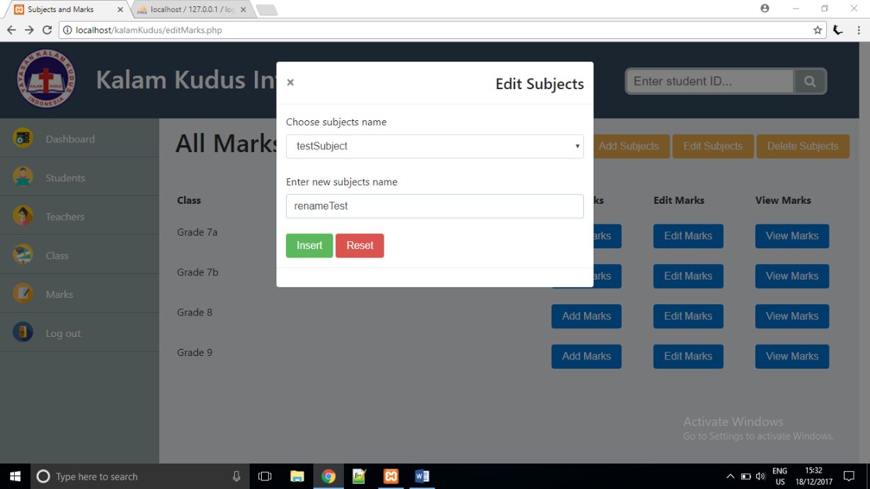

If admin clicks ‘Insert’ button, the subject will be updated and the change is also applied to the database. To view the subject, admin can click ‘View All Subjects’ button.

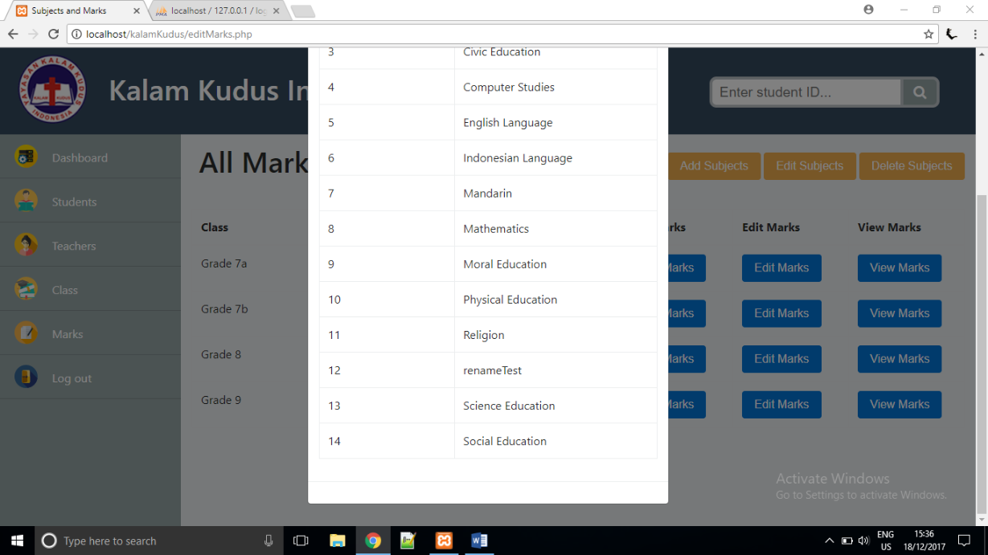

a new class has been edited

If admin clicks ‘Delete Subject’ button, the modal box will appear and admin can choose which subject to be deleted from the database.

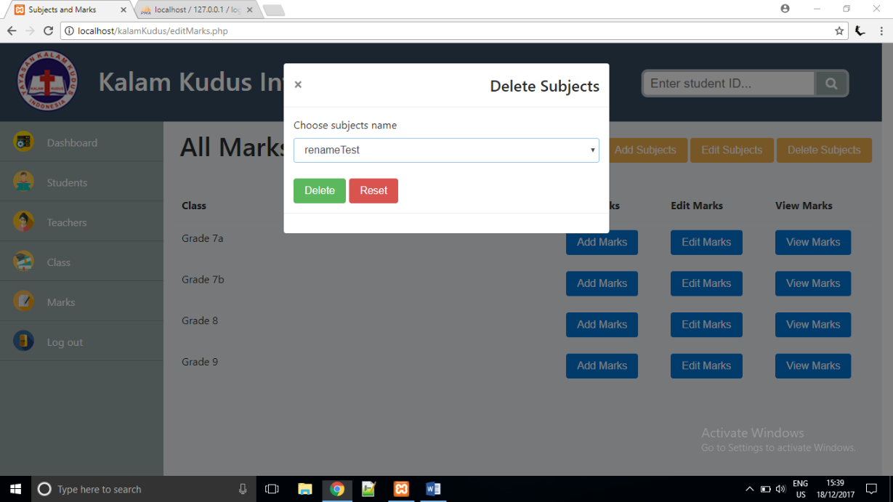

If admin clicks ‘Delete’ button, the subject will be deleted and then return to editMarks.php. To view the subject, admin can click ‘View All Subjects’ button.

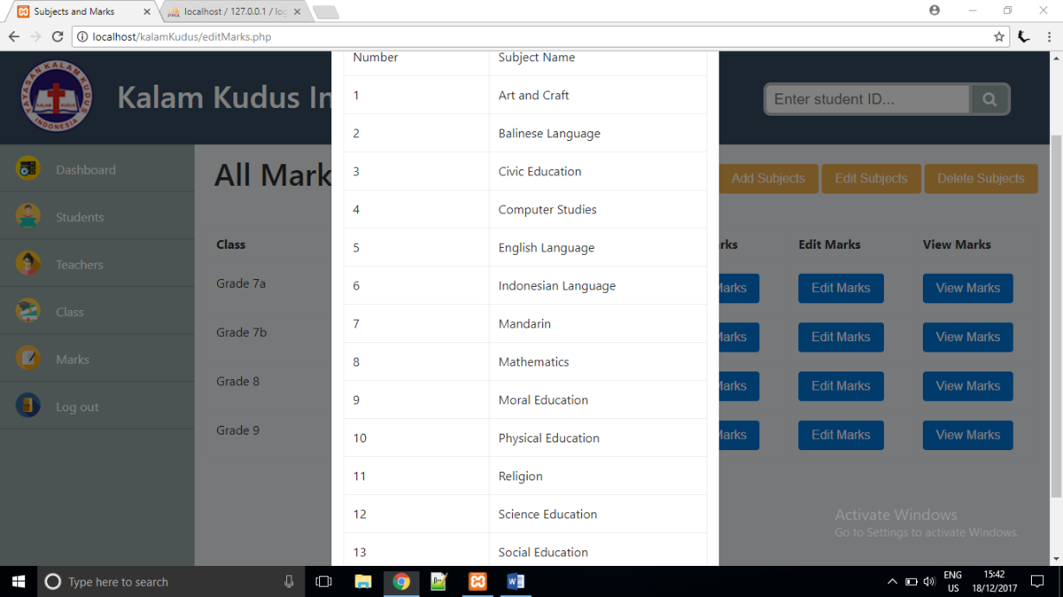

If admin clicks ‘Add Marks’ button, the modal box will appear and admin can choose which student, which subject, and what type of marks to be added.

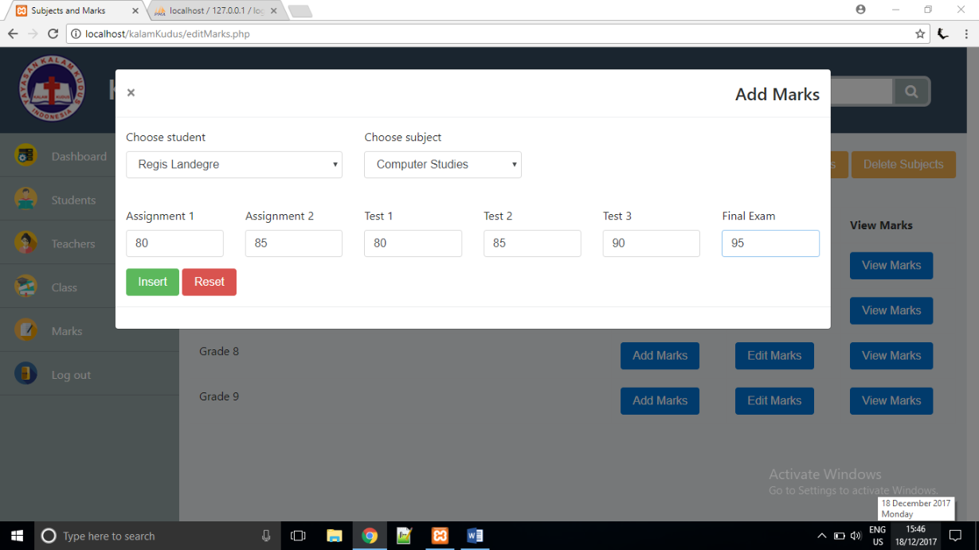

If admin clicks ‘Insert’ button, a new mark will be added and be saved to the database. To view the marks, admin can click ‘View Marks’ button.

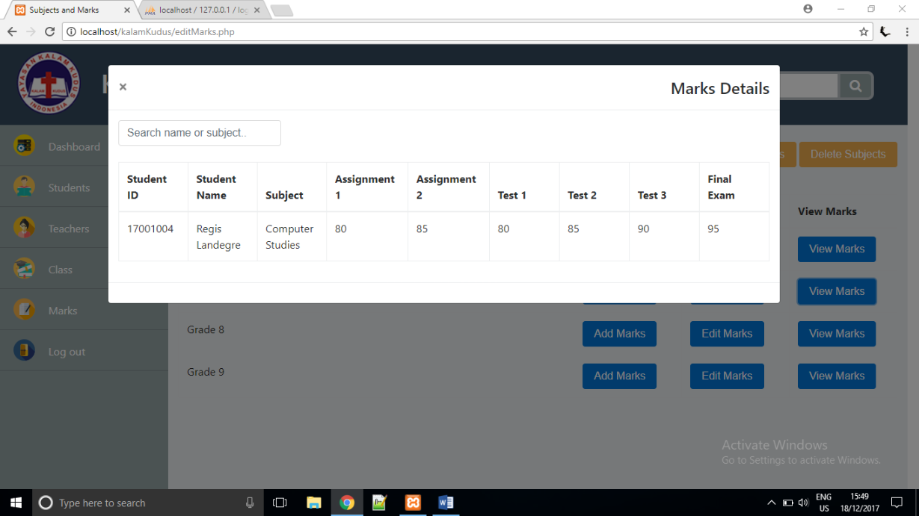

If admin clicks ‘Edit Marks’ button, the modal box will appear and admin can choose which student, which subject, and what type of marks to be edited.

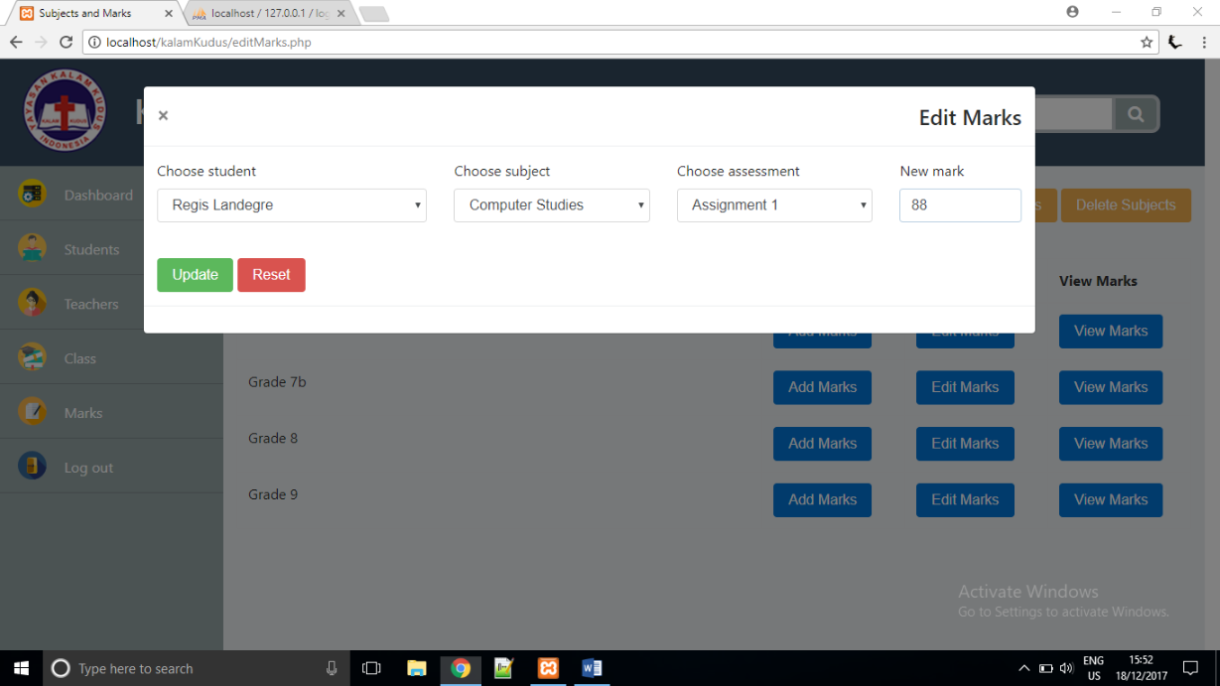

If admin clicks ‘Insert’ button, a new mark will be saved and the change is also applied to the database. To view the marks, admin can click ‘View Marks’ button.

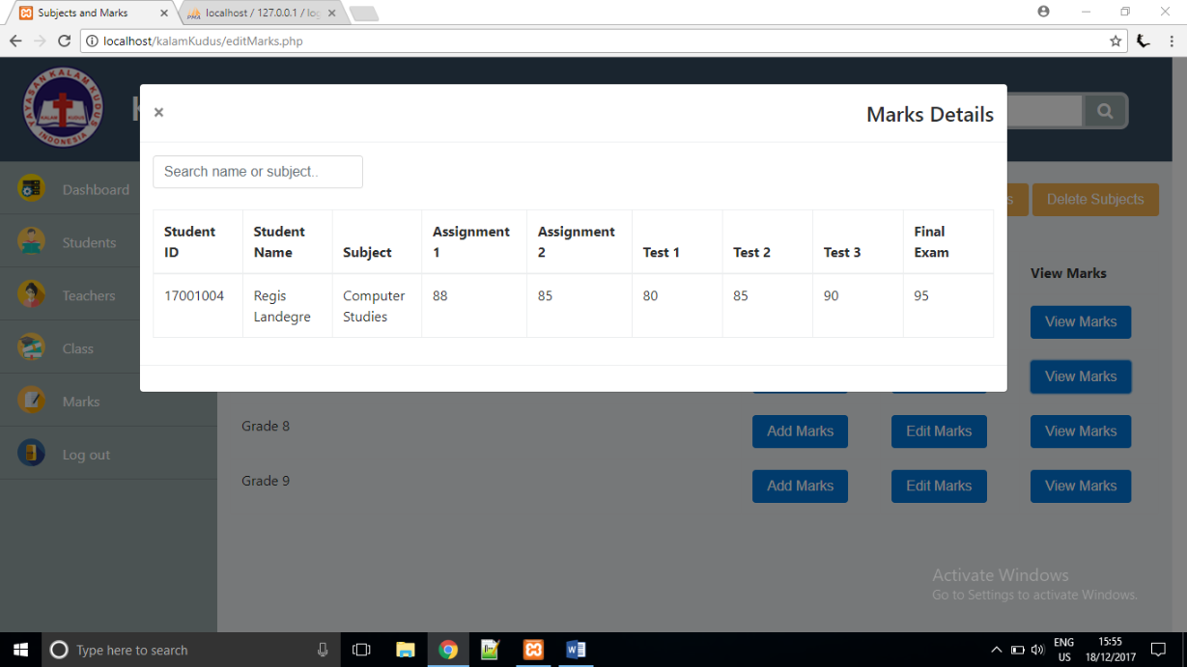

the mark has been changed

If admin clicks ‘Log out’ from the navigation bar, it will direct to log in form in index.php.



# Test Analysis Report

From unit, integration and system testing, we can say that the system and codes are working fine and has passed the testing process. The scope of our testing is to make sure every functions of the system can work perfectly according what the tasks they are assigned. Overall, we have found bugs and errors and have corrected it.

# Updated Gantt Chart

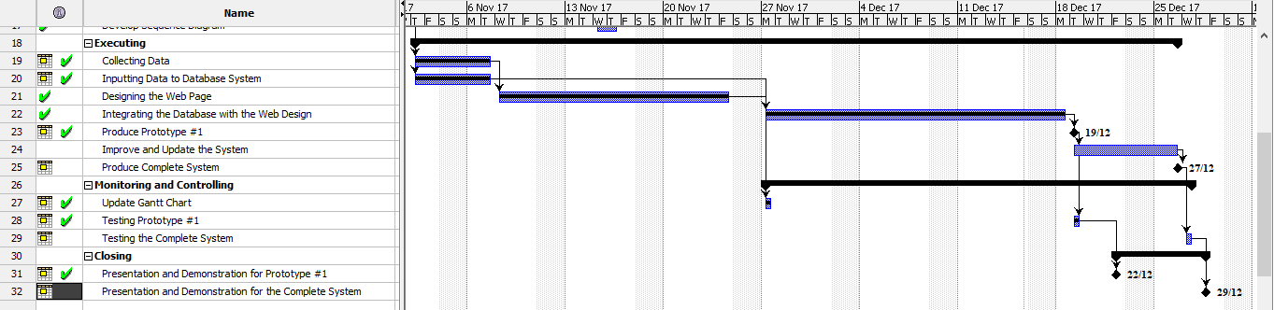

# References

[1] Pfleeger, S. L., Atlee, J. M. (2010). Software Engineering Theory and Practice – Fourth Edition. Pearson Education, United States